ACB
Better Together Wherever We Are

60th Annual
National Conference & Convention American Council of the Blind and Special-Interest Affiliates
July 16 – 23, 2021
Dan Spoone, President
Large Print Program
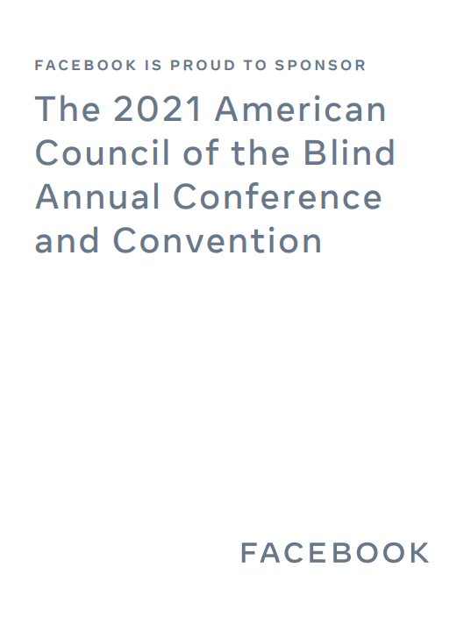

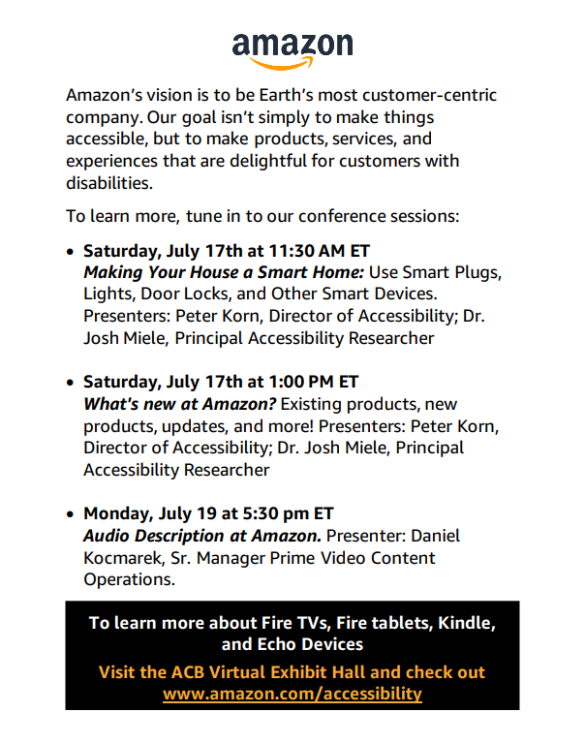

Table of Contents Conference and Convention
CALENDAR
Calendar………………………………………….……8
Conference Gems…………………………………25
President’s Message…………………………….28
Abbreviations in this Program……….………31
Registration Information………………………33
Communication Center Services…….………34
Digital Information & Internet………………35
Religious Activities………………………………39
ACB Fundraisers……………………………….…40
Convention Standing Rules……………………42
General Session Agenda……………………….48
ACB Boards & Governing Committees…….64
Program Sessions………………………………..67
Special-Interest Affiliate Meetings……….165
AABT……………………………………………165
AAVIA………………………………………….166
AAVL……………………………………………168
ACBDA…………………………………………169
ACBGE…………………………………………170
ACBNG…………………………………………170
ACBF……………………………………………173
ACBL……………………………………………174
ACBRA…………………………………………175
ACBS……………………………………………176
BITS……………………………………………177
BRL……………………………………………..178
BPI……………………………………………..179
CCLVI………………………………………….181
FIA……………………………………………..182
GDUI……………………………………………184
IVIE…………………………………………….185
LUA……………………………………………..186
RSVA……………………………………………187
ACB Committee Meetings……………………188
ACB Women………………………………….188
Advocacy Services…………………………189
Auction………………………………………..189
ADP…………………………………………….189
DKM First Timers……………………….….192
Employment………………………………...192
Environmental Access…………………...193
Information Access……………………….194
International Relations………………….194
Leadership Training…………………..….195
Membership…………………………………195
Multicultural Affairs………………………195
Rehab Issues Task Force………………..196
Resource Development………………....196
SASI……………………………………….…..196
Scholarship………………………………….197
Transportation……………………………..197
ACB Community Calls……………………..…..198
Other Meetings and Programs……………...200
2021 ACB Exhibitors……………………………202
2021 Audio Described Tours………………..204
ACB Officers……………………………………...208
ACB Board of Directors………………….…….208
ACB Board of Publications……………………209
ACB Enterprises & Services…………………209
ACB Office Staff & Consultants……………..210
2021 Convention Coordinating
Committee……………………………………211
2021 Convention Program Committee…..212

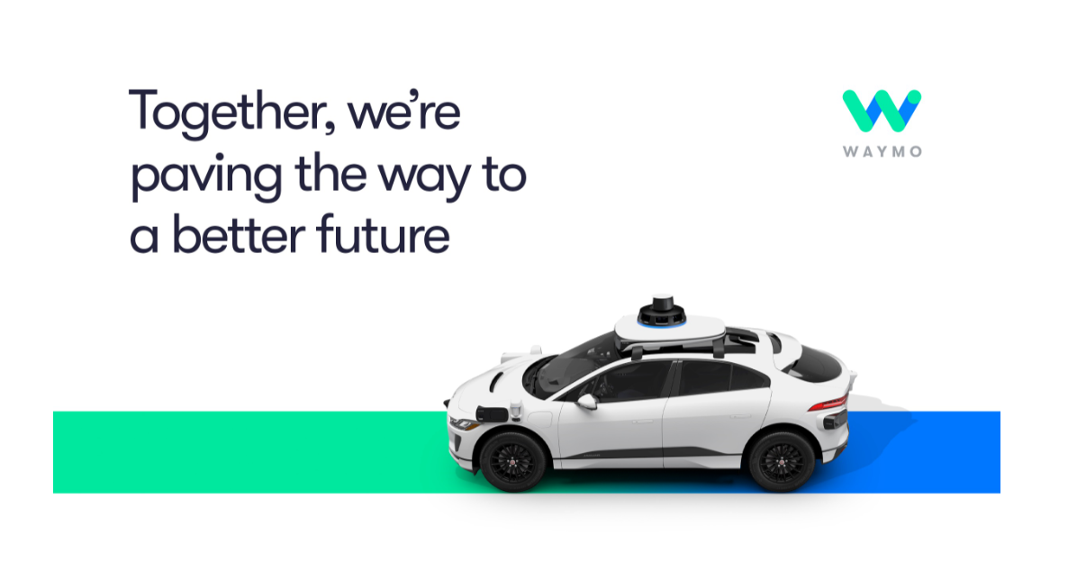
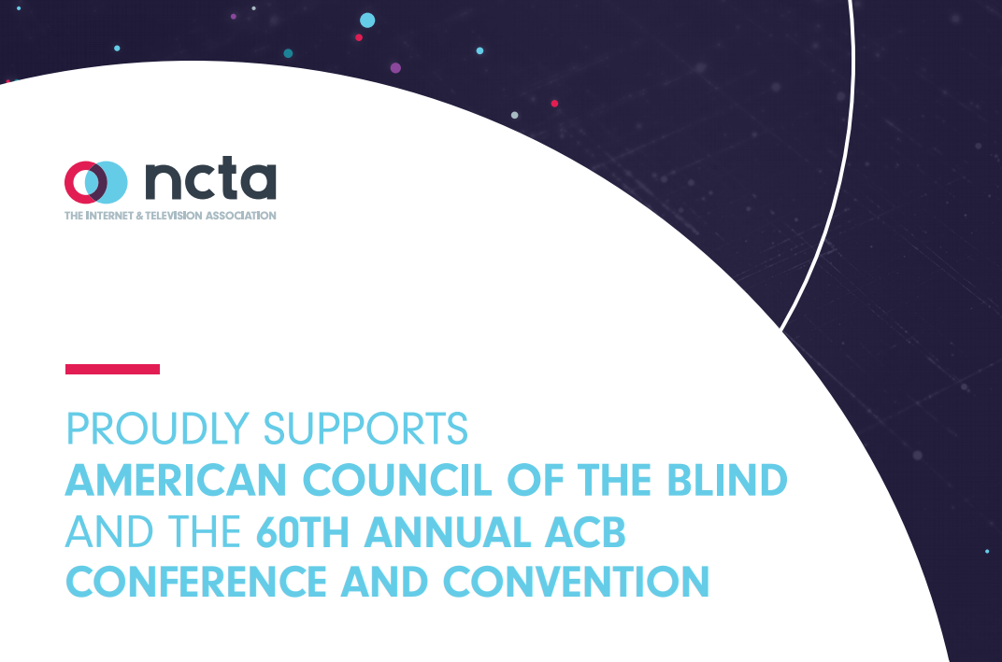

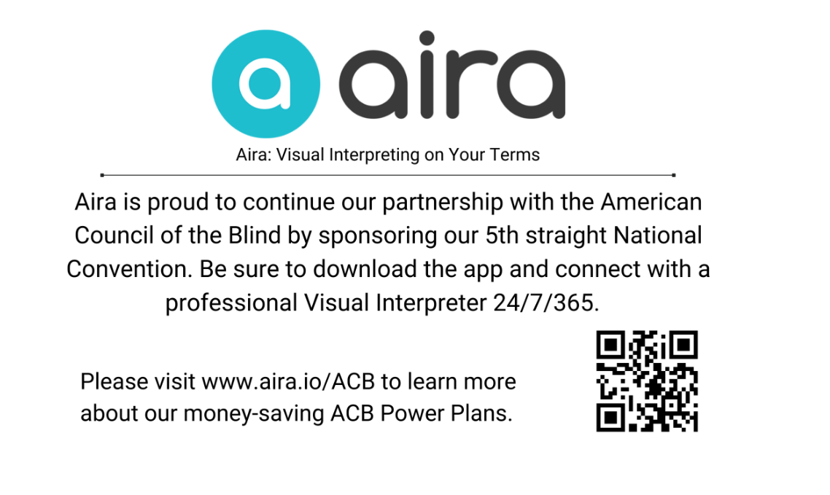

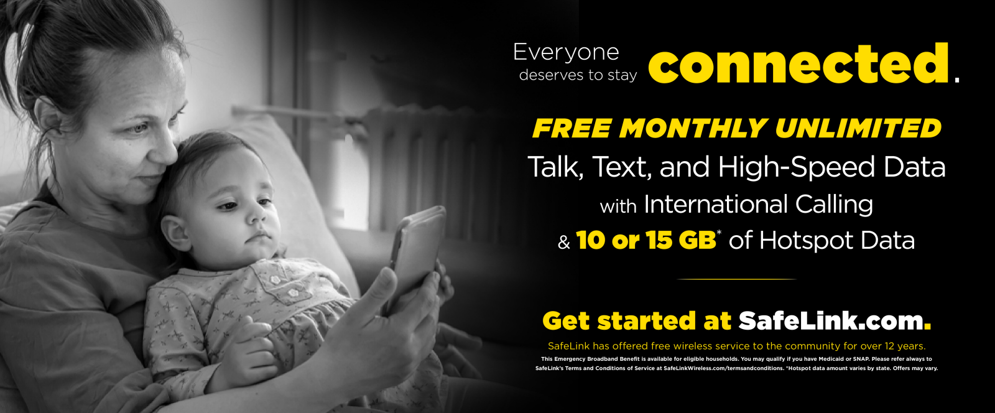

Calendar
Friday, July 16
10:00am – 4:00pm: ACB Board Meeting
11:30am – 12:45pm: Vispero Interactive Discussion – Software, Hardware and Training
11:30am – 12:45pm: GDB Virtual Barking Up the Aisle
11:30am – 12:45pm: Microsoft Soundscape
1:00pm – 2:15pm: Microsoft Windows
1:00pm – 2:15pm: Sharing with Seeing Eye
2:30pm – 3:45pm: Bookshare Office Hours at ACB!
2:30pm – 3:45pm: Microsoft Accessibility
4:00pm – 5:15pm: ACBF Tour – Mammoth Cave
4:00pm – 5:15pm: LUA - One Poet, One ACB
4:00pm – 5:15pm: En-Vision America – Shoulda, Coulda, Woulda, WILL: Why Asking for Help is so Difficult
5:30pm – 6:45pm: BPI - Discover Your Vino Type
5:30pm – 6:45pm: LUA - Exploring Virtual Book Clubs
5:30pm – 6:45pm: HumanWare - Discover the New X Series Braille Displays and Upcoming Enhancements for the BrailleNote Touch Plus and Victor Reader!
7:00pm – 8:30pm: Scholarship Recipients Meet and Greet (by invitation only)
7:00pm – 8:45pm: ACB Film Night - “Winner of the 2021 Best Picture Academy Award, Nomadland”
7:30pm – 8:45pm: DKM JPMorgan Chase Reception (by invitation only)
9:00pm – 11:00pm: FIA – Showcase of the Performing Arts
9:00pm – 11:00pm: ACBS/ACBNG – Friday Night Bash
9:00pm – 11:00pm: RSVA® Networking Mixer
11:00pm – 12:15am: FIA – Showcase After Hours

Saturday, July 17
9:00am – 10:00am: Morning Coffee
10:00am – 11:15am: Saturday School - “Teaching Through the Years”
10:00am – 11:15am: BITS/SASI – Do You Hear What I Hear?
10:00am – 11:15am: FIA – Board Meeting
10:00am – 11:15am: GDUI – Howl and Rewards Ceremony
11:30am – 12:45pm: Saturday School – “Teaching and Learning Online”
11:30am – 12:45pm: BITS - Make Your House a Smart Home
11:30am – 12:45pm: GDUI – Class Lecture: Author Talk with Christi Bane
1:00pm – 3:45pm: AAVL – Business Meeting
1:00pm – 2:15pm: ACBS - The Sento Showdown Team Presents: An Overview of Console and Video Game Accessibility
1:00pm – 2:15pm: BITS – What’s New at Amazon
1:00pm – 2:15pm: BPI – 3D Audio Excursion!
1:00pm – 2:15pm: RSVA® "The Journey- Navigating the Challenges"
2:00pm – 7:00pm: Community Hospitality
2:30pm – 3:45pm: AAVL – Business Meeting
2:30pm – 3:45pm: AAVIA – Supreme Court Year in Review
2:30pm – 3:45pm: RSVA® "The Importance of the RS15"
2:30pm – 3:45pm: IAC – 411: Braille Notetaking Devices Versus Mainstream Products
2:30pm – 3:45pm: Berl Colley Leadership Institute: Creating a Welcoming Affiliate Culture
4:00pm – 5:15pm: Saturday School - "Advocating for the Best Learning Options in a Hybrid Environment"
4:00pm – 5:15pm: ACBDA – Social: Together We Make a Difference

4:00pm – 5:15pm: BPI - Self Care: Massage, Essential Oils and Breathing
4:00pm – 5:15pm: RSVA® “The Most Recent Happenings in the Ever-Changing Legal and Legislative Landscape Involving Randolph-Sheppard Vendors”
4:00pm – 5:15pm: IAC – 411: Rehabilitation, Providing Remote Services
4:00pm – 5:15pm: ADP – Audio Description in Museums
5:30pm – 6:45pm: ACBF Goes to Camp
5:30pm – 6:45pm: Sister Power – Happy Hour
5:30pm – 6:45pm: Audio Described Film – “Straight Off the Canvas”
5:30pm – 6:45pm: RSVA® “Perspective From the Other Side”
6:00pm – 6:45pm: Giving Society Reception (by invitation only)
7:00pm – 9:00pm: An Evening with ACB – “Get Up and Get Moving” Campaign Kick-Off
9:00pm – 10:15pm: ACB Next Generation - Meet & Greet Social
9:00pm – 10:15pm: BPI – Mixer
9:00pm – 10:15pm: SASI – Social Happy Hour

Sunday, July 18
9:00am – 10:00am: Morning Coffee
10:00am – 11:00am: Non-denominational Service words of encouragement
11:30am – 12:45pm: ACBF - Your Family History – Connect the Dots and Grow the Branches
11:30am – 12:45pm: ACBS – Scholarship Celebration
11:30am – 12:45pm: BITS - Virtual Technology Showcase Part One
11:30am – 12:45pm: BPI – Sunday Matinee
11:30am – 12:45pm: LUA – How Do I, Answers to 7 Questions

11:30am – 12:45pm: ACB – Committee Chairs Meeting
1:00pm – 2:15pm: BITS - Virtual Technology Showcase Part Two
1:00pm – 2:15pm: BPI - Using Clubhouse, TikTok and WhatsApp
1:00pm – 2:15pm: Audio Description Project Website Overview and Update (acb.org/adp)
1:00pm – 2:15pm: RSVA® - Business Meeting
1:00pm – 3:45pm: MCAC - “One ACB Moving Forward”
2:00pm – 7:00pm: Community Hospitality
2:30pm – 3:45pm: So What Do I Do With This Law Degree?
2:30pm – 3:45pm: CCLVI – Vendor Showcase
2:30pm – 3:45pm: FIA - You Gotta Have Harp
2:30pm – 3:45pm: Conversation with Dr. Hoby Wedler
2:30pm – 5:15pm: SASI - Employment Strategies for Those with a Dual Sensory Loss
2:30pm – 3:45pm: RSVA® - Business Meeting
4:00pm – 5:15pm: Disability History/Awareness Society Implementation
4:00pm – 5:15pm: “Adventures in Coaching: Exploring the Hottest New Career”
4:00pm – 5:15pm: How a Vision Zero Campaign Can Set a New Standard for Safety on Our Streets
4:00pm – 5:15pm: Raising Revenue for Affiliate Conventions
6:00pm – 6:45pm: ACB Walk: Get Moving Together!
7:00pm – 10:30pm: Opening General Session

Monday, July 19
9:00am – 10:00am: Morning Coffee
10:30am – 2:00pm: Morning General Session
2:00pm – 7:00pm: Community Hospitality
2:30pm – 3:45pm: AAVIA – A View from Across the Atlantic
2:30pm – 3:45pm: Navigating the Health Care System as an Adult with Vision Loss
2:30pm – 3:45pm: Diabetes Education 101: Thriving and Living with Diabetes
2:30pm – 3:45pm: Smart Home Devices – Work Smarter Not Harder
2:30pm – 3:45pm: Sensuality and Sexuality with Disability
2:30pm – 3:45pm: LUA – A Conversation with NLS
4:00pm – 5:15pm: AAVL - Safety and Fall Prevention; Prescription Drug Labeling
4:00pm – 5:15pm: Diabetes Education 101: Diabetes Self-Management
4:00pm – 5:15pm: When Your Civil Rights as an LGBTQ Person are Threatened You May Need a Good Lawyer
4:00pm – 5:15pm: To Cross, or Not to Cross - Strategies and Considerations for Crossings with No Traffic Signal or Stop Sign
4:00pm – 5:15pm: State Commissioners and the Future of Blind Rehabilitation
4:00pm – 5:15pm: ADP – Audio Description in the Performing Arts
5:30pm – 6:45pm: Non-Traditional Blind Sports
5:30pm – 6:45pm: ACBS – Business Meeting
5:30pm – 6:45pm: Out and About with Canines and Canes
5:30pm – 6:45pm: Audio Description at Amazon
5:30pm – 6:45pm: Get Hired – Envision Workforce Innovation Center Talent Network
7:00pm – 9:00pm: An Evening with ACB: Audio Description and Streaming Services
7:30pm – 8:45pm: A Night of Great Opera Arias
7:30pm – 8:45pm: CCLVI/ACBF – Game Night: Family Feud
9:00pm – 10:15pm: Milly's Place - ACB Lions 50th Anniversary Party
9:00pm – 10:15pm: Prose and Poetry Reading

9:00pm – 10:15pm: ACB Next Generation - After Hours Social
9:00pm: Convention Nightcap

Tuesday, July 20
9:00am – 10:00am: Morning Coffee
10:30am – 2:00pm: Morning General Session
2:00pm – 7:00pm: Community Hospitality
2:30pm – 3:45pm: Practical and Legal Issues for Government Employees: Issues and Challenges for Today
2:30pm – 3:45pm: Diabetes and Nutrition 101: Current Nutrition Trends & Their Impact on Diabetes
2:30pm – 3:45pm: Adaptive Sports an Active Body = A Healthy Mind
2:30pm – 3:45pm: Podcasting for Beginners
2:30pm – 5:15pm: CCLVI – Business Meeting
4:00pm – 5:15pm: Diabetes and Fitness 101
4:00pm – 5:15pm: Self-Defense with BPI
4:00pm – 5:15pm: What’s New at the Corner?
4:00pm – 5:15pm: Podcasts Featuring Audio Description
4:00pm – 6:45pm: Voices from Around the World: Ten Voices, Ten Worlds
5:30pm – 6:45pm: ACBF/MCAC Schools for the Blind: From Segregation to Integration
5:30pm – 6:45pm: Space Camp for Interested Visually Impaired Students (SCI-VIS)
5:30pm – 6:45pm: Content Creators Café
5:30pm – 6:45pm: Pedestrian Control Over Drivers' Yielding
5:30pm – 6:45pm: HumanWare - Meet HumanWare’s Low Vison Line-Up, Including a New Family Member!
7:00pm – 11:00pm: ACB Diamond Jubilee Auction
7:30pm – 8:45pm: BPI from Grape to Glass
9:00pm – 10:15pm: ACB Next Generation: After Hours Social
9:00pm – 10:40pm: BPI Movie Night: The Way He Looks
9:00pm: Convention Nightcap

Wednesday, July 21
9:00am – 10:00am: Morning Coffee
10:30am – 2:00pm: Morning General Session
2:00pm – 7:00pm: Community Hospitality
2:30pm – 3:45pm: Diabetes and Advocacy 101
2:30pm – 3:45pm: LUA/BRL - Visit with ACB's Guest Talking Book Narrator
2:30pm – 3:45pm: CCLVI Family - What are Friends For?
2:30pm – 3:45pm: GDUI - Help Drive the Future of Driving!
4:00pm – 5:15pm: Living Life to the Fullest with Diabetes

4:00pm – 5:15pm: BPI - Audio Description: Dragging the Boys of Audio Description Behind the Curtain
4:00pm – 5:15pm: Meet the Author: Judy Dixon, Writer “What it is, Where to Find it, and How to Use it”, published by National Braille Press
4:00pm – 5:15pm: ACB Women – Yoga with Leslie Spoone
4:00pm – 5:15pm: Membership Committee - How to Create a Successful Virtual Conference
5:30pm – 6:45pm: ACBL – Lessons in Leadership
5:30pm – 6:45pm: BPI – Behind the Makeup: The Art and History of Drag
5:30pm – 6:45pm: Audio Description in the Out of Doors
5:30pm – 6:45pm: DKM Reception
7:00pm – 9:00pm: An Evening With ACB: Panel on Increasing Financial Literacy
9:00pm – 10:15pm: ACB Next Generation - After Hours Social
9:00pm – 10:15pm: Baby Boomer Trivia
9:00pm – 10:15pm: A Night of Music and Protests
9:00pm: Convention Nightcap

Thursday, July 22
9:00am – 10:00am: Morning Coffee
10:30am – 2:00pm: Morning General Session
2:00pm – 7:00pm: Community Hospitality
2:30pm – 3:45pm: ACBRA - Program and Business Meeting
2:30pm – 3:45pm: ACBS - The Sento Showdown Presents: Live Demo of Accessible Video Games
2:30pm – 3:45pm: BPI - So You Want to Pick the Right Therapist
2:30pm – 3:45pm: BRL - Program: Graphics and E-readers
2:30pm – 3:45pm: GDUI – Community Run Guide Dog Schools Update
2:30pm – 3:45pm: Tips and Tricks for Nailing that Job Interview
4:00pm – 5:15pm: BPI - Protecting Your Partner Even if You Don't Have One!
4:00pm – 5:15pm: BRL – Program: Moving the Braille Revival League forward
4:00pm – 5:15pm: GDUI/IRC – Global Tails
4:00pm – 5:15pm: “So You Want to Be an Entrepreneur?”
4:00pm – 5:15pm: Diversity - Describing Race, Skin Color, Ethnicity, Gender, and Disability Within Today’s Audio Description
5:30pm – 6:45pm: Helen Keller and the Lions
5:30pm – 6:45pm: ACB Next Generation – “Who Wants to Be a Millionaire - ‘90s Trivia Edition”
5:30pm – 6:45pm: FIA Scholarship Winners Come Together
5:30pm – 6:45pm: A Conversation with AFB
5:30pm – 6:45pm: What's New in Google Accessibility
7:00pm – 9:00pm: ACB Banquet
9:00pm – 10:15pm: ACB Next Generation: After Hours Social
9:00pm: Convention Nightcap
Friday, July 23
9:00am – 9:30am: Morning Coffee
9:30am – 4:00pm: Morning General Session
4:00pm – 5:15pm: LGBTQ History
4:30pm – 5:45pm: Convention Wrap Up with the Board of Publications
5:30pm – 6:45pm: BPI - Wine from Two Perspectives: Winemakers and Wine-Drinkers
6:00pm – 7:45pm: An Evening with ACB - Audio Description and Olympics Opening Ceremony Extravaganza
8:00pm – 11:00pm: Olympic Opening Ceremony with Audio Description

Conference Gems
Many, many thanks to our 2021 corporate sponsors. Their continued generous support of the American Council of the Blind and our conference and convention is sincerely appreciated.
Look for the 2021 corporate sponsors on www.acb.org, in the conference and convention program and newspaper, on ACB Radio, on the convention T-shirt, and throughout the week. Be sure to thank them for their generous support.

Diamond Sponsors:
- Comcast
- Facebook – ACB General Sessions
- Google – Conference and Convention Communication Center
- JPMorgan Chase –
- Microsoft - ACB Radio Streaming
Emerald Sponsors:
- Amazon – Conference Virtual Exhibit Hall
- Charter Communications
- Vanda
- Verizon – Information and Technology Help Desk
- Vispero – Podcasts

Ruby Sponsors:
- Adobe
- Aira
- AT&T
- Cruise
- LinkedIn
- National Cable and Telecom Association – ACB Activities
- Perkins School for the Blind - Convention Broadcast Center
- T-Mobile Accessibility – Continuing Education Credits (CEC)

- TracFone Wireless Inc. – ACB Scholarship Mentoring Program
- Waymo – Audio Description Project
Onyx Sponsors:
- Democracy Live, Inc. – ACB Link
Coral Sponsors:
- National Industries for the Blind – ACB Employment Session
- National Library Service – ACB Information Access
Pearl Sponsors:
- Library Users of America – Talking Book Narrator

President’s Message
I want to welcome everyone to the 60th annual conference and convention of the American Council of the Blind, for our second straight virtual gathering broadcast across ACB Radio and Zoom platform. In these unique times, the efforts of our members to pull together and present an outstanding event is a testimony to the passion and tenacity of our ACB Family.
The theme of the 2021 convention is “Better Together Wherever We Are!” This is a great theme for this year's convention since today’s obstacles represent tomorrow’s opportunities. Making opportunities turn into successes for people who are blind or visually impaired is what our work at ACB is all about!
You will hear much more about ACB's successes during what should be our busiest and most information-packed convention ever.
Every ACB convention relies on scores of volunteers who work to make this event possible. I want to personally thank the members of the Convention Committee, chaired by Janet Dickelman; the Convention Program Committee, and the ACB Radio team.
Likewise, let me acknowledge the work of our Alexandria and Minneapolis staff. You are all fabulous!
Finally, a very warm welcome to those of you attending the ACB convention for the first time. This virtual event will offer our members and friends a wonderful chance to experience a truly exceptional program in the comfort of your own home. There will be over 25 hours of audio-described tours, a robust vendor exhibit hall and eight days of outstanding workshops with prime time shows each evening, daily general sessions with knowledgeable presenters across the full range of issues that impact our community and over 130 breakout sessions from our affiliates, committees and sponsors. This unique experience will shape our organization for years to come, and we can’t wait to get together in person next year. Plan on joining us in 2022 and come to Omaha, Nebraska.
Enjoy a great convention!
Dan Spoone, ACB President

Abbreviations in this Program
ACB – American Council of the Blind
AABT – American Association of Blind Teachers
AAVL – Alliance on Aging and Vision Loss
AAVIA – American Association of Visually Impaired Attorneys
ACBDA – ACB Diabetics in Action
ACBF – ACB Families
ACBGE – ACB Government Employees
ACBL – ACB Lions
ACBNG – ACB Next Generation
ACBRA – ACB Radio Amateurs
ACBS – ACB Students
ADP – Audio Description Project
AFB – American Foundation for the Blind
APH – American Printing House for the Blind
BITS – Blind Information Technology Specialists
BOP – Board of Publications
BPI – Blind LGBT Pride International
BRL – Braille Revival League
CCLVI – Council of Citizens with Low Vision International
DKM – Durward K. McDaniel First Timer
FIA – Friends-in-Art of ACB
GDUI – Guide Dog Users, Inc.
IRC – International Relations Committee
IVIE – Independent Visually Impaired Entrepreneurs
LUA – Library Users of America
MCAC – Multicultural Affairs Committee
NIB – National Industries for the Blind
NLS – National Library Service for the Blind and Print Disabled
RSVA – Randolph-Sheppard Vendors of America
SASI – Sight and Sound Impaired Committee
VIVA – Visually Impaired Veterans of America

Registration Information
While most of the conference and convention will be live streamed on ACB Radio, registering will allow you to be eligible for the daily door prize drawings and to actively participate in Zoom meetings.
To register once the convention has started, you can call 612-332-3242.
Convention registration hours are: Thursday, July 15 through Friday, July 23rd from 9:00 am to 5:00 pm EDT.
Refunds: ACB will make no refunds for convention administrative fees, sponsorship donations or Continuing Education Flex packages.
Refunds will be issued only for merchandise that has been purchased but not yet shipped. A refund request can be made by emailing nbecker@acb.org or calling (612) 332-3242
on or before June 21, 2021.

Communication Center Services
Sponsored by Google
Convention Newspaper
This year's newspaper is “The Digital Daily, Second Edition.” It will be published daily, Friday, July 16 through Friday, July 23.
If you signed up for the ACB Students fundraiser, the newspaper will be sent to you using the email address you provided when you registered.
The newspaper will also be read daily on ACB Radio and posted to the ACB convention announce list.
Ads and Announcements
Ads, announcements, and other items for newspaper publication must be emailed to Sharon Lovering at slovering@acb.org by 2 pm Eastern each day and included as an email message, or as a Word, text, or PDF attachment.
The BOP allows ads to run for up to three days to give important convention announcements more space. BOP editorial policy prohibits the production or distribution of campaign materials by the Communication Center.
Ads/announcements must be no longer than 75 words.
The newspaper advertisement/announcement needs to be paid before it is sent to production and the prices are:
Individuals, ACB affiliates and blind representatives of MLM companies - $0; Exhibitors - $40/day or $100 for 3 days; all others - $50/day or $125 for 3 days

Digital Information & Internet
If you registered for the convention, you will receive Zoom invitations for all sessions or you can also join via computer or phone.
All general sessions, and much of our afternoon and evening programming will be live streamed on ACB radio using multiple streams.
Other sessions will be recorded and aired on ACB radio and available as podcasts when editing is completed.
How to participate at the convention
There are several options to participate at the convention:
- Listen from your computer by going to acbradio.org and selecting the stream you want to hear.
- Follow the convention via ACB Link on your smart phone - Download ACB Link from the Apple app store for your iPhone or from the Google Play Store for your Android phone.
- Listen on the telephone by calling (518) 906- 1820 and follow the menu prompts.
- To watch the convention live go to www.acb.org/live.
A list of Alexa skills will be available near the opening of convention.
Additional listening options will be posted on the ACB convention website and to the convention email list.
For general convention questions, call our convention information desk at (612) 470-1947 or email them at Acb.info.helpdesk@gmail.com
You can reach a help desk representative between 9:00 am and 8:00 pm Eastern time.
If you need technology assistance during the convention, contact ACB’s technology help desk at acb.tech.help@gmail.com or call us at (612) 470-1959.
Email list
The ACB Convention email list keeps you up to date on all the news. Such as receiving “The Digital Daily” and all the other pertinent information. To subscribe, go to the ACB website at www.acb.org, or send a blank message to acbconvention+subscribe@acblists.org.
Social Media
To connect with ACB at the convention:
- Like us on Facebook at: www.facebook.com/americancounciloftheblindofficial
- Twitter at: www.twitter.com/acbnational
- ACB’s YouTube Channel: http://tinyurl.com/gloz7bq

ACB Photography
ACB may be using recorded video from general sessions and at many social events. It is understood that all recorded audio and video at the 2021 conference and convention are the property of ACB and are for ACB's use.

Religious Activities
Sunday, July 18
10:00am – 11:00am: Non-denominational Service words of encouragement. We are truly living in times of uncertainty. Many of us are gripped with fear and fright, anxiety, and angst, along with terror and trepidation that threaten to keep us from having peace in our lives. So, can we offer a few words of encouragement designed to revitalize our hope so that we can live lives filled with boldness and confidence even in these days?
Rev. Michael Garrett, Missouri City, TX

ACB Fundraisers
You can show your support for ACB in several ways:
Convention Sponsorships
Become an individual ACB Conference and Convention Sponsor. Individual sponsorships are Bronze ($25), Silver ($50), Gold ($100), Platinum ($250), and Titanium ($500)

Sponsors are recognized both in general session and in the newspaper.
For information on becoming an individual or corporate sponsor, contact our Minneapolis office at (612) 332-3242.
Get Moving Together!
Sunday, July 18 – 6:00pm
Help kick off the ACB general sessions by joining ACB members and friends during the live virtual Brenda Dillon Memorial Walk. Lace up your shoes, grab your water bottle, and be a part of one of the kickoff events in the ACB Health and Wellness campaign.
ACB Diamond Jubilee Auction!
Tuesday, July 20 – 6:00pm
Come bid and win from your easy chair. Over 60 items with exciting vacations, scrumptious treats, latest technology, and unique crafts.
ACB Raffle
Win $5,000 in cold hard cash!
Limited tickets are available; $50 each. Buy one for yourself, your affiliate, or find up to four friends and split the cost five ways. To purchase tickets, call (612) 332-3242.
MMS Program
Help support ACB all year ‘round through ACB’s Monthly Monetary Support program (MMS); it's easy and quick. Find out more about the Monthly Monetary Support Program by emailing askacbmms@gmail.com or call (202) 743-0755 to inquire about how you can support ACB and your affiliate.

Convention Standing Rules
Adopted by the ACB Board of Directors, May 22, 2021
- Each debatable issue before the convention shall be limited to approximately twenty (20) minutes with a three-minute time limit per speaker, alternating between affirmative and opposing speakers, unless a majority of the members agree to extend debate for an additional period of time.
  - Motions to close debate will not be recognized by the chair during the first debate period. After the first debate period, properly moved motions such as “I call for the question” or “I move the previous question” will be handled by the chair and voted on by the assembly.
  - The chair may close debate when no one seeks the floor.
  - Each member is respectfully urged to speak directly to the issue before the assembly and avoid unnecessary and time-consuming dialogue.
  - No member will be recognized a second time to debate until all who wish to debate have been recognized.
  - The parliamentarian will act as timekeeper.
- Recognition to speak will be given to those members who properly address the chair using the “raise hand” feature of the Zoom internet meeting client program, giving their names and affiliation.

- Changes to the published convention program may be proposed to the membership as deemed necessary by the presiding officer or his/her appointee. The presiding officer will explain the reason for such change and inform the assembly of their right to question the recommended modification. After this explanation, if twenty-five (25) or more members object to the proposed change by raising their hands using the Zoom meeting client, the change will then require debate and a majority vote to modify the convention program.
- Nominating and seconding speeches shall be limited to five minutes per candidate with the speaking time allocated according to the candidate's wishes. A person nominated for an office more than once shall be limited to one minute.
- When no candidate for office receives a majority vote, the election shall be between the top two candidates. Affiliate votes will be reported in whole or half numbers. In all uncontested elections as verified after three calls for additional nominations, the chair may declare the candidate elected by acclamation. “Write in” candidacies are not permitted.
- Anyone meeting the requirements for voting membership in ACB in accordance with Constitution Article III-A-1 and bylaw 1 is entitled to vote on any matter coming before the convention, provided that:
  - The person's name appears on an affiliate's certified membership list as submitted on March 15th or has been added to that list prior to the established record date for the convention, which date is thirty (30) days prior to the date of the opening session;
  - No challenges to, or questions about, a person's membership status will be considered after the close of registration on the day immediately preceding the final day on which convention business is to be conducted;
  - No challenges to, or questions about, a person's membership status will be considered during the time a record vote is being conducted.
- During the 2021 virtual conference and convention, we will ensure all members eligible to have the ability to cast their individual votes via a secret ballot. However, as it is not feasible to do so using paper as prescribed in By law 2, Section D of the ACB Constitution and By laws, said By law section is suspended only for the 2021 conference and convention per requirements of the District of Columbia Non-Profit code.

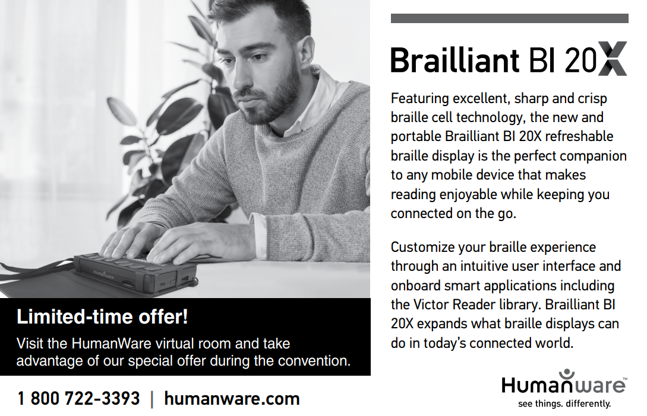

General Session Agenda
Sunday, July 18
Broadcast on ACB Radio Mainstream
7:00pm: Call to Order: Dan Spoone, President, American Council of the Blind, Orlando, FL
Moment of reflection
Presentation of Colors
National Anthem: Matthew H. Shifrin, Auburndale, MA
Welcome to Convention: Janet Dickelman, convention coordinator, Saint Paul, MN
ACB Highlight Video
7:30pm: ACB President's and ACB Director's Report: President's Report: Dan Spoone, Orlando, FL; Executive Director's Report: Eric Bridges, ACB Executive Director, Alexandria, VA
8:00pm: Sponsor Presentation: Jeff Petty, Principal Program Manager for Windows Accessibility, Microsoft, Seattle, WA
8:15pm: Credentials Committee Report: Ralph Smitherman, Jackson, MS
8:25pm: Convention Standing Rules and Nominating Committee Report: Brian Charlson, Watertown, MA
8:35pm: Life Member Presentations: Dan Spoone, ACB President, Orlando, FL; and Nancy Becker, ACB Chief Financial Officer, Brooklyn Center, MN
9:00pm: ACB Angels Presentations: Tony Stephens, ACB Director of Development, Alexandria, VA; and Dan Dillon, ACB Board Member, Hermitage, TN

ACB Angel Presentations:
Charlie Crawford (1947-2020), Maryland;
Berl Colley (1942-2020), Washington
9:20pm: “Special Thank You Tribute”
9:30pm: ACB First Timers: Kenneth Semien Sr., Chair, Durward K. McDaniel First Timers Committee, Beaumont, TX
9:40pm: ACB JPMorgan Chase Leadership Fellows: Eric Bridges, ACB Executive Director, Alexandria, VA
10:00pm: Roll Call of Affiliates: Denise Colley, ACB Secretary, Lacey, WA
10:30pm: ACB Elections

Monday, July 19
Broadcast on ACB Radio Mainstream
10:30am: Call to Order
Pledge of Allegiance: JPMorgan Chase Leadership Fellows
10:40am: ACB Business
ACB Sponsor Recognitions: Tony Stephens, Director of Development, Alexandria, VA
10:50am: Candidate Speeches
11:00am: Sponsor Presentation: Google
11:15am: ACB Angels Presentations:
11:30am: ACB Elections; Affiliate Roll Call
Presiding Officer: Mark Richert, First Vice President, Falls Church, VA
12:00pm: International Perspective: How Are the Winds Blowing in the Caribbean? Kenneth Suratt, Executive Officer, Trinidad and Tobago Blind Welfare Association, Port of Spain, Trinidad and Tobago; Cheryl Adams, President, Voice of the Disabled and National Society of and for the Blind, Georgetown, St. Vincent and the Grenadines; and Desmond Brown, President, Bahamas Alliance for the Blind and Visually Impaired, Nassau, Bahamas
12:30pm: Scholarship Presentations
12:50pm: Break
1:05pm: Presentation of Vernon Henley Media Award: Deb Cook Lewis, Board of Publications, Clarkston, WA
1:20pm: News from the National Library Service for the Blind and Print Disabled (NLS), Jason Yasner, NLS Interim Director, Washington, DC; and Mark Santangelo, Chief, NLS Patron and Network Engagement Division, Washington, DC
1:30pm: Election results; nominations for next election; door prizes, and announcements

Tuesday, July 20
Broadcast on ACB Radio Mainstream
10:30am: Call to Order
Pledge of Allegiance: Recipients of Ross Pangere Scholarships
10:35am: ACB Business
ACB Sponsor Recognitions: Tony Stephens, ACB Director of Development, Alexandria, VA
10:40am: Candidate Speeches
10:50am: Sponsor Presentation: Monica Desai, Global Head, Connectivity and Access Policy, Facebook, Washington, DC
11:05am: ACB Angels Presentations
11:30am: ACB Elections: Affiliate Roll Call
Presiding Officer: Ray Campbell, Second Vice President, Glen Ellyn, IL
11:50am: Mike May: Chief Evangelist, GoodMaps, Reno, NV; and Evelyn Tichenor, Chief of Staff, Goodmaps, Nashville, TN
12:10pm: ACB Advocacy Updates: Clark Rachfal, Director of Advocacy, Alexandria VA; and Swatha Nandhakumar, Advocacy and Outreach Specialist, Naperville, IL
12:35pm: Scholarship Presentations
12:50pm: Break
1:05pm: ADP Awards
1:30pm: Election results; nominations for next election; door prizes, and announcements

Wednesday, July 21
Broadcast on ACB Radio Mainstream
10:30am: Call to Order
Pledge of Allegiance: JPMorgan Chase Fellows
10:35am: ACB Business
ACB Sponsor recognition: Tony Stephens, Director of Development, Alexandria, VA
10:40am: Candidate Speeches
10:50am: Sponsor Presentation: Jim Sinocchi, Head of the Global Office of Disability Inclusion, JPMorgan Chase, Boston, MA; Lauren Oplinger, Vice President, Public Finance Sales Group, New York, NY
11:05am: ACB Angels Presentations
11:20am: ACB Elections; Affiliate Roll Call
Presiding Officer: Denise Colley, Secretary, Lacey, WA,
11:50am: Kathy Martinez, President and CEO Disability Rights Advocates, Berkeley, CA
12:10pm: CCLVI Scholarship Presentations
12:25pm: ACB Scholarship Presentations
12:50pm: Break
1:05pm: Talking Book Narrator: JP Linton, “Master of the Spoken Word”, Duart (formerly Benefit Media Inc), New York, NY
1:30pm: Election results; nominations for next election; door prizes, and announcements

Thursday, July 22
Broadcast on ACB Radio Mainstream
10:30am: Call to Order
Pledge of Allegiance: DKM First Timers', Kaila Allen, Mesa, AZ; Belinda Gail Collins - St. Pauls, NC
10:35am: ACB Business:
ACB Sponsor recognitions: Tony Stephens, Director of Development, Alexandria, VA
10:40am: Candidate Speeches
10:50am: Sponsor Presentation
11:05am: ACB Angels presentations
11:20am: ACB Elections; Affiliate roll call
Presiding Officer: David Trott, ACB Treasurer, Talladega, AL
11:40am: ACB's Growth report: Eric Bridges, ACB Executive Director, Alexandria, VA; and Nancy Becker, ACB Chief Financial Officer, Brooklyn Center, MN
12:15pm: ACB Scholarship Presentations
12:50pm: Break
1:05pm: Report on the ACB Walk and Auction: Donna Brown, Walk Chair, Romney, WV; Leslie Spoone, Chair, ACB Auction Committee, Orlando FL; and Dan Dillon, Chair, ACB Resource Development Committee, Hermitage, TN
1:30pm: Election results; nominations for next election; door prizes, and announcements
Friday, July 23
Broadcast on ACB Radio Mainstream
9:30am: Call to Order
Pledge of Allegiance: ACB Staff
ACB Sponsor recognition: Tony Stephens, Director of Development, Alexandria, VA
9:45am: Candidate Speeches, ACB elections begin
10:10am: TBA
10:30am: Affiliate roll call
11:00am: Treasurer’s report: David Trott, Talladega, AL
11:15am: Election results announced; nominations for next election, candidate speeches, and next election begins
11:30am: ACBES Report: Rev. Michael Garrett, Chair, ACB Enterprises and Services, Missouri City, TX
11:45am: Affiliate roll call
12:10pm: Member and Affiliate Relationships: Cindy Hollis, Membership Services Coordinator, Flat Rock, MI
12:45pm: Election results announced; nominations for next election, candidate speeches, and next election begins
1:00pm: Lunch
1:30pm: Affiliate roll call
1:50pm: Tony Stephens, ACB Director of Development, Alexandria, VA
2:15pm: Election results announced; nominations for next election, candidate speeches, and next election begins
2:30pm: Convention Report: Janet Dickelman, Convention Coordinator, Saint Paul, MN
3:10pm: Officer Roundtable
3:30pm: Affiliate Roll Call
3:55pm: Election Results
4:00pm: Closing Remarks: Dan Spoone
7:00pm: ACB Banquet
Banquet Emcee: Dan Spoone, ACB President, Orlando, FL
Moment of reflection:
God Bless America, Anthony Corona, BPI member and host of Sunday Edition, Miami, FL
Keynote Speaker: Peter Sagal
Best known as the host of the Peabody Award-winning NPR news quiz “Wait Wait...Don’t Tell Me!” One of the most popular shows on public radio.
In addition, he is, has been, and perhaps someday will be again, a husband, father, playwright, screenwriter, author, journalist, columnist, marathoner, Jeopardy contestant, dramaturg, podcast host, documentary host, foreign correspondent, wedding officiant, and magician’s assistant.
He is the author of “The Book of Vice” and “The Incomplete Book of Running”, a memoir about the 2013 Boston Marathon Bombing and other adventures while running long distances.
During the infamous Boston Marathon bombing incident, Peter was guiding a blind runner through his first Boston marathon. They finished just five minutes before the bombing occurred. The difference between running the last mile or taking a walking break was a literal life or death situation for the duo.

In 1997, Peter got a call from a friend telling him about a new show at NPR, which was looking for “funny people who read a lot of newspapers.” He auditioned and appeared as a panelist on the first broadcast of Wait, Wait... Don't Tell Me! in January of 1998 and moved with his family to Chicago to become the host in May, alongside the original judge and scorekeeper, Carl Kasell. In the two decades since, he has traveled the country with the show.
He's interviewed two Presidents; a number of Nobel Prize winners; astronauts and rocket scientists; musicians Elvis Costello, Yo Yo Ma, and Ice Cube; actors Tom Hanks and Scarlett Johansson; and many, many others. Wait, Wait has grown from 50,000 weekly listeners on nine stations at its launch to over five million listeners on more than 700 stations, making it the most-listened-to hour in public radio. This, however, has not gone to his head.
Peter lives in the Chicago area with his wife Mara, son Elliott, and two dogs, DeeDee and Dutchie, who like to see their names in print.
You won’t want to miss Peter and his engaging and humorous banquet speech!
7:45pm: Presentation of the Ned E. Freeman Excellence in Writing and Hollis Liggett Braille Free Press Awards; Penny Reeder, Board of Publications, Montgomery Village, MD
Presentation of the Durward K. McDaniel, James R. Olsen, and Affiliates Growth Award; Debbie Rozear, ACB Awards Committee co-chair, Allentown, PA
ACB Braille Forum Raffle Drawing: David Trott, ACB Treasurer, Talladega, AL; and Nancy Becker, ACB CFO, Brooklyn Center, MN

ACB Boards & Governing
Committees
ACB Board of Directors
Friday, July 16
10:30am – 4:00pm: ACB Board Meeting

Board of Publications
Chair: Deb Cook Lewis
Friday, July 23
4:30pm – 5:45pm: Convention Wrap Up with the Board of Publications.

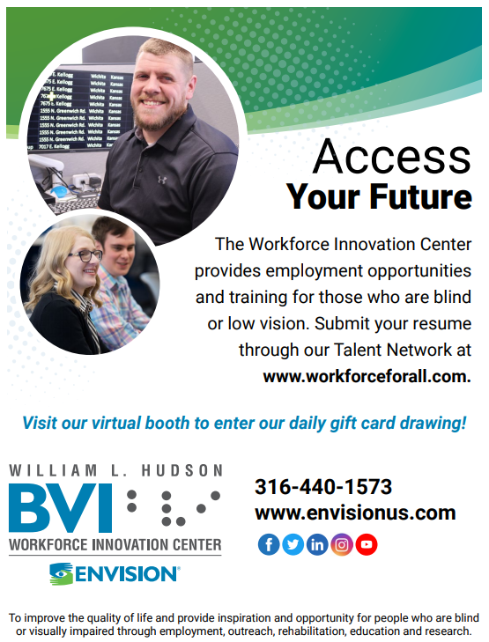

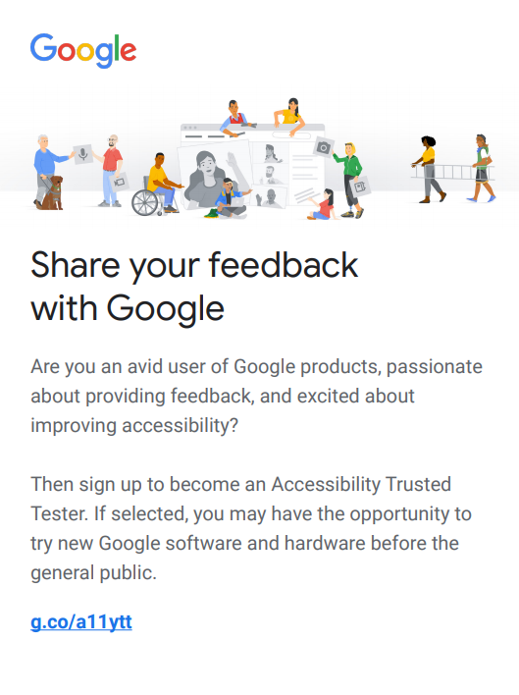
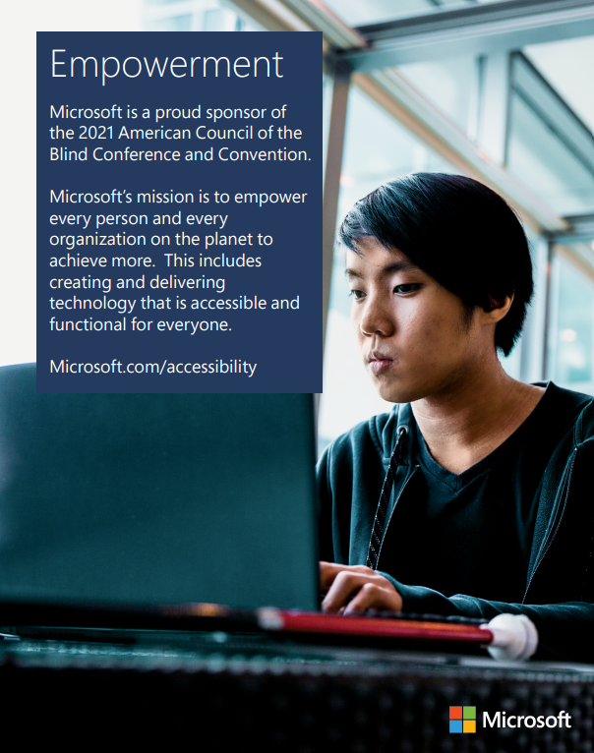

Program Sessions
Friday July 16
10:00am – 4:00pm: ACB Board Meeting
11:30am – 12:45pm: Vispero Interactive Discussion - Software, Hardware, and Training: In this live, interactive session, we'll cover new products, advances in online training, and you'll have the opportunity to have your questions answered by industry experts.
Presenters: Eric Damery, Vice President of Software Product Management, Clearwater, FL; Rachel Buchanan, Product Manager, User Education and Outreach, Clearwater, FL; Mike Wood, Strategic Accounts Manager, Education, Clearwater, FL; Michelle Williams, Sales Director, North Central US, Clearwater, FL; Ron Miller, Blindness Technology Product Specialist, Clearwater, FL
11:30am – 12:45pm: GDB Virtual Barking Up the Aisle: Attention GDB alumni and anyone interested in Guide Dogs for the Blind and guide-dog access! Please join us for an update on the DOT Air Carriers Access Act Service Animal Ruling with national experts including: Mr. Ray Prentice (Alaska Airline Accessibility Director), and Mr. Eric Lipp, (CEO of Open Doors Organization). What is the ‘Ruling’ in brief? How is the implementation going? Who can you give feedback to and how? Plus creative efforts to make the process more usable. This concern is weighing on many -- Join us to shape the future of air travel for guide-dog teams. You can send your questions and concerns ahead of time to Rabih Dow, GDB Director of Outreach and Advocacy at RDow@guidedogs.com.

11:30am – 12:45pm: Microsoft Soundscape – Opening the Door to New Experiences: Abstract: Microsoft Soundscape is a research project that explores the use of innovative audio-based technology to enable people, particularly those with blindness or low vision, to build a richer awareness of their surroundings, thus becoming more confident and empowered to get around. Unlike step-by-step navigation apps, Soundscape uses 3D audio cues to enrich ambient awareness and provide a new way to relate to the environment. It allows you to build a mental map and make personal route choices while being more comfortable within unfamiliar spaces.
In addition to providing you with updates since last year; this presentation will focus on a number of key and empowering experiences we are developing with our collaborators. We will share the work we are doing with Orientation & Mobility specialists, and those working the field of Adaptive Sports, to make Soundscape a key tool in their toolkit and how those very features will allow you to create your own route-based experience, enjoy new activities, and develop new skills.
Presenters: Amos Miller, Jarnail Chud; Marie Trudelle, Lighthouse for the Blind; Russ Myer, Capital Region Nordic Alliance
1:00pm – 2:15pm: Microsoft Windows Session by Microsoft: Microsoft’s mission is to “empower every person and every organization on the planet to achieve more”. Windows is used by hundreds of millions of people throughout the world and is a critical component of Microsoft’s strategy to achieve its mission. Windows includes features designed to empower every person to achieve their full potential, including people with vision, hearing, mobility, cognitive and speech disabilities. During this session we will cover a few of these Window’s features.
1:00pm – 2:15pm: Sharing with Seeing Eye: Come join staff from The Seeing Eye for a fun and informative discussion on The Seeing Eye’s program, what it’s like to partner with a dog, and an update on what we’ve been up to lately. We love questions, so to make sure your question gets answered, send them ahead of time to, whitec@seeingeye.org.
2:30pm – 3:45pm: Bookshare Office Hours at ACB: The latest Bookshare updates; answers to your Bookshare questions.
Presenter: Angela Griffith, Customer Support Specialist, Palo Alto, CA
2:30pm – 3:45pm: Accessibility at Microsoft: Join us to learn about accessibility at Microsoft. Go beyond the basics to explore topics such as technology and mental health, AI and data representation, and how the blind community is shaping the future of product accessibility.
Presenter: Megan Lawrence
4:00pm – 5:15pm: ACBF Tour - Mammoth Cave: Explore the wonders and history of this incredible underground world. An audio experience prepared by Mammoth Cave Park. They will be on hand to answer your questions. A virtual journey you won't soon forget.
4:00pm – 5:15pm: LUA - One Poet, One ACB: Join LUA as we listen to, and comment on, some of the most inspiring poetry of our times. We’ll learn and listen to what the sound of the future is from recordings by

aspiring greats like youth poet Laureate Amanda Gorman.
4:00pm – 5:15pm: En-vision America: Shoulda, Coulda, Woulda, WILL: Why Asking for Help is so Difficult: En-Vision America will briefly address the psychology of why it’s so hard to ask for help, offer hints on overcoming hesitations and crafting more effective requests.
5:30pm – 6:45pm: BPI: Discover Your Vino Type: Red, White, Sparkling! With so many choices in the fascinating world of wine, what is your Vino Type? Do you like sweet wines? Do you like full-bodied? There's no right or wrong. ACB's resident wine expert extraordinaire, Gabriel Lopez Kafati will lead us through the discovery of the notes and flavors of the wines that best suit your palate.
Hosted by: Gabriel Lopez Kafati, Miami Lakes, FL
5:30pm – 6:45pm: LUA Exploring Virtual Book Clubs: Whether you love novels or nonfiction, there's a book club you can join from the comfort of your living-room, and all you need is your telephone. Join LUA for a lively panel discussion covering clubs which meet virtually to discuss books available in accessible formats.
5:30pm – 6:45pm: HumanWare - Discover the new X Series braille displays and upcoming enhancements for the BrailleNote Touch Plus and Victor Reader! Join us to discuss all that is new and exciting with HumanWare’s wide range of blindness products. Meet our new intelligent braille displays and get an overview of all that is coming on the BrailleNote Touch Plus. Finally, learn how to easily manage maps online and explore anywhere with the most recent Victor Reader Trek update.
Presenter: Peter Tucic, Brand Ambassador of Blindness Products at HumanWare, Chicago, IL
7:00pm – 8:30pm: Scholarship Recipients Meet and Greet (by invitation Only)
7:00pm – 8:45pm: ACB Film Night. Winner of the 2021 Best Picture Academy Award, “Nomadland” is about a woman in her sixties who, after losing everything in the Great Recession, embarks on a journey through the American West, living as a van-dwelling modern-day nomad. Frances McDormand also won an Academy Award for Best Performance by an Actress and the director, Chloe Zhao, won the Academy Award for Best Direction. (Viewer discretion is advised. This film contains adult themes and language.)
7:30pm – 8:45pm: DKM and JPMorgan Chase reception (by invitation only)
9:00pm – 11:00pm: FIA Showcase of the Performing Arts: Get ready for another outstanding panoply of performances from musicians, poets, and others. The pinnacle of diversity, creativity, and professionalism.
9:00pm – 11:00pm: ACBS/ACBNG Friday Night Bash: Grab a drink and some snacks, then settle into a lively evening of ice breakers and group activities as we mingle with members, friends, & our supporters—all from the comfort of your own home! You might even win a door prize or two! Join in the fun as ACB Students and ACB Next Generation open the 2021 Virtual Convention Week!
9:00pm – 11:00pm: RSVA® Networking Mixer: Get to know other members and friends of RSVA®. Spend time playing games including trivia.
11:00pm – 12:15am: FIA Showcase After Hours: Participate in our celebration of the Showcase with performers and those behind the scenes who put it all together.

Saturday, July 17
10:00am – 11:15am: Saturday School: “Teaching Through the Years”: Memories, thoughts, and opinions of a blind educator as she discusses her multi-faceted career teaching blind students.
Presenter: Chris Baugh, Classroom Teacher, Maryland School for The Blind, Baltimore, MD
10:00am – 11:15am: BITS/SASI: Do You Hear What I Hear: Are you getting the most from your hearing devices? Have you ever wondered if any hearing aids will work with other technology such as your iPhone? Come enjoy an informative presentation during which two audiologists and a Hearing Care Professional will serve as panelists as they address these issues and answer your questions.
Presenters: Dr. Carol Hamer, Audiologist, Hellen Keller National Center, Sands Point, NY; Jacob Smith, Hearing Instrument Dispenser, Oak Lawn, IL; Dr. Nancy Mascia, Audiologist, Alabama Department of Rehabilitation Services, Birmingham, AL
10:00am – 11:15am: FIA Board Meeting: All welcome. Hear an overview of our activities during the past year and take part in officer elections.
10:00am – 11:15am: Howl and Rewards Ceremony: Join us for our inaugural 2021 session with Andrea and Margie working doubles! Andrea starts the route in the lead by welcoming everyone; sharing details about the raffle, convention specials, door prizes and more. Then Margie takes the lead- presiding over the awards ceremony.
Each year GDUI recognizes three outstanding individuals who have made significant contributions to the lives of guide dog teams through their dedication, work, advocacy, and support. Each award is given to honor the individuals for which they are named.
Join with us to celebrate the outstanding recipients of The Ethel Bender, Moffitt-Gleitz, and Lieberg-Metz Awards.
Presenters: Andrea Giudice, GDUI Convention co-coordinator, West Hartford, CT; Margie Donovan, GDUI Awards Committee Chair, Folsom, CA
11:30am – 12:45pm: Saturday school: “Teaching and Learning Online: Wrestling with The Technology”: How do you cope when your online learning or teaching environment has accessibility glitches? This session explores strategies and concrete suggestions for growing your confidence with online learning technologies. The Canvas learning management system will be used as examples throughout. We will also discuss the process of getting inaccessible materials remediated so they can be used with screen readers, braille, and magnification.
Presenters: Deborah Armstrong, Alternative Media Specialist, De Anza College, Cupertino, CA; Mike Calvo, CEO and Co-Founder, Pneuma Solutions, Orlando, FL
Co-sponsored by: AABT, BITS and ACBS
11:30am – 12:45pm: BITS: Make Your House a Smart Home: Use Smart Plugs, Lights, Door Locks, and Other Smart Devices; learn about all of the things that you can do to make your house a smart home.
Presenters: Peter Korn, Director of Accessibility, Amazon Lab 126, Seattle, WA; Joshua Miele, Principal Accessibility Researcher, Amazon Lab126, Sunnyvale, CA; Elodie Fichet, PhD, Sr. Accessibility Program Manager, Seattle, WA
11:30am – 12:45pm: GDUI - Class Lecture - Author talk with Christi Bane: You won’t want to miss this! Our speaker knows the guide dog world from both the training and raising perspective. Her book, Forward Together: an inside look at guide dog training was published in 2020. It reveals the professional methods behind teaching guide dog skills. Christi shares her knowledge of, and experience with, a wide range of guide dog skills, how to match dogs to handlers, and teaching handlers how to work with their new guide dogs.
Presenter: Christi Bane, Palmetto, FL
1:00pm – 3:45pm: AAVL Business Meeting: All members are encouraged to attend the Alliance on Aging and Vision Loss Business Meeting, at which advocacy activities, elections, bylaws and other AAVL affairs will be conducted.
1:00pm – 2:15pm: The Sento Showdown Team Presents An overview of Console and Video Game Accessibility: Have you wondered what it would be like to experience video games using elements of assistive technology? Ever considered pursuing your own experience playing video games?
Join the team of organizers that hosted The Showdown during Summer 2020, the first ever Mortal Kombat 11 tournament exclusive to players who are blind and visually impaired. They will provide an overview on navigation using Narrator, the Microsoft screen reader that was implemented into the Xbox One and later consoles. Travel in this virtual tour, filled with narrated examples of playable game designs across the universes of Marvel’s Spider-Man Remastered, Microsoft’s Killer Instinct, Capcom’s Resident Evil 6, NetherRealm Studios’ Mortal Kombat 11, The Coalition’s Gears 5, and the latest golden standard title of our time, Naughty Dog’s the Last of Us Part II. You are invited to engage with the group and ask your questions afterwards.
Disclaimer: Mortal Kombat 11, Resident Evil 6, Gears 5 and The Last of Us Part II are all games rated M for mature audiences by the ESRB. Viewer discretion is advised.

Panelists:
Gable Meade, Gamer, Cedar Rapids, IA; Carlos Martinez, Gamer, Los Angeles, CA; Carlos Vasquez, Gamer, Houston, TX; Dexter Roberts, Gamer, Los Angeles, CA; Alex Vasquez, Gamer, Los Angeles, CA
Sponsored by: ACB Students
1:00pm – 2:15pm: BITS What’s New at Amazon: Existing products, new products, updates, all
things new at Amazon, how drones would deliver Amazon packages and more!
Presenters: Peter Korn, Director of Accessibility, Amazon Lab 126, Seattle, WA; Joshua Miele, Principal Accessibility; Researcher, Amazon Lab126, Sunnyvale, CA; Elodie Fichet, PhD, Sr. Accessibility Program Manager, Seattle, WA
1:00pm – 2:15pm: BPI: 3D Audio Excursion: Grab your headphones and come with us on a 3D audio experience! Let your headphones be your virtual reality goggles as we take you to places so real, you feel like you're actually there. Listen as your environment takes shape above, below and all around you.
BPI members Chris Snyder, Los Angeles, CA and Byron Lee, Minneapolis, MN, will host a Q&A.
1:00pm – 2:15pm: RSVA® “The Journey- Navigating the Challenges”: Motivational speaker: Dr. Bill Takeshita, OD, FAAO, F.C.O.V.D., Northridge, CA, will speak on his own challenges as a sighted optometrist and continuing his career after losing his sight.
2:30pm – 3:45pm: AAVIA: Supreme Court Year in Review: If you're curious about how the Court affects your life or how it explains its decisions, join us in listening to a knowledgeable and engaging observer recount the past year's big decisions.
Presenter: Bill Piatt, law professor, San Antonio, TX
2:30pm – 3:45pm: RSVA® “The importance of the RS15”: Kathy Roet, Director of the Business Enterprise Program, Iowa Department of the Blind, Des Moines, IA will lead this deepening discussion following the initial presentation at the 2021 Sagebrush conference. She will share how to use this RSA form to show the details of each state’s current program.
2:30pm – 3:45pm: 411 from the IAC - Part 1: Braille Notetaking Devices Versus Mainstream Products: Can a blind person be as effective using a mainstream product like an iPhone or are braille notetakers still the way to go in this space? Peter Tucic from HumanWare and Greg Stilson, American Printing House for the Blind will discuss the HumanWare BI line of products and the Mantis. This promises to be a lively discussion with some tips and tricks for both types of users.
Presenters: Peter Tucic, HumanWare, Brand Ambassador, Chicago, IL; Greg Stilson, Head of Global Innovation, American Printing house for the Blind, Madison, WI
2:30pm – 3:45pm: Berl Colley Leadership Institute: Creating a Welcoming Affiliate Culture: We know that effective strategies for leadership transitions, succession planning and many other activities are essential to fostering an effective organization and encouraging more people to step into leadership roles. However, none of that matters unless your organization’s culture supports it. Join the Berl Colley Leadership Institute Committee for an engaging, interactive session that will provide you with useful strategies and techniques to strengthen your affiliate and create a culture that is welcoming and encouraging to newcomers, members, and aspiring leaders.
4:00pm – 5:15pm: Saturday School: “Advocating for the Best Learning Options in a Hybrid Environment”: In this workshop, we will explore how parents and college students can work with schools to get the best learning options whether instruction takes place in person, online, or using a combination of both methods.
Presenters: Tabitha Brecke, Accommodations Specialist and Adult Education Adjunct Professor, Auburn, AL; Kaila Allen, Parent with Special Needs Experience, Mesa, AZ; Hayley Agers, Parent and Former Independent Living Instructor, Marysville, WA; Nat Ratcliff, Student Perspective, Carson, CA
Co-sponsored by: AABT, ACBS AND ACB Next Gen
4:00pm – 5:15pm: ACBDA Social - Together We Make a Difference: Have you ever wanted to meet the officers and board members for American Council of the Blind Diabetics in Action? Now is your chance. Grab your favorite drink and come meet old and new members, build friendships, create a bond in which we can together make a difference in our lives and the community around us.
4:00pm – 5:15pm: BPI: Self-care - Massage, Essential Oils and Breathing: In our frantic and hectic world, we often forget to pamper ourselves. Join us for some self-massage and other holistic therapeutic ideas.
Presenter: Ray Lewis, holistic healer and massage therapist, St Louis, MO
4:00pm – 5:15pm: RSVA® “The most recent happenings in the ever-changing legal and legislative landscape involving Randolph-Sheppard vendors.” Speakers will identify the latest legal cases and evaluate the RSA rule making for the funding from the stimulus bill.
Speakers: Chris Prentice, ACB American Association of Visually Impaired Attorneys, Austin, TX; Jeff Thom, RSVA® Advocate/Retired Attorney, Sacramento, CA
Co-sponsored by: RSVA® and AAVIA
4:00pm – 5:15pm: (411) from the IAC – Part 2: Rehabilitation, providing remote services: Hear from two rehabilitation professionals about what providing rehabilitation services virtually has been like.
Megan Conway from the Helen Keller National Center and David Kingsbury from the Carroll Center for the Blind will discuss providing rehabilitation services virtually, what accessibility challenges they faced and how they worked through them to continue serving their clients. We then begin a conversation about remote support-based services. Many of us continue to work from home and we give you some opinions on the leading products in this space and some tips and tricks when working with each of these products. We will discuss Apple, Microsoft, AIRA and more during this part of the 411 presentations.
In addition, Judy Dixon will make a brief presentation about a new technology found on the latest iPhones. Is this truly the thing to have for your iPhone? Come learn more how this technology can be put to use in your environment to help follow people in a line, learn about a new space, and locate large objects.
Presenters: Megan A. Conway, PhD, Research and Accessibility Specialist, Helen Keller National Center, Healdsburg, CA; David Kingsbury, Assistive Technology
Instructor at the Carroll Center, Stoughton, MA; Judy Dixon, Co-chair of the IAC, Arlington, VA; Ray Campbell, Second Vice President of ACB, Glen Ellyn, IL
Co-sponsored by: Information Access committee and Rehabilitation Issues Task Force
4:00pm – 5:15pm: ADP Audio Description in Museums: This panel of leading museum access professionals’ profiles various ways audio description is used in museum settings, and how each museum has coped with providing description services during a pandemic.
Moderator: Joel Snyder, PhD, Founder and Senior Consultant, ACB Audio Description Project, Takoma Park, MD
Panelists: Beth Ziebarth, Director, Accessibility Services, Smithsonian Institution, Washington, DC; Jessica Doonan, Manager, Accessibility, Museum of Fine Arts, Boston, MA; Charlotte Martin, Senior Manager, Access Initiatives, Intrepid Sea, Air & Space Museum, New York, NY; Robert Bready, Vice President for Operations, U.S. Olympic and Paralympic Museum, Colorado Springs, CO
5:30pm – 6:45pm: ACBF Goes to Camp: It's summertime! Time for sitting around the campfire, telling stories and eating hotdogs and s'mores! Whether you're a kid or an adult, camp is a special experience. Enjoy stories read by a Talking Book narrator at our virtual campfire; share your camp memories and help us learn about today's camp opportunities.
5:30pm – 6:45pm: Sister Power Happy Hour: Leading the festivities this year are Pam Shaw, “Joy Restoration Coach”, Philadelphia, PA and Debbie Hazelton, ACB Radio Program Director, Dothan, AL. Share in the joy, inspiration & empowerment these two phenomenal women bring with them wherever they go!
Sponsored by: ACB Women
5:30pm – 6:45pm: “Straight Off the Canvas”: This film is the winner of several industry awards. Created with description, it profiles Elizabeth Castallano, a visually impaired art teacher and artist. It also tells the story of blind art teacher Jessica Jones and her students at the Lavelle School for the Blind in Bronx, NY. Film producer Anthony Saldana, and other team members who worked on the production, will be in attendance, will speak about working on the film, and will answer questions from attendees.
Cosponsored by: ADP, FIA, and AABT
5:30pm – 6:45pm: RSVA® Perspective from the other side: Speakers will feature vendors and their experiences in a mostly white male profession. They will share tips for others considering the RS program.
7:00pm – 9:00pm: An evening with ACB: Get Up and Get Moving Campaign Kick-Off: Join ACB Leaders and our Health Hero partners as we officially kick off the Get Up and Get Moving Campaign. The campaign raises awareness on the issues critical for people who are blind and visually impaired seeking to take back their health as we all come out of the pandemic. Learn how you can be a part of this three-year campaign and take the Get Up and Get Moving Challenge.
9:00pm – 10:15pm: ACB Next Generation – Meet and Greet Social: Whether you've been with Next Gen from the pre-affiliate days or you're hearing about us for the first time, come hang out, bring your favorite snack and drink, and mingle with new and old friends to kick off another awesome convention.
9:00pm – 10:15pm: BPI Mixer: BPI is 21 years old; from our beginning as BFLAG, to the current affiliation, we have always brought fun to Convention! This year, we celebrate all the voices, new and old of BPI, its allies and friends. Join us for a lot of laughs and maybe even a tear or two. For sure, a bunch of virtual hugs!
9:00pm – 10:15pm: SASI Social Happy Hour: Mix your favorite cocktail or mocktail, grab something delicious to munch on, imagine yourself seated on a white leather couch in a 50th floor hotel hospitality suite in your favorite city, and join us for virtual mingling. Meet other SASI folks, ask questions about resources, or just hang out.
Sunday, July 18
10:00am – 11:00am: Non-denominational Service Words of encouragement.
11:30am – 12:45pm: ACBF Your Family History - Connect the Dots and Grow the Branches: Mobile apps and podcasts and webinars; newspapers and family memories and yearbooks; new technology that brings family photos to life and much more. Find new and updated ways to begin your family tree or add new branches to your existing research.
11:30am – 12:45pm: ACBS Scholarship Celebration: Meet the extraordinary 2020 Scholarship winners and celebrate their achievements, success, and future endeavors.
Keynote Speaker: Gabriel Lopez Kafati, President Blind LGBT Pride International, Miami, FL
11:30am – 12:45pm: BITS Virtual Technology Showcase Part One: The four major companies in the field of access technology: Vispero, HIMS, HumanWare, and APH, will update attendees on their products.
11:30am – 12:45pm: Sunday Matinee with BPI: “Rafiki”: 2018 Kena and Ziki long for something more. Despite the political rivalry between their families, the girls resist and remain close friends, supporting each other to pursue their dreams in a conservative society. When love blossoms between them, the two girls will be forced to choose between happiness and safety. Inspired by Monica Arac de Nyeko's “Jambula Tree”, which chronicles a story of two girls in love in Uganda. “Rafiki” challenges deep rooted cynicism about same sex relationships between actors, crew, friends, and family in Kenya. (Viewer discretion is advised. This film contains adult themes and language.)
Following the movie, BPI will host a by-invitation-only discussion forum.
11:30am – 12:45pm: How do I, answers to 7 questions: Join us while we get answers to library related questions from a panel of NLS affiliated librarians. How can I get books embossed for my personal use? How can I borrow a book from overseas? Where do I turn to borrow, or purchase raised line maps? What are the best places to obtain materials in large print formats? What is the best way to listen to books on a smart speaker? How can I tell when it's time to purchase a book rather than borrow it? When can I ask for reference assistance?
11:30am – 12:45pm: ACB Committee Chairs Meeting
1:00pm – 2:15pm: BITS Virtual Technology Showcase Part two: This showcase will feature innovative products from cables to computers, and everything in between.
1:00pm – 2:15pm: BPI: Using Clubhouse, TikTok and WhatsApp: People are talking: what drives your voice? Facebook and Twitter were once the reigning social giants. The networking landscape has changed significantly. Newer applications like TikTok and clubhouse are clamoring with new forms of social expression and conversation. WhatsApp has also shaped the way we communicate with one another over the past few years. With all the social networking noise, how do you find the right volume for you?
In this roundtable discussion, we'll hear from three members of our community who will share their favorite platforms that amplify their voices. Join us for a discussion that will expand your social networking horizons.
Presenters: BPI members: Leah Gardner, Oakland, CA and Byron Lee, Minneapolis, MN
1:00pm – 2:15pm: Audio Description Project Website Overview and Update (acb.org/adp): The number of audio-described videos available has increased dramatically in the past year to the 6,000-plus range. The ADP website is the place to find pointers to them all. This presentation will cover how you can best use the website to find what interests you and how to access description resources.
Presenter: Fred Brack, ADP Webmaster and Social Media Manager, Raleigh, NC, fbrack@acb.org, facebook.com/acbadp, twitter.com/ADPwebmaster
1:00pm – 3:45pm: RSVA Business Meeting
1:00pm – 3:45pm: MCAC “One ACB Moving Forward”: Our theme this year is symbolic of the diversity of our organization as we come together looking toward a brighter future. To that end, our session will feature a panel of individuals from diverse backgrounds who will share with us unique aspects of their cultures. They will highlight family traditions, cultural customs, poems, special events and other aspects of their cultures. This promises to be an informative and entertaining session.
Panelists: Catalina Martinez, Roseville, MN; Hannah Mae Aldeza, Customer Service Professional, Transcriptionist and an ESL Teacher, Philippines; Art Cabanilla, President, Hawaii Association of the Blind; Swatha Nandhakumar, Advocacy and Outreach Specialist, Naperville, IL
2:30pm – 3:45pm: So, What Do I Do with This Law Degree: Join in a stimulating roundtable among attorney members of the ACB Community, describing some of the varied settings: private practice, government, and academics — in which they have been employed. Especially if you or someone you know is thinking about a legal career, this lively discussion will deepen your understanding of how attorneys with visual impairments handle different kinds of work and what kinds of challenges they face.
Presenters: Dave Adams, Telford, PA; Steve Blow, Albany, NY; Pshon Barrett, Jackson, MS; Cynthia Hawkins, S. Gulfport, FL; Charles Nabarrete, W. Covina, CA; Chris Prentice Austin, TX
2:30pm – 3:45pm: CCLVI Vendor Showcase: Come see the latest technology in low vision devices. What devices will help you stay independent and how much do they cost?
2:30pm – 3:45pm: You Gotta Have Harp: Relax while learning about the harp through presentations and performances. In honor of FIA past president Lynn Hedl.
Presenters: Nancy Pendegraph, Huntsville, AL; Jason Castonguay, Manchester, CT
2:30pm – 3:45pm: Conversation with Dr. Hoby Wedler: Dr. Webler is a Computational Chemist, Entrepreneur, Wine Expert, and Promoter of diversity and inclusion. Listen to the life lessons from this remarkable man from Petaluma, CA.
Co-sponsored by: ACB Next Gen, ACBS, BPI, IVIE, and ACB Employment Committee
2:30pm – 5:15pm: SASI presents Employment Strategies for those with a Dual Sensory Loss: Sight and Sound Impaired (SASI) Committee presents a panel of people who have a dual sensory loss of hearing and vision loss. The panel will discuss how they used reasonable accommodations, communication techniques, assistive technology and other strategies to gain and maintain employment.

Panelists: Scott Davert, Coordinator of Technology Research and Innovation Center for the Helen Keller National Center, Sands Point, NY; Megan Conway, Research and Accessibility Specialist, Helen Keller National Center, Healdsburg, CA; Kerry Thompson, Senior Officer for Communications, Inclusion, & Analytics, Disability Rights Fund, Boston, MA; Brian Horst, Child Support Program Administrator, Division of Child Support, Washington, DC
4:00pm – 5:15pm: Disability History/Awareness Society Implementation: Join us for a discussion about disability history/awareness with AFB’s President Kirk Adams, ACB’s President Dan Spoone, and ACB Students President Minh Ha, as we discuss the benefits and disadvantages of mandatory and

voluntary disability awareness education in society.
Co-Sponsored by: ACBS/ACBNG
4:00pm – 5:15pm: “Adventures in Coaching: Exploring the Hottest New Career”: Ever wonder how to become a coach? Would you like to earn while you learn? This workshop will uncover the answers you’ve been looking for. Hear straight talk on the common challenges new coaches face. Discover what clients want and how to fill this need immediately. Hear from successful coaches who have built profitable businesses.
Presenters: Pam Shaw, Joy Restoration Coach, The Joy Filled Life, Philadelphia, PA; Lisa Pisano, Director of Admissions, Coach Training Alliance, Ft. Collins, CO
Panel: Peter Altschul, Moderator; Ardis Bazyn, Business Coach, Bazyn Communications, Burbank, CA; Satauna Howery, Voice Coach, Clifton Park, NY
Co-sponsored by: Employment Committee, IVIE, and ACBNG
4:00pm – 5:15pm: How a Vision Zero campaign can set a new standard for safety on our streets: To Mobility and Beyond is pleased to present Leah Shahum, Founder and Director of the Vision Zero Network as our keynote speaker. She brings two decades of proven success championing movements to advance safe, healthy, active transportation and serves on the Steering Group of the national Road to Zero Coalition, as well as the Advisory Board of the Collaborative Sciences Center for Road Safety (CSCRS). Other credits are too numerous to list, but Leah is sure to inspire attendees with jaw dropping statistics and proven methods to affect much needed improvements to the pedestrian environment.
Presenter: Leah Shahum, Founder, Vision Zero Network, Oakland, CA
Co-sponsored by: Environmental Access and Transportation Committees
4:00pm – 5:15pm: Raising Revenue for Affiliate Conventions: Join the Resource Development Committee and delve into ways to fund-raise at affiliate conventions. We’ll show you how to approach corporations for sponsorships and provide information on how to hold a successful auction.
Presenters: Margarine G. Beaman, Volunteer Fund-raiser for ACB and numerous other organizations, Austin, TX; Dan Dillon, ACB Board Member, Hermitage, TN; Leslie Spoone, ACB Auction Committee Chair, Orlando, FL; Janet Dickelman, Convention Coordinator, St Paul, MN
6:00pm – 6:45pm: ACB Walk - Get Moving Together: Help kick off the ACB General Session by joining ACB members and friends during the live Virtual Brenda Dillon Memorial Walk on Sunday, July 18 at 6:00pm. Lace up your shoes, grab your water bottle, and be a part of one of the kickoff events in the ACB health and wellness campaign.
7:00pm – 10:30pm: Opening General Session

Monday, July 19
10:30am – 2:00pm: Morning General Session
2:30pm – 3:45pm: A View from Across the Atlantic: AAVIA is privileged to welcome a barrister who will share with us what it is like as one of very few people who are blind, to pursue a career before the London bar. Are the issues, resources, options, attitudes and technology different? Join us in finding out.
Presenter: Adal Ibrar, Barrister, London, UK
AAVIA will hold their Business Meeting at the conclusion of our presentation.
2:30pm – 3:45pm: Navigating the Health Care System as an Adult with Vision Loss: ACB member and author of “Navigating Health Care When All They Can See is That You Can’t” and “When Your Ears Can’t Help You See” Deborah Kendrick and attorney Meredith Weaver will discuss the challenges of weaving your way through the health care system. Deborah Kendrick, author, Cincinnati, OH; Meredith Weaver, Staff Attorney, Disability Rights Advocates, Berkeley, CA
Co-Sponsored by: AAVL and ACB Advocacy Services Committee
2:30pm – 3:45pm: Diabetes Education 101: Thriving and living with diabetes: Living with diabetes is tough and living with vision loss adds to the challenge.
Presenters: Brenda Jagatic, BScN, RN, Certified Diabetes Care & Education Specialist, Marquette, MI; Lisa Golden, MA.Ed.HD, Certified Rehabilitation Counselor, Certified Diabetes Care and Education Specialist, Crowley, TX
2:30pm – 3:45pm: Smart Home Devices - Work Smarter, Not Harder: ACB Next Gen and CCLVI want to help open your eyes to the exciting world of smart home devices beyond the basics. Did you know you can have your floors vacuumed and mopped while you're on a community call, stay in your comfy bed to turn on your ceiling fan in the middle of the night, or even be able to see who's ringing your doorbell if you can't see through the peephole? We'll discuss smart home devices to help you in the kitchen, keep your home clean, allow you to multitask even better than you are now, and even some to give you peace of mind and security.
Presenters: Aaron Linson - Search Consultant at Talentric LLC and Advocate for all Blind/VI People - Louisville, KY; Tim Schwartz, Host of Life After Blindness podcast and Co-host of the RNIB (Royal National Institute of Blind People) Tech Talk - Cincinnati, OH
Co-sponsored by: ACB Next Gen and CCLVI
2:30pm – 3:45pm: Sensuality and Sexuality with Disability: In this session we strive to help each other embrace the sensual inside of us. We strive to talk through barriers both in perception and in physicality that may or may not prevent us from being able to enjoy the dating world, our own sensuality and of course barriers to getting to that point where we might want to be intimate with another person.
Topics such as self-care, self-love and of course consent will be explored in this groundbreaking seminar.
Join Blind LGBT Pride International, Next Generation and American Council of the Blind Students as we seek to break the barriers that have traditionally held us back from feeling like and being seen as sensual or sexual beings.
This will be a safe and respectful open space for all of us to learn to love not only someone else but ourselves in the mix!
Presenters: Laura Milar, certified sex therapist, San Francisco, CA; Holly Scott-Gardner, Disability Rights Advocate/Writer, London, UK
2:30pm – 3:45pm: A conversation with NLS: Join LUA's traditional up close and personal visit with the representative of the National Library Service Director.
4:00pm – 5:15pm: Safety and Fall Prevention; Prescription Drug labeling:
Part 1: Fall prevention, Information is the key! Seniors with vision loss are at heightened risk of falls and other types of accidents. Safety expert Cecilia Warren will help us learn to address this problem and improve your quality of life.
Cecilia Warren, Director, Emergency Preparedness Policy, Maryland Department of Disabilities, Baltimore, MD
Part 2: Accessible Drug Labeling and Medication Management for the Blind and Low Vision Community: The lack of accessible drug labeling and assistance with medication are problems that threatens lives and causes significant medical issues. If you struggle with the availability of accessible drug labeling or the need for help with medication management, come listen to the founders of Accessible Pharmacy Services for the Blind. You just may find that solutions are here! Medication Management for the Blind and Low Vision Community
Speakers: Dr. Alex Cohen, PhD, Chief Marketing & Accessibility Officer at Accessible Pharmacy Services for the Blind; Andy Burstein, Chief Executive Officer at Accessible Pharmacy Services for the Blind, Philadelphia, PA
4:00pm – 5:15pm: Diabetes Education 101 Diabetes Self-Management: In this session, we will review the Association of Diabetes Care and Education Specialists’ 7 self-care behaviors and how they can help you live a healthy and abundant life. This includes monitoring, taking medication, problem solving, healthy coping and reducing risks.
Speakers: Brenda Jagatic, BScN, RN, Certified Diabetes Care & Education Specialist, Marquette, MI; Lisa Golden, MA.Ed.HD, Certified Rehabilitation Counselor, Certified Diabetes Care and Education Specialist, Crowley, TX
4:00pm – 5:15pm: When Your Civil rights as LGBTQ person are threatened you may need a good lawyer: Learn about legal advocacy from Lambda Legal and the ACLU. Also hear about the LGBTQ+ agenda on Capitol Hill and our expectations for the Biden Administration.
Presenters: Molly Broadway, Help America Vote Act (HAVA) Training and Technical Support Specialist, Houston, TX;
Cicely Reid, Attorney Pro Bono Coordinator, Houston, TX; Scott Marshall, Attorney, Alexandria, VA
4:00pm – 5:15pm: To cross, or not to cross – Strategies and considerations for crossings with no traffic signal or stop sign: When you're at a crossing that has no stop sign or traffic signal, do you wonder when is the appropriate time to cross, and whether it is safe to do so? Then this presentation is for you! Come learn about analyzing these crossings and what kinds of skills you'll need.
Presenter: Dona Sauerburger, MA, COMS, Gambrills, MD
Co-sponsored by: Environmental Access and Transportation Committees
4:00pm – 5:15pm: State Commissioners and the Future of Blind Rehabilitation: Ever wonder what State Commissioners dream about for the future of blind rehabilitation; or what they might agree and disagree with in ACB’s Rehabilitation Issues Task Force White Paper? Join us to find out what they think about rehabilitation now, and future trends they’d like to see.
Panelists: Joe Xavier, Director California Department of Rehabilitation, Sacramento, CA; Daniel B. Frye, JD., Administrator, Services for the Blind and Vision Impaired, New Hampshire Bureau of Vocational Rehabilitation, Concord, NH; Raymond E. Hopkins, Commissioner Virginia Department for the Blind and Vision Impaired, Richmond, VA
4:00pm – 5:15pm: Audio Description in the Performing Arts: This panel of leading theater access professionals highlights various ways audio description has been provided in performing arts venues, and how each has evolved to provide virtual description services during a pandemic.
Moderator: Joel Snyder, PhD, Founder and Senior Consultant, ACB Audio Description Project, Takoma Park, MD
Panelists; Brenna Nicely, Education and Engagement Director, American Repertory Theatre, Cambridge, MA; Mary Hanks, Audio Describer, Houston Grand Opera, Houston, TX; Jess Curtis, Artistic Director, Jess Curtis/Gravity, San Francisco, CA; Alice Shepherd, Artistic Director, Kinetic Light, London, UK
5:30pm – 6:45pm: Non-Traditional Blind Sports: From skateboarding to darts to hunting and fishing, join us as we talk with a panel of sports and recreation enthusiasts about some unique activities not traditionally participated in by the blind and visually impaired.
Panel: Curtis Ruttle, Founder, Alt Route Project, Calgary, Alberta, Canada; Matt Janz, Founder, Skate Bats, Calgary, Alberta, Canada; Tom Fisher, Vice President of North American Association of Blind Sportsmen (NAABS), Gig Harbor, WA; Dr. Andre Watson, PsyD, Clinical Psychologist, Delaware County, PA
Sponsored by: ACB Next Gen
5:30pm – 6:45pm: ACBS Business Meeting
5:30pm – 6:45pm: Out and About with Canines and Canes: A panel of cane and guide dog users, with some vision to none, discuss pedestrian adventures, tips and tricks for fun and safe travel. Come hear how getting lost can be a confidence-boosting adventure and how to leverage blind street smarts to create a more pedestrian friendly environment for everyone!
Moderator: Sheila Styron, chair, ACB Transportation Committee, Kansas City, MO
Co-sponsored by: Environmental Access and Transportation Committees
5:30pm – 6:45pm: Audio Description at Amazon: Over the last few years, Amazon has made great strides in expanding the availability of audio description, now offering more titles with AD than any other streaming service. In this session, Amazon experts from Device Accessibility and Prime Video will discuss how we have been able to scale up audio-description production, and the many advantages we anticipate this will have for our customers who are blind or visually impaired.
5:30pm – 6:45pm: Get Hired – Envision Workforce Innovation Center Talent Network: The Envision Workforce Innovation Center talent network allows interested job seekers who are blind or low vision to gain access to the latest job opportunities, events, training sessions, and other career-related information. Also learn about Envision nationwide programs such as the Accessible Products Hotline.
7:00pm – 9:00pm: An Evening with ACB: Audio Description and Streaming Services: This industry panel features representatives from major streaming services to discuss their product’s, programming, services, and offerings.
Moderator: Carl Richardson, Co-Chair, ACB Audio Description Project, Brighton, MA
Panelists: Melanie Goodman, Lead Digital Supply Chain Specialist, HULU, Agoura Hills, CA; Martha Heller, Vice President, Government Relations and Regulatory Counsel, Viacom CBS, Paramount+ Washington, DC; Sarah Herrlinger, Director, Global Accessibility Policy & Initiatives, Apple, Cupertino, CA; Daniel Kocmarek, Sr., Manager, Prime Video, Seattle, WA; Mirka Pavlikova, Manager, Technical Production, Walt Disney Studios, Burbank, CA; Allison Smith, Globalization Innovation Manager, Netflix, Los Gatos, CA; Andy Larkin, Senior Manager, Accessibility, HBO Max, Chicago, IL; Peacock with Thomas Wlodkowski, Vice President, Accessibility, Comcast, Philadelphia, PA

7:30pm – 8:45pm: A Night of Great Opera Arias: From Mozart to Puccini; from Callas to Pavarotti! Join Gabriel and Jason, as they present what is considered the greatest Opera Arias and Opera moments.
They will educate us in their fun and friendly way. You will walk away from this program loving Opera!
Co-sponsored by: BPI and FIA
7:30pm – 8:45pm: CCLVI/ACBF Game Night - Family Feud: Grab your favorite snacks and have some laughs and fun with friends after a busy day at the virtual convention.
9:00pm – 10:15pm: Milly's Place - ACB Lions 50th Anniversary Party: Time to celebrate our successes, make new friends, and share news from our local clubs. Former Lions, current Lions, and those wanting to explore becoming a Lion are welcome.
9:00pm – 10:15pm: Prose and Poetry Reading
Facilitator: Carla Hayes, McMurray, PA
Co-sponsored by: FIA, ACB Next Gen, and BPI
9:00pm – 10:15pm: ACB Next Generation After Hours Social: Join us around the virtual watering hole for some casual time to continue to get to know each other as well as discuss the day's events.

Tuesday, July 20
10:30am – 2:00pm: Morning General Session
2:30pm – 3:45pm: Practical and Legal Issues for Government Employees: Issues and Challenges for Today: Members of ACBGE and AAVIA will discuss current challenges, practices and law bearing upon the provision of reasonable accommodations to workers with visual impairments. Participants will address the process of obtaining assistive technology and will reflect on the frustrations and the triumphs people face every day.
Presenters: Renee Zelickson, ACBGE President, and Social Security Administration Employee, Chicago, IL; Pat Sheehan, ACB Board Member, and Veteran Affairs Employee, Silver Spring, MD
Co-sponsored by: AAVIA and ACBGE
2:30pm – 3:45pm: Diabetes and Nutrition 101: Our speakers will discuss current nutrition trends & their impact on diabetes. We’ll discuss challenges to healthy eating such as sick days, holidays, traveling & dining out. We’ll also provide tips for healthy grocery shopping and meal planning.
Presenters: Marjorie Debruyne, RD, CDCES, Bloomington, IN; Jeff Bishop, ACBDA Board Member, Kirkland, WA
2:30pm – 3:45pm: Adaptive Sports, an Active Body = A Healthy Mind: BPI is partnering with Strive4you to inspire and teach us about such adapted sports as Bowling Bonanza; Star Spangle Goalball and Southern Classic Kickball. Let's all get up and get moving together!
Presenters: Ricky Jones, Co-Executive Director, Strive4you, Nashville, TN; Christy Ray, Co-Executive Director, Strive4you, Nashville, TN
2:30pm – 3:45pm: Podcasting for Beginners: This session is for those who are interested in, and nervous about, creating podcasts. We will discuss needed and basic techniques.
Presenter: Derek Lane, Instructor, IC Music, LLC, Owner, Lane's Audio, Morganton, NC
Co-sponsored by: ACB Next Generation, BPI, FIA and IVIE
2:30pm – 5:15pm: CCLVI Business Meeting: Come join us for our business meeting. We will have elections for the entire Board. We will also be discussing what we have been doing in the past year.
4:00pm – 5:15pm: Diabetes and Fitness 101: Join us to learn about the importance of exercise and how it plays a role with managing diabetes.
Speakers: Karen Kemmis, PT, RN, DPT, Syracuse, NY; Steve Bauer, CCA Board Member, Culver, CA
4:00pm – 5:15pm: BPI Self Defense: BPI partners with Strive4you to start us on the road of learning self-defense techniques. With their adaptive program, we will learn the basics of strengthening our core and using well-honed skills that will inspire us to get up and get moving with confidence and the ability to defend ourselves.
Presenters: Ricky Jones, Co-executive Director, Strive4you, Nashville, TN; Christy Ray, Co-Executive Director, Strive4you, Nashville, TN
4:00pm – 5:15pm: IVIE Business Meeting
4:00pm – 5:15pm: What's New at the Corner: Learn about the latest Hybrid Pedestrian Beacon, Rectangular Rapidly Flashing Beacon and other new pedestrian signals specified in the Federal Highway Administration Manual on Uniform Traffic Control Devices, how they work and whether they are accessible.
Presenters: Lukas Franck, Sr., Guide Dog Mobility Instructor and COMS from The Seeing Eye, Morristown, NJ; Representative from Polara Enterprises, a manufacturer of accessible pedestrian signals.
Co-sponsored by: Environmental Access and Transportation Committees
4:00pm – 5:15pm: Podcasts Related to Audio Description: Meet the hosts of five podcasts featuring audio description, and learn how each got started, what they cover, and their plans for the future.
Moderator: Kim Charlson, Co-Chair, Audio Description Project, Watertown, MA
Podcasts include:
- Picture This: A Podcast on All Aspects of Audio Description
Co-Hosts: Brian Charlson, Watertown, MA; Carl Richardson, Brighton, MA
Picturethis.audiodescription@gmail.com
- Reid My Mind Podcast
Host: Thomas Reid
reidmymindradio@gmail.com
Social Audio Description Podcast
Co-Hosts: Kensuke Nakamura and Caitlin Walsh
kensukevic@gmail.com
- Talk Description to Me
Co-Hosts: JJ Hunt, and Christine Malec, Toronto, ONT, Canada
talkdescriptiontome@gmail.com
- The Know Your Narrator Podcast
Host: Roy Samuelson, roysamuelson@hey.com
4:00pm – 6:45pm: Voices from Around the World - Ten Voices, Ten Worlds: This is our tenth annual Voices from Around the World celebration, so we decided to pull out all the stops. This year we will take a deep dive into issues surrounding culture and disability. Some cultures embrace it while others may relegate the members who are blind or have low vision to a fate worse than death.
This year’s panel discussion promises to be livelier than ever. Listing the panelists here would spoil the surprise, so we ask that you indulge us by helping to support our 10th anniversary and welcoming our international guests.
5:30pm – 6:45pm: ACBF/MCAC Schools for the Blind - From Segregation to Integration: The U.S. Supreme Court ruled unanimously in 1954 that segregation in public schools was unconstitutional. How did that landmark case affect schools for the blind across the country? What had gone before, and what came afterward, in the integration of the schools? Micheal Hudson, Director of the museum at the American Printing House for the Blind, will guide us through this chapter of our history from both the students' and the staff's points of view.
5:30pm – 6:45pm: Space Camp for Interested Visually Impaired Students (SCI-VIS): Three, two, one...blast-off! Join Dan Oates, SCI-VIS Coordinator, as he discusses the program, the adaptations and the experience of students going to space camp. SCI-VIS is a week-long camp that takes place in September at the U.S. Space and Rocket Center in Huntsville, AL. Coordinated by teachers of the visually impaired, students can participate fully in the space camp experience. The Space Camp, Aviation Challenge and Robotics programs are adapted for the blind and visually impaired through which computers used by students have been adapted for speech and large print output. Materials and equipment (including simulators) used during missions are available in Braille and large print.
Presenters: Dan Oates, SCIVIS Coordinator, Romney, WV; Jim Allan, SCIVIS Texas Coordinator and Accessibility Contact, and Accessibility Coordinator at the Texas School for the Blind and Visually Impaired, Austin, TX; Trina Britcher, SCIVIS Material Coordinator and Adjunct Faculty at Marshall University, Bridgeport, WV
Co-sponsored by: ACB Next Gen and AABT
5:30pm – 6:45pm: Content Creators Café: Join a diverse group of content creator panelists to learn the ins and outs of content creation! The world of social media content is ever changing, and new trends come up virtually every day, so you won’t want to miss this exciting event! We’ll delve into every aspect of the creation process from a blind and visually impaired perspective. Everything from the process of curating the content itself as well as the assistive and mainstream technology solutions utilized to get this content out into the world will be covered!
Steven Salas, Content Creator, Podcaster and Chair of the ACB Next Generation Public Relations Committee, Austin, TX; Chris Peterson, Podcaster, Richfield, MN; Amy Wilson, TikTok and Content Creator
Co-sponsored by: ACB Next Gen, BITS, FIA and IVIE
5:30pm – 6:45pm: Pedestrian Control Over Drivers' Yielding: All pedestrians are reliant on drivers to yield when they share spaces like crosswalks with vehicles. Many variables affect drivers' behaviors. In this presentation we will review these factors, emphasizing the principles and techniques pedestrian can use to increase the likelihood of drivers yielding.
Presenters: Rev. Dr. Gene Bourquin, COMS, NY, NY; Chiang Mai, Thailand
Co-sponsored by: Environmental Access and Transportation Committees
5:30pm – 6:45pm: HumanWare: Meet HumanWare’s low vison line up including a new family member! Explore HumanWare’s low vision portfolio starting with the Reveal 16 product line and its easy-to-use interface. Experiment the very versatile and portable Explore handheld magnifiers and be excited with a sneak preview of its soon to be released new family member.
Presenters: Eric Beauchamp, Director of Product Management, Montreal, Quebec, Canada; Roger Steinberg, Low Vision Products Manager at HumanWare, Lake Wylie, SC
7:00pm – 11:00pm: ACB Diamond Jubilee Auction: Over 60 items with exciting vacations, scrumptious treats, latest technology and unique crafts. Be a part of the fun and join us via Zoom; or listen on ACB radio. Can't wait for the auction to begin? Watch your email on Thursday July 15th and Friday the 16th for the Appetizer Auction where a handful of items will be up for bid several times a day.
7:30pm – 8:45pm: BPI from Grape to Glass: In this informative, entertaining, and educational discussion, wine expert Hoby Wedler, Petaluma, CA will walk you through some fundamentals of winemaking and describe the process from start to finish. You will learn how grapes go from mere buds on a vine to delicious wine in a glass before you.
9:00pm – 10:15pm: ACB Next Generation After Hours Social: Join us around the virtual watering hole for some casual time to continue to get to know each other as well as discuss the day's events.
9:00pm – 10:40pm: BPI Movie Night: “The Way He Looks”: Leonardo is a blind teenager dealing with an overprotective mother while trying to live a more independent life. To the disappointment of his best friend, Giovana, he plans to go on an exchange program abroad. When Gabriel, a new student in town, arrives at their classroom, new feelings blossom in Leonardo making him question his plans. (Viewer discretion is advised. This film contains adult themes and language.)
Following the movie, BPI will host a by-invitation-only discussion forum.

Wednesday, July 21
10:30am – 2:00pm: Morning General Session
2:30pm – 3:45pm: Diabetes and Advocacy 101: Speakers: Clark Rachfal, ACB, Director of Advocacy & Governmental Affairs and Chris Gray, ACBDA President learn what ACB and ACBDA are doing to promote advocacy in affordable medication and accessible durable medical equipment for those with diabetes. Also learn more information about advocating for yourself and being your advocate with your medical team.
2:30pm – 3:45pm: Visit with ACB's guest talking book narrator: JP Linton of Duart, formerly Benefit Media Inc. will speak at Wednesday morning’s General Session. This is a wonderful opportunity to hear from and talk with Mr. Linton in this smaller more intimate gathering.
Co-sponsored by: BRL and LUA
2:30pm – 3:45pm: CCLVI Family – That’s What Friends are For: Are you having a problem handling low vision? What’s been your journey with low vision? We will discuss the journey of low vision, and share experiences, offer encouragement and strategies. Come join our low vision community as we support one another.
2:30pm – 3:45pm: GDUI: Help Drive the Future of Driving: In this interactive session, Dr. Giudice will describe some of his current research on making autonomous vehicles (AVs) accessible for use by blind and visually impaired passengers, discuss the many benefits and huge potential of this newest form of transportation, and highlight some of the challenges that need to be addressed. A significant part of successfully making AVs accessible is getting input from the key stakeholders and users of these vehicles. Thus by answering attendees’ questions, both those submitted prior to the session as well as in real time, Dr. Giudice will foster a discussion of user preferences and concerns around the roll-out of AVs. This brain storming can be used to guide future research.
Presenter: Nicholas A. Giudice, PhD., Professor of Spatial Informatics: School of Computing and Information Science- University of Maine, Founder & Chief Research Scientist: VEMILab, Co-founder & Chief Research Officer, Unar Labs, LLC., nicholas.giudice@maine.edu
4:00pm – 5:15pm: Living Life to the Fullest with Diabetes: ACBDA has several members who will serve on a panel sharing more about life with diabetes and things they have found to be helpful in their journey.
4:00pm – 5:15pm: BPI Audio Description: Dragging the Boys of Audio Description Behind the Curtain: Join BPI Board Member Chris Snyder as he welcomes Roy Samuelson, audio description narrator, Los Angeles, CA, JJ Hunt and Byron Lee as they share behind the scenes stories and walk us through the art of creating audio description.
4:00pm – 5:15pm: Meet the Author: Meet Judy Dixon, Writer, Arlington, VA: Judy has just authored Audio Description: What it is, Where to Find it, and how to Use it, published by National Braille Press. Learn about how she came to write this book, do her research, and ask your questions.
Sponsored by: LUA, BRL, and ADP
4:00pm – 5:15pm: Yoga with Leslie Spoone: Join Leslie for a relaxing, fun and stress-free session with basic yoga poses.
Presenter: Leslie Spoone, Certified Aerobics Instructor and Certified Personal Trainer, Orlando, FL
Sponsored by: ACB Women
4:00pm – 5:15pm: Membership Committee; How to Create a Successful Virtual Conference and Convention
Panel 1: Tools for planning a virtual or hybrid virtual and in person conference
Panelists: Ardis Bazyn, ACB Membership Committee Chair, Burbank, CA; Tyson Ernst, ACB Radio, Springfield, IL; Sarah Harris, First Vice President, California Council of the Blind, Fresno, CA; Gabriel Lopez Kafati, President, Blind LGBT Pride International, Miami, FL; Kati Lear, Florida Council of the Blind convention chair, Daytona Beach, FL; Sheila Young, Florida Council of the Blind President, Orlando, FL
Panel 2: How to hold virtual elections
Panelists: Maria Hansen, 1st Vice President, Guide Dog Users Inc. and President Guide Dog Users of New York, New York City, NY; Sarah Harris, First Vice President, California Council of the Blind, Fresno, CA
These panels will highlight best practices for positively planning a great conference/convention. Specific tools will be suggested for arranging the conference and holding elections.
Hand-outs will be available as email attachments to those registering.
5:30pm – 6:45pm: ACBL Lessons in Leadership: Speaker - Dr. Patti Hill, Third Vice President of Lions Clubs International. Since joining the Edmonton (Alberta, Canada) Host Lions Club in 1990, Dr. Hill has served in many capacities, including multinational coordinator for Campaign SightFirst II, Secretary for the Alberta Lions Eyebank Society, Vice President of the Lions Eye Research Institute of Northern Alberta, and Committee Member of the USA/Canada Lions Leadership Forum.
5:30pm – 6:45pm: BPI Behind the Makeup: The Art and History of Drag: This comprehensive conversation about the art of drag performance featuring the history, art and stories surrounding this well revered part of the LGBTQ experience also featuring the world's first ever audio described drag performance.
5:30pm – 6:45pm: Audio Description in the Out of Doors: National Park Service, the UniDescription Project, and the UniD App: This session features the National Park Service's work to bring audio description and increased access into park settings and highlights the NPS's collaboration with the University of Hawaii's UniDescription Project to use its UniD app in U.S. and Canadian parks.
Moderator: Jo Lynn Bailey-Page, ACB Audio Description Project Coordinator
Panelists: Brett Oppegaard, Ph.D., Associate Professor, School of Communications, University of Hawaii at Manoa and Principal Investigator of the UniDescription Project, Honolulu, HI; Michele Hartley, Media Accessibility Coordinator, Harpers Ferry Center, National Park Service, Harpers Ferry, WV; Holly Griesemer, Management and Program Analyst for the National Park Service Midwest Region: Rivers, Trails & Conservation Assistance and Accessibility Programs, Omaha, NE; Clark Rachfal, Director, Advocacy and Governmental Affairs, American Council of the Blind (ACB), Alexandria, VA
5:30pm – 6:45pm: DKM Reception: Let’s Get “Together in Harmony” as we celebrate the 25th annual DKM First Timers Reception. Come out and connect with the 2021 Class of DKM First Timers and the 2021 Class of ACB/JPMorgan Chase Leadership Fellows. Don’t miss out on the Wednesday evening “Sounds of Harmony Sing Along!”
7:00pm – 9:00pm: An Evening With ACB: Panel on Increasing Financial Literacy: Financial issues touch every aspect of our lives. The more we can learn about successfully navigating this whole area of interest, the more successful we can become in handling various financial matters that contribute to our independence.
Although we could never hope to fully handle this subject in one panel session, we are presenting a sampling of topics we believe will be of interest and assistance to convention attendees.
Brian Charlson, Watertown, MA, an expert in the area of credit through his work on the Structured Negotiation on Credit Report Accessibility, will share this expertise with us and present a discussion of the importance of knowing your credit status, and how to obtain and utilize your free and accessible credit reports from the three major credit bureaus. All financial literacy starts with credit, and Brian will tell us just what we need to know about it to make it work for us.
Judy Dixon, Arlington VA, our resident expert in iOS-related photography, will stretch our comfort zones by demonstrating the techniques she uses to allow a totally blind person to deposit a check into her bank account using only her iPhone.
Kelly Ford, a brilliant trainer, answer man, and problem solver from Microsoft's Enterprise Disability Answer Desk, Madison, WI, is adept at all things Excel. Kelly will share information on pivot tables and data types, two awesome and exciting features that are accessible and will allow us to track our expenses and get stock-related information using some cool Excel techniques.

9:00pm – 10:15pm: ACB Next Generation After Hours Social: Join us around the virtual watering hole for some casual time to continue to get to know each other as well as discuss the day's events.
9:00pm – 10:15pm: Baby Boomer Trivia: Whether you are an honest-to-goodness baby boomer, or just happen to have absorbed all those factoids about those who grew up in the post-World War II generation, join AAVL and test your skill and maybe win a prize!
9:00pm – 10:15pm: A Night of Music and Protests: Music and protest had always walked hand and hand. Join Anthony Corona and Jason Castonguay as we present music that has moved the LGBTQ community.

Presenters: Anthony Corona, BPI/Sunday Edition, Miami, FL; Jason Castonguay, Manchester, CT
Co-sponsored by: BPI and FIA

Thursday, July 22
10:30am – 2:00pm: Morning General Session
2:30pm – 3:45pm: ACBRA Program and Business Meeting: Learn about the clear node device from ACBRA member Steve Dresser; followed by our business meeting.
2:30pm – 3:45pm: ACBS The Sento Showdown Presents: Live Demo of Accessible Video Games: Join the organizers of The Sento Showdown, a tournament held exclusively for blind and visually impaired players, in their quest to immerse you into the world of accessibility in gaming. They will showcase advanced mastery levels of narrated gameplay across a variety of popular video game titles for your entertainment. Bring your questions and your best gaming spirit!
Disclaimer: Some of the games featured in this presentation may be rated M for mature audiences by the ESRB. Viewer discretion is advised.
Panelists: Gable Meade, Gamer, Cedar Rapids, IA; Carlos Martinez, Gamer, Los Angeles, CA; Carlos Vasquez, Gamer, Houston, TX; Dexter Roberts, Gamer, Los Angeles, CA; Alex Vasquez, Gamer, Los Angeles, CA
Sponsored by: ACB Students
2:30pm – 3:45pm: So, You Want to Pick the Right Therapist? Will he or she be affirming of blindness, LGBTQ+ status or gender identity: Learn from both blind and sighted therapists’ tips to help you choose the right professional to meet your needs.
Presenters: Jessica Kell, certified family therapist, Baltimore, MD; Ronald Miner Hughes, MSW, DCSW, LCSW, ACHS, MAC, DD, Psychotherapy and Hypnotherapy Specialist, Retired Director of Clinical Healthcare and Employee Assistance, Manchester, CT
2:30pm – 3:45pm: BRL Program Graphics and e-readers
Part One: BEYOND Braille: Using the graphics capabilities of braille printers. Learn how from a presenter from View Plus.
Part Two will begin at 3:00pm: An update on the NLS e-reader Project.
Speaker: Tamara Rorie, National Library Service, Washington, DC
2:30pm – 3:45pm: Community Run- Guide Dog Schools Update: The past 12 months have been challenging. Grab your favorite toy and settle from your scampering about to learn the creative ways guide dog schools have weathered the pandemic. The innovations they are using so as to pull in to the harness and move forward!
Presenters: Representatives from multiple guide dog schools.
2:30pm – 3:45pm: Tips and Tricks for Nailing that Job Interview: Learn new ways to address those annoying interviewing challenges.
Panelists: Anthony Corona, BPI/Sunday Edition, Miami, FL; Pam Shaw, “Joy Restoration Coach,” Philadelphia, PA; Michael Garrett, ACB Enterprises and Services, Chair, Missouri City, TX; Brooke Jostad, Employment Committee Chair, Fort Collins, CO
Facilitators: Carrie Muth, Coos Bay, OR; Peter Altschul, Columbia, MO
Co-sponsored by: ACB Next Gen, IVIE, and Employment Committee
4:00pm – 5:15pm: BPI protecting your partner even if you don't have one: We don't like to think about such things, let alone talk about a medical power of attorney, advanced directives, and estate planning (wills/trusts).
Legal marriage does confer some spousal rights, but it is wise to make sure that all of your own wishes are legally documented. Whether you need a lawyer's help with this is up to you since an array of self-help legal resources are available.
Presenter: Scott Marshall, Attorney, Alexandria, VA
4:00pm – 5:15pm: BRL - Moving the Braille Revival League Forward: We will host a panel discussion focusing on tangible things BRL can do at the state and national levels to forward the needs of braille users. We will then hold the Braille Revival League Business Meeting.
4:00pm – 5:15pm: Global Tails: With greater global awareness of guide dogs, more and more training programs are being established around the world. How do such programs get started? Often, knowledge sharing from more established schools plays an important role. What have these cross-border exchanges been like? Presenters from several schools will share their experiences of helping to create the best guide dogs around the world!

Presenters: David Locklin, Director of Programs, Leader Dogs for the Blind, Rochester Hills, MI; Dave Johnson, Director of Programs, The Seeing Eye, Morristown, NJ
Diane Bergeron, President, CNIB Guide Dogs, Toronto, Ontario, Canada
Co-sponsored by: GDUI and IRC
4:00pm – 5:15pm: “So You Want to Be An Entrepreneur?”: Is the being your own boss lifestyle right for you?: Join current and former business owners from ACB Women and IVIE for a lively and informative discussion exploring the pleasures and pitfalls of creating your own business.
Presenters: Ardis Bazyn, CEO, Bazyn Communications, Burbank, CA; Norma Boge, Owner of Lifetech Iowa, Des Moines, IA; Linda Porelle, Retired Social Worker/Life Coach, San Francisco, CA; Leslie Spoone, Certified Personal Trainer and Aerobics Instructor, Orlando, FL
4:00pm – 5:15pm: Diversity: Describing Race, Skin Color, Ethnicity, Gender, and Disability within Contemporary Audio Description: Direct and thoughtful discussion by a panel of audio description experts on the importance of diversity within the field, how to describe in today’s diverse world, and reflecting what consumers want to hear in their description.
Moderator: Kim Charlson, Audio Description Project Co-Chair, Watertown, MA
Panelists: Dr. Rachel Hutchinson, Project and Community Engagement Manager, Royal Holloway, University of London, Inclusive Description for Equality and Access (IDEA) #InclusiveAD, London, UK; Thomas Reid, Reid My Mind Radio, Stroudsburg, PA; Cheryl Green, Audio Describer/Voicer, Portland, OR; Maria Vicky Diaz, Ph.D., Dicapta Foundation, Oviedo, FL; Renee Arrington-Johnson, Audio Description Consumer, Member, ACB ADP Steering Committee, Lyndhurst, OH
Co-sponsored by: ADP and MCAC
5:30pm – 6:45pm: Helen Keller and the Lions: In 1925 Helen Keller challenged the Lions to be “knights of the blind.” Micheal Hudson, Director of the American Printing House for the Blind Museum in Louisville, KY, takes us back nearly 100 years and helps us discover how it all happened. An amazing piece of Helen Keller history. Your questions welcome.
5:30pm – 6:45pm: ACB Next Gen Who Wants to Be a Millionaire ‘90s Trivia Edition: Are you from “West Philadelphia, born and raised”? Do you go “chasing waterfalls” while listening to “Jagged Little Pill” in your Nirvana band t-shirt and flannel long sleeves? And “can you handle the truth”. Join us for some pre-banquet fun as we play Who Wants to Be A Millionaire - ‘90s trivia edition.
Sponsored by: ACB Next Gen
5:30pm – 6:45pm: FIA Scholarship Winners Come Together: Learn about the exploits of FIA Scholarship Winners and their plans for the future.
Panelists: Wayne Pearcy, Allston, MA; Matthew Shifrin, Newton, MA; Meghan Downing, Santa Barbara, CA; and the 2021 FIA scholarship winner
Moderator: Peter Altschul, Columbia, MO
Co-sponsored by: FIA, AABT and ACBS

5:30pm – 6:45pm: Join us for a conversation with AFB as they celebrate 100 years. We’ll review the highlights of the past 100 years and our special connection to ACB.
5:30pm – 6:45pm: Google – What's New in Google Accessibility
7:00pm – 9:00pm: ACB Banquet
9:00pm – 10:15pm: ACB Next Generation After Hours Social: Join us around the virtual watering hole for some casual time to continue to get to know each other as well as discuss the day's events.

Friday, July 23
9:30am – 4:00pm: Morning General Session
4:00pm – 5:15pm: LGBTQ History: Eric Marcus, Journalist and podcaster, New York, NY returns to lead a fascinating discussion on how the HIV/AIDS epidemic changed the LGBTQ community forever.
4:30pm – 5:45pm: Convention Wrap Up with the Board of Publications. As we did last year, the BOP will lead a discussion summarizing our convention experience and exploring the future. We may still be in the midst of elections, we still have an exciting final evening activity, but we’re close enough to the finish line to begin recapping and exploring our convention experience in this our second virtual convention.
5:30pm – 6:45pm: BPI: Wine from Two Perspectives: Winemakers and Wine-drinkers: BPI invites Dr. Hoby Wedler, Petaluma, CA and Gabriel Lopez Kafati, Miami, FL to share their perspectives in a fun and engaging duel of the experts. Let's hear what winemakers offer, while exploring what wine-drinkers want. Bring a glass of your favorite wine and all of your questions, as we sip, learn, and laugh together.
6:00pm – 7:45pm: An Evening with ACB: Audio Description and Olympics Opening Ceremony Extravaganza: Pre-Show Olympic coverage spotlighting the process of providing audio description for the Olympics through interviews with NBC personnel responsible for delivering television coverage of the event, profiles of the audio describers, interviews with present and past Paralympians, the members of the U.S. Goalball team, and much more.
8:00pm – 11:00pm: The Olympic Opening Ceremony with audio description carried on all ACB media outlets, making for one huge audio-described “Watch Party.” Our thanks to NBC for their collaboration on this event!

Special-Interest Affiliate
Meetings

American Association of Blind Teachers
President: Tabitha Brecke
Program Chair: Carla Hayes
Registration: $10
Saturday, July 17
10:00am – 11:15am: Saturday School: “Teaching Through the Years”
11:30am – 12:45pm: Saturday School: “Teaching and Learning Online: Wrestling with the Technology”
4:00pm – 5:15pm: Saturday School: “Advocating for the Best Learning Options in a Hybrid Environment”
5:30pm – 6:45pm: “Straight Off the Canvas”

Sunday, July 18
2:30pm – 3:45pm: Conversation with Dr. Hoby Wedler, Petaluma, CA, Computational Chemist
Tuesday, July 20
5:30pm – 6:45pm: Space Camp for Interested Visually Impaired Students (SCI-VIS)
Thursday, July 22
5:30pm – 6:45pm: FIA Scholarship Winners Come Together

American Association of Visually Impaired Attorneys
President: Steven Mendelson
Registration: $10
Saturday, July 17
2:30pm – 3:45pm: Supreme Court Year in Review
4:00pm – 5:15pm: RSVA® “The most recent happenings in the ever-changing legal and legislative landscape involving Randolph-Sheppard vendors”
Sunday, July 18
2:30pm – 3:45pm: So, What Do I Do with This Law Degree?
Monday, July 19
2:30pm – 3:45pm: A View from Across the Atlantic
Tuesday, July 20
2:30pm – 3:45pm: Practical and Legal Issues for Government Employees: Issues and Challenges for Today

Alliance on Aging and Vision Loss
President: Jeff Thom
Registration: $10
Saturday, July 17
1:00pm – 3:45pm: AAVL Business Meeting.
Sunday, July 18
1:00pm – 3:45pm: AAVL Business Meeting.
Monday, July 19
2:30pm – 3:45pm: Navigating the Health Care System as an adult with Vision Loss
4:00pm – 5:15pm: Safety and Fall Prevention; Prescription Drug Labeling
Wednesday, July 21
9:00pm – 10:15pm: Baby Boomer Trivia

ACB Diabetics in Action
President: Chris Gray
Program Chair: Danette Dixon
Registration: $25
Those paying the affiliate registration cost will receive handouts upon request.
Saturday, July 17
4:00pm – 5:15pm: ACBDA Social – Together We Make a Difference
Monday, July 19
2:30pm – 3:45pm: Diabetes Education 101 – Thriving and Living with Diabetes
4:00pm – 5:15pm: Diabetes Education 101 – Diabetes Self-Care Management
Tuesday, July 20
2:30pm – 3:45pm: Diabetes and Nutrition 101
4:00pm – 5:15pm: Diabetes and Fitness 101

Wednesday, July 21
2:30pm – 3:45pm: Diabetes and Advocacy 101
4:00pm – 5:15pm: Living Life to the Fullest with Diabetes

ACB Government Employees
President: Renee Zelickson
Tuesday, July 20
2:30pm – 3:45pm: Practical and Legal Issues for Government Employees: Issues and Challenges for Today

ACB Next Generation
President: Amanda Selm
Registration: $10
Friday, July 16
9:00pm – 11:00pm: FIA Showcase of the Performing Arts
9:00pm – 11:00pm: ACBS/ACBNG Friday Night Bash
Saturday, July 17
4:00pm – 5:15pm: Saturday School: Advocating for the Best Learning Options in a Hybrid Environment
5:30pm – 6:45pm: “Straight Off the Canvas.”
9:00pm – 10:15pm: ACB Next Generation - After Hours Social
Sunday, July 18
2:30pm – 3:45pm: Conversation with Dr. Hoby Wedler, Petaluma, CA, Computational Chemist
4:00pm – 5:15pm: Disability History/Awareness Society Implementation
4:00pm – 5:15pm: “Adventures in Coaching: Exploring the Hottest New Career”

Monday, July 19
2:30pm – 3:45pm: Smart home devices - Work Smarter, Not Harder
2:30pm – 3:45pm: Sensuality and Sexuality with Disability
5:30pm – 6:45pm: Non-Traditional Blind Sports
9:00pm – 10:15pm: Prose and Poetry Reading
9:00pm – 10:15pm: ACB Next Generation - After Hours Social
Tuesday, July 20
2:30pm – 3:45pm: Podcasting for Beginners
5:30pm – 6:45pm: Space Camp for Interested Visually Impaired Students (SCI-VIS)
5:30pm – 6:45pm: Content Creators Café
9:00pm – 10:15pm: ACB Next Generation - After Hours Social
Wednesday, July 21
9:00pm – 10:15pm: ACB Next Generation - After Hours Social
Thursday, July 22
2:30pm – 3:45pm: Tips and Tricks for Nailing that Job Interview
5:30pm – 6:45pm: Who Wants to Be a Millionaire ‘90s Trivia Edition
9:00pm – 10:15pm: ACB Next Generation - After Hours Social

American Council of Blind Families
President: Carla Ruschival
Registration: $15
Register for ACB Families to be eligible to win. Winners will be drawn following the close of the ACB Conference and Convention.
Friday, July 16
4:00pm – 5:15pm: ACBF Tour - Mammoth Cave
Saturday, July 17
5:30pm – 6:45pm: ACBF Goes to Camp
Sunday, July 18
11:30am – 12:45pm: ACBF Your Family History - Connect the Dots and Grow the Branches
Monday, July 19
7:30pm – 8:45pm: CCLVI/ACBF Game Night - Family Feud
Tuesday, July 20
5:30pm – 6:45pm: ACBF/MCAC Schools for the Blind - From Segregation to Integration

American Council of Blind Lions
President: Carla Ruschival
Registration: $10
Register for ACB Lions to be eligible to win our special door prizes. Winners will be drawn following the close of the ACB Conference and Convention

Monday, July 19
9:00pm – 10:15pm: Milly's Place - ACB Lions 50th Anniversary Party
Wednesday, July 21
5:30pm – 6:45pm: Lessons in Leadership
Thursday, July 22
5:30pm – 6:45pm: Helen Keller and the Lions

ACB Radio Amateurs
President: Harvey Heagy
Registration: $5
Thursday, July 22
2:30pm – 3:45pm: ACBRA Program and Business Meeting

American Council of Blind Students
President: Minh Ha
Program Chair: Antoinette Cervantes
Friday, July 16
9:00pm – 11:00pm: ACBS/ACBNG Friday Night Bash
Saturday, July 17
1:00pm – 2:15pm: The Sento Showdown Team Presents: An overview of Console and Video Game Accessibility
Sunday, July 18
11:30am – 12:45pm: ACBS scholarship celebration
2:30pm – 3:45pm: Conversation with Dr. Hoby Wedler, Petaluma, CA, Computational Chemist
4:00pm – 5:15pm: Disability History/Awareness Society Implementation
Monday, July 19
2:30pm – 3:45pm: Sensuality and Sexuality with Disability
5:30pm – 6:45pm: ACBS Business Meeting
Thursday, July 22
2:30pm – 3:45pm: ACBS The Sento Showdown Presents: Live Demo of Accessible Video Games
5:30pm – 6:45pm: FIA Scholarship Winners Come Together

Blind Information Technology Specialists
President: Earlene Hughes
Registration: $10
Saturday, July 17
10:00am – 11:15am: Do you hear what I hear?
11:30am – 12:45pm: Make your House a Smart Home
1:00pm – 2:15pm: BITS: What’s New at Amazon?
Sunday, July 18
11:30am – 12:45pm: BITS Virtual Technology Showcase Part One
1:00pm – 2:15pm: BITS Virtual Technology Showcase Part Two

Braille Revival League
President: Paul Edwards
Registration: $10
Wednesday, July 21
2:30pm – 3:45pm: Visit with ACB's guest talking book narrator
4:00pm – 5:15pm: Meet the Author
Thursday, July 22
2:30pm – 3:45pm: Graphics and e-readers
4:00pm – 5:15pm: BRL Moving the Braille Revival League forward

Blind LGBT Pride International
President: Gabriel Lopez Kafati
Program Chair: Anthony Corona
Registration: $10
Friday, July 16
5:30pm – 6:45pm: Discover Your Vino Type
Saturday, July 17
1:00pm – 2:15pm: BPI: 3D Audio Excursion!
4:00pm – 5:15pm: Self-care - Massage, Essential Oils and Breathing
9:00pm – 10:15pm: BPI mixer
Sunday, July 18
11:30am – 12:45pm: Sunday Matinee With BPI: Rafiki
1:00pm – 2:15pm: BPI: Using Clubhouse, TikTok and WhatsApp
2:30pm – 3:45pm: Conversation with Dr. Hoby Wedler, Petaluma, CA, Computational Chemist
Monday, July 19
2:30pm – 3:45pm: Sensuality and Sexuality with Disability
7:30pm – 8:45pm: A Night of Great Opera Arias
9:00pm – 10:15pm: Prose and Poetry reading
Tuesday, July 20
2:30pm – 3:45pm: Adaptive Sports an Active Body = A Healthy Mind
2:30pm – 3:45pm: Podcasting for Beginners
4:00pm – 5:15pm: BPI self-defense
7:30pm – 8:45pm: From grape to glass
9:00pm – 10:40pm: BPI Movie Night: The Way He Looks
Wednesday, July 21
4:00pm – 5:15pm: BPI Audio Description: Dragging the boys of Audio Description Behind the Curtain
5:30pm – 6:45pm: BPI Behind the Makeup: The Art and History of Drag
9:00pm – 10:15pm: A Night of Music and Protests
Thursday, July 22
2:30pm – 3:45pm: So, you want to Pick the Right Therapist
4:00pm – 5:15pm: BPI Protecting Your Partner even if You Don't Have One!
Friday, July 23
5:30pm – 6:45pm: Wine from Two Perspectives: Winemakers and Wine-drinkers

Council of Citizens with Low Vision International (CCLVI)
A Vision for the Future
President: Patti Cox
Registration: $15
Sunday, July 18
2:30pm – 3:45pm: CCLVI vendor showcase
Monday, July 19
2:30pm – 3:45pm: Smart home devices - Work Smarter, Not Harder
7:30pm – 9:30pm: CCLVI/ACBF Game Night - Family Feud
Tuesday, July 20
2:30pm – 5:15pm: CCLVI Business Meeting
Wednesday, July 21
2:30pm – 3:45pm: CCLVI Family – That’s what friends are for

Friends-in-Art of ACB
President: Mike Mandel
Program Chair: Peter Altschul
Registration: $10
Friday, July 16
9:00pm – 11:00pm: FIA Showcase of the Performing Arts
11:00pm – 12:15am: FIA Showcase After Hours
Saturday, July 17
10:00am – 11:15am: FIA Board Meeting
5:30pm – 6:45pm: “Straight Off the Canvas”
Sunday, July 18
2:30pm – 3:45pm: You Gotta Have Harp
Monday, July 19
7:30pm – 8:45pm: A Night of Great Opera Arias
9:00pm – 10:15pm: Prose and Poetry Reading
Tuesday, July 20
2:30pm – 3:45pm: Podcasting for Beginners
5:30pm – 6:45pm: Content Creators Café
Wednesday, July 21
9:00pm – 10:15pm: A Night of Music and Protest
Thursday, July 22
5:30pm – 6:45pm: FIA Scholarship Winners Come Together

Guide Dog Users, Inc.
President: Sarah Calhoun
Program Co-Chairs: Andrea Giudice and Deb Trevino
Registration: $15
GDUI registrants will be entered into a drawing held on Wednesday, July 21 for fun and fabulous prizes!
Saturday, July 17
10:00am – 11:15am: Howl and Rewards Ceremony
11:30am – 12:45pm: Author talk by Christi Bane
Wednesday, July 21
2:30pm – 3:45pm: Help Drive the Future of Driving!
Thursday, July 22
2:30pm – 3:45pm: Community Run- Guide Schools Update
4:00pm – 5:15pm: Global Tails- Sponsored by GDUI and IRC

Independent Visually Impaired Entrepreneurs
President: Ardis Bazyn
Program Chair: Carla Hayes
Registration: $6
Sunday, July 18
2:30pm – 3:45pm: Conversation with Dr. Hoby Wedler, Petaluma, CA, Computational Chemist
4:00pm – 5:15pm: “Adventures in Coaching: Exploring the Hottest New Career”
Tuesday, July 20
2:30pm – 3:45pm: “Podcasting for Beginners”
4:00pm – 5:15pm: IVIE Business Meeting
5:30pm – 6:45pm: Content Creators Café
Thursday, July 22
2:30pm – 3:45pm: “Tips and Tricks for Nailing that Job Interview”
4:00pm – 5:15pm: “So You Want to be an Entrepreneur?”

Library Users of America
President: Judy Wilkinson
Registration: $10
Registrants will be eligible for door prize drawings.
Friday, July 16
4:00pm – 5:15pm: One Poet, One ACB.
5:30pm – 6:45pm: Exploring Virtual Book Clubs
Sunday, July 18
11:30am – 12:45pm: How do I, Answers to 7 Questions
Monday, July 19
2:30pm – 3:45pm: A conversation with NLS

Wednesday, July 21
2:30pm – 3:45pm: Visit with ACB's Guest Talking Book Narrator
4:00pm – 5:15pm: Meet the Author

Randolph-Sheppard Vendors of America RSVA®
President: Dan Sippl
Convention Chair: Scott Eggen
ACB Program Liaison: Ardis Bazyn, Co-liaison Karen Blachowicz
Registration: $40 (Registration includes a
$20 donation entitling registrants a ticket into a drawing occurring on Friday, July 23)
Friday, July 16
9:00pm – 11:00pm: RSVA® networking Mixer
Saturday, July 17
1:00pm – 2:15pm: RSVA® “The Journey- Navigating the Challenges”
2:30pm – 3:45pm: RSVA® “The importance of the RS15”
4:00pm – 5:15pm: RSVA® “The most recent happenings in the ever-changing legal and legislative landscape involving Randolph-Sheppard vendors”
5:30pm – 6:45pm: RSVA® Perspective from the other side
Sunday, July 18
1:00pm – 3:45pm: RSVA® Business Meeting

ACB Committee Meetings

ACB Women
Chair: Linda Porelle
Saturday, July 17
5:30pm – 6:45pm: Sister Power Happy Hour
Wednesday, July 21
4:30pm – 5:45pm: Yoga with Leslie Spoone
Thursday, July 22
4:00pm – 5:15pm: “So, You Want to be an Entrepreneur?”

Advocacy Services Committee
Chair: Jeff Thom
Sunday, July 18
2:30pm – 3:45pm: Navigating the Health Care System as an Adult with Vision Loss

Auction
Chair: Leslie Spoone
Tuesday, July 20
7:00pm – 11:00pm: ACB Diamond Jubilee Auction

Audio Description Project Steering Committee
Co-Chairs: Kim Charlson and Carl Richardson
Friday, July 16
7:00pm – 8:45pm: ACB Film Night: 2021 Best Picture Academy Award, Nomadland
Saturday, July 17
4:00pm – 5:15pm: Audio Description in Museums
5:30pm – 6:45pm: ADP/FIA/AABTACBNG Session
Film Screening: “Straight Off the Canvas”
Sunday, July 18
1:00pm – 2:15pm: Audio Description Project Website Review and Update: New Features and Enhancements
Monday, July 19
4:00pm – 5:15pm: Audio Description in the Performing Arts
7:30pm – 9:00pm: An Evening with ACB: Audio Description and Streaming Services
Tuesday, July 20
4:00pm – 5:15pm: Podcasts Featuring Audio Description
Wednesday, July 21
4:00pm – 4:30pm: ADP/BRL/LUA Session
Meet Judy Dixon, author of Audio Description: What it is, Where to Find it, and how to Use it, published by National Braille Press in 2021.
5:30pm – 6:45pm: Audio Description in the Out of Doors: National Park Service
Thursday, July 22
4:00pm – 5:15pm: Diversity: Describing Race, Skin Color, Ethnicity, Gender, and Disability within Today’s Audio Description
Friday, July 23
6:00pm – 7:45pm: Evening with ACB: Audio Description and Olympics Opening Ceremony Extravaganza
8:00pm – 11:00pm: Olympic Opening Ceremony with Audio Description

DKM First Timers
Committee Chair: Kenneth Semien Sr.
Friday, July 16
7:30pm – 8:45pm: DKM JPMorgan Chase Reception (by invitation only)
Wednesday, July 21
5:30pm – 6:45pm: DKM Reception

Employment Committee
Chair: Brooke Jostad
Sunday, July 18
2:30pm – 3:45pm: Conversation with Dr. Hoby Wedler, Petaluma, CA: Computational Chemist
4:00pm – 5:15pm: “Adventures In Coaching: Exploring The Hottest New Career”
Thursday, July 22
2:30pm – 3:34pm: “Tips and Tricks for Nailing That Job Interview”
4:00pm – 5:15pm: “So, You Want to be an Entrepreneur?”

Environmental Access Committee
Chair: Becky Barnes Davidson
Sunday, July 18
4:00pm – 5:15pm: How a Vision Zero Campaign Can Set Up a New Standard for Safety on our Streets
Monday, July 19
4:00pm – 5:15pm: To Cross, or Not to Cross - Strategies and Considerations for Crossings with no Traffic Signal or Stop Sign
5:30pm – 6:45pm: Out and About with Canines and Canes
Tuesday, July 20
4:00pm – 5:15pm: What's New at the Corner?
5:30pm – 6:45pm: Pedestrian Control Over Drivers' Yielding

Information Access Committee
Chair Jeff Bishop
Saturday, July 17
2:30pm – 5:15pm: 411 from the IAC
Wednesday, July 21
7:00pm – 9:00pm: Increasing Financial Literacy

International Relations
Committee Chair: Sandra Sermons
Tuesday, July 19
4:00pm – 6:45pm: Voices from Around the World, Ten Voices, Ten Worlds

Thursday, July 22
4:00pm – 5:15pm: Global Tails

Leadership Training
Committee Chair: Rebecca Bridges
Saturday, July 17
2:30pm – 3:45pm: Berl Colley Leadership Institute: Creating a Welcoming Affiliate Culture

Membership
Committee Chair: Ardis Bazyn
Wednesday, July 21
4:00pm – 5:15pm: Membership Seminar

Multicultural Affairs
Committee Chair: Peggy Garrett
Sunday, July 18
1:00pm – 3:45pm: “One ACB Moving Forward”
Tuesday, July 20
5:30 pm – 6:45 PM Schools for the Blind – From Segregation to Integration

Rehab Issues Task Force
Chair: Doug Powell
Saturday, July 17
4:00pm – 5:15pm: 411 from the IAC
Monday, July 19
4:00pm – 5:15pm: State Commissioners and the Future of Blind Rehabilitation

Resource Development Committee
Chair: Doug Powell
Sunday, July 18
4:00pm – 5:15pm: Raising Revenue for Affiliate Conventions

Sight and Sound Impaired
Committee Co-Chairs: Karyn Campbell and Carl Richardson
Saturday, July 17
10:00am – 11:15am: Do You Hear What I Hear?
9:00pm – 10:15pm: SASI Social Happy Hour
Sunday, July 18
2:30pm – 5:15pm: SASI presents Employment Strategies for those with a Dual Sensory Loss

Scholarship
Committee Chair: Rebecca Bridges
Friday, July 16
7:00pm – 8:30pm: Scholarship Winners Meet and Greet (by invitation only)

Transportation
Committee Chair: Sheila Styron
Sunday, July 18
4:00pm – 5:15pm: How a Vision Zero Campaign Can Set Up a New Standard for Safety on our Streets
Monday, July 19
4:00pm – 5:15pm: To Cross or Not to Cross - Strategies and Considerations for Crossings with no Traffic Signal or Stop Sign
5:30pm – 6:45pm: Out and About with Canines and Canes
Tuesday, July 20
4:00pm – 5:15pm: What's New at the Corner?
5:30pm – 6:45pm: Pedestrian Control over Drivers' Yielding

ACB Community Calls
Saturday, July 17 – Friday, July 23
9:00am – 10:00pm: Morning Coffee. Join the ACB Community with your morning beverage of choice, and let’s go over the day’s activities together. There’s sure to be a friendly voice, good info shared, and some great energy to kick start your convention day.
Saturday, July 17 – Thursday, July 22
2:00pm – 7:00pm: Community Hospitality. Convention week is all about being together, wherever we are. Drop in to share your convention experiences, ask your questions, and connect with others. Stay for five minutes or an hour or two. You’re sure to run into an old friend or acquaint with anew.
Monday, July 19 – Thursday, July 22
9:00pm: Convention Nightcap
After an amazing day of learning and sharing, it’s time to kick off your shoes, enjoy a nightcap, and take some time to connect with others. We’ll swap convention stories, have some laughs, and just relish in being together wherever we are.

Other Meetings and Programs
Guide Dogs
Friday, July 16
11:30am – 12:45pm: GDB Virtual Barking Up the Aisle
1:00pm – 2:15pm: Sharing with Seeing Eye

Advocacy Issues
Friday, July 16
4:00pm – 5:15pm: En-Vision America: Shoulda, Coulda, Woulda, WILL: Why Asking for Help is So Difficult
5:30pm – 6:45pm: Audio Description at Amazon
5:30pm – 6:45pm: HumanWare: Discover the new X Series braille displays and upcoming enhancements for the BrailleNote Touch Plus and Victor Reader!

Tuesday, July 20
5:30pm – 6:45pm: HumanWare - Meet HumanWare’s low vison line up including a new family member!

Thursday, July 22
4:30pm – 5:45pm: A Conversation with AFB

Career Development
Monday, July 19
5:30pm – 6:45pm: Get Hired – Envision Workforce Innovation Center Talent Network

Technology
Friday, July 16
11:30am – 12:45pm: Vispero Interactive Discussion - Software, Hardware, and Training
11:30am – 12:45pm: Microsoft Soundscape
1:00pm – 2:15pm: Microsoft Windows
2:30pm – 3:45pm: Bookshare Office Hours at ACB
2:30pm – 3:45pm: Microsoft Accessibility

Thursday, July 22
5:30pm – 6:45pm: Google – What's New in Google Accessibility? Come find out about our new accessibility products and features!

2021 ACB Exhibitors
Aira
Amazon
American Printing House for the Blind
AT Guys
Bureau of Engraving and Printing
Christian Record Services
Computers for the Blind
Dream Vision Group
En-Vision America
Envision-Workforce Innovation Center
Facebook
GoodMaps
Google
Guide Dog Foundation for the Blind
Guide Dogs for the Blind
Guide Dogs of America
GuideLights And Gadgets
Guiding Eyes for the Blind
HIMS, Inc.
HumanWare
IAAIS: International Association of Audio Information Services
Imagination Videobooks
Industries for the Blind and Visually Impaired
Insightful Visionaries
Irie-AT Braille and Low Vision
Leader Dogs for the Blind
Low Vision International America
Microsoft
National Braille Press
National Library Service
Newsreel Magazine
NRTC on Blindness and Low Vision
OntheMuV - Minitreadmill and Sitmill
Ruffwear
San Francisco LightHouse for the Blind and Visually Impaired
Sensee
Southeastern Guide Dogs
The Seeing Eye
Verizon Communications
ViewPlus Technologies
Vispero (Freedom Scientific, Optelec, and Enhanced Vision)

2021 Audio Described Tours
Our tour channel will be available Friday, July 16th through Friday July 23rd. The tour loop will run at six-hour intervals and below is a list of the tours and the hour within that interval the tour will be presented. The tours will start at 10am and will repeat again beginning at 4:00pm, 10:00pm and 4:00am.

Tour Schedule:
Friday July 16 and Tuesday, July 20
Hours 1 and 2: Flight 93 Memorial and Visitor Center – Shanksville, PA
Hour 3: Castle Williams, National Park Service
Hour 4: Horseshoe Bend National Battlefield Park, National Park Service
Hours 5 and 6: Mount Rushmore National Memorial, Mount Rushmore Society

Saturday, July 17 and Wednesday, July 21
Hours 1 and 2: 90 Minutes: Walt Disney Family Museum and 30 Minutes: U.S. Channel Islands National Park – Ventura, CA
Hour 3: Chicago Botanic Garden’s Buehler Enabling Garden and Smithsonian’s National Museum of Natural History Elephant Diorama
Hour 4: Salvador Dali Museum in St. Petersburg, FL.
Hour 5: U.S. Olympic and Paralympics Museum: selected exhibits – Colorado Springs, CO
Hour 6: National Portrait Gallery: selected presidential portraits – Washington, DC

Sunday July 18 and Thursday, July 22
Hour 1: Riverlands Migratory Bird Sanctuary, US Army Corp of Engineers
Hours 2 and 3: 30 Minutes: Smithsonian Institution/National Museum of American History: The Star-Spangled Banner: The Flag That Inspired the National Anthem – Washington, DC. 90 minutes: Wright Brothers National Memorial Visitor Center, National Park Service

Hour 4: Smithsonian Institution/Air and Space Museum, Einstein Planetarium: “And A Star to Steer Her By” with Alec Guinness – Washington, DC
Hours 5 and 6: Flight 93 Memorial and Visitor Center – Shanksville, PA

Monday, July 20 and Friday, July 23
Hour 1: Dry Tortugas National Park/Fort Jefferson – Florida Keys, FL and U.S. Holocaust Memorial and Museum: The Hall of Witness and the Hall of Remembrance – Washington, DC
Hour 2: White House – Washington, DC
Hour 3: Guggenheim Museum “In the Mind’s Eye” – New York, NY
Hour 4: Getty Museum: selected items – Los Angeles, CA
Hours 5 and 6: Holocaust Museum Houston

ACB Officers
President: Dan Spoone, Orlando, FL
First Vice President: Mark Richert, Falls Church, VA
Second Vice President: Ray Campbell, Glen Ellyn, IL
Secretary: Denise Colley, Lacey, WA
Treasurer: David Trott, Talladega, AL
Immediate Past President: Kim Charlson, Watertown, MA

ACB Board of Directors
Sara Alkmin, Madison, WI
Jeff Bishop, Kirkland, WA
Donna Brown, Romney, WV
Dan Dillon, Hermitage, TN
Katie Frederick, Worthington, OH
James Kracht, Miami, FL
Doug Powell, Falls Church, VA
Patrick Sheehan, Silver Spring, MD
Michael Talley, Hueytown, AL
Jeff Thom, Sacramento, CA

ACB Board of Publications
Deb Cook Lewis, Chair, Clarkston, WA
Penny Reeder, Montgomery Village, MD
Paul Edwards, Miami, FL
Zelda Gebhard, Edgeley, ND
Susan Glass, Saratoga, CA
Penny Reeder, Montgomery Village, MD

ACB Enterprises and Services
Directors
Michael Garrett, Chair, Missouri City, TX
Jeff Thom, Vice President, Sacramento, CA
David Trott, Secretary-Treasurer, Talladega, AL
Kim Charlson, Watertown, MA
George Holliday, Philadelphia, PA
Dan Spoone, Orlando, FL

ACB Office Staff and
Consultants
Staff:
Eric Bridges, Executive Director
Jo Lynn Bailey-Page, ADP Coordinator & Grant Writer
Nancy Christine Feela, Administrative Assistant
Jennifer Flatt, Manager of Communications
Kolby Garrison, Membership Services Administrative Assistant
Kelly Gasque, Multimedia Design Specialist
Cindy Hollis, Membership Services Coordinator
Erika Keller, Human Resources/Payroll Specialist
Sharon Lovering, Editor, Braille Forum
Nancy Marks-Becker, Chief Financial Officer
Swatha Nandhakumar, Advocacy & Outreach Specialist
Clark Rachfal, Director of Advocacy and Governmental Affairs
Tony Stephens, Director of Development
Consultants:
Fred Brack, Audio Description Project Webmaster
Debbie Hazelton, Program Director, ACB Radio
Rick Morin, Technical Director, ACB Radio
Lane Waters, Accounting Consultant
Timothy Wynn, Audio Description Television Listings Coordinator

2021 Convention Coordinating
Committee
Janet Dickelman, Chair, St. Paul, MN
Margarine Beaman, Austin, TX
Nancy Becker, Staff Liaison, Minneapolis, MN
Sally Benjamin, Tallahassee, FL
Danielle (D.J.) McIntyre, Loganville, GA
Rick Morin, Waltham, MA
Vicky Prahin, Columbus, OH
Michael Smitherman, Jackson, MS
Dan Spoone, Officer Liaison, Orlando, FL
Rhonda Trott, Talladega, AL

2021 Convention Program
Committee
Janet Dickelman, Convention Coordinator, St. Paul, MN
Dan Spoone, Chair, Orlando, FL
Jo Lynn Bailey-Page, San Mateo, CA
Nancy Becker, Staff Liaison, Minneapolis, MN
Eric Bridges, Arlington, VA
Ray Campbell, Glen Ellyn, IL
Kim Charlson, Watertown, MA
Judy Dixon, Arlington, VA
Katie Frederick, Worthington, OH
Rick Morin, Waltham, MA
Mark Richert, Falls Church, VA
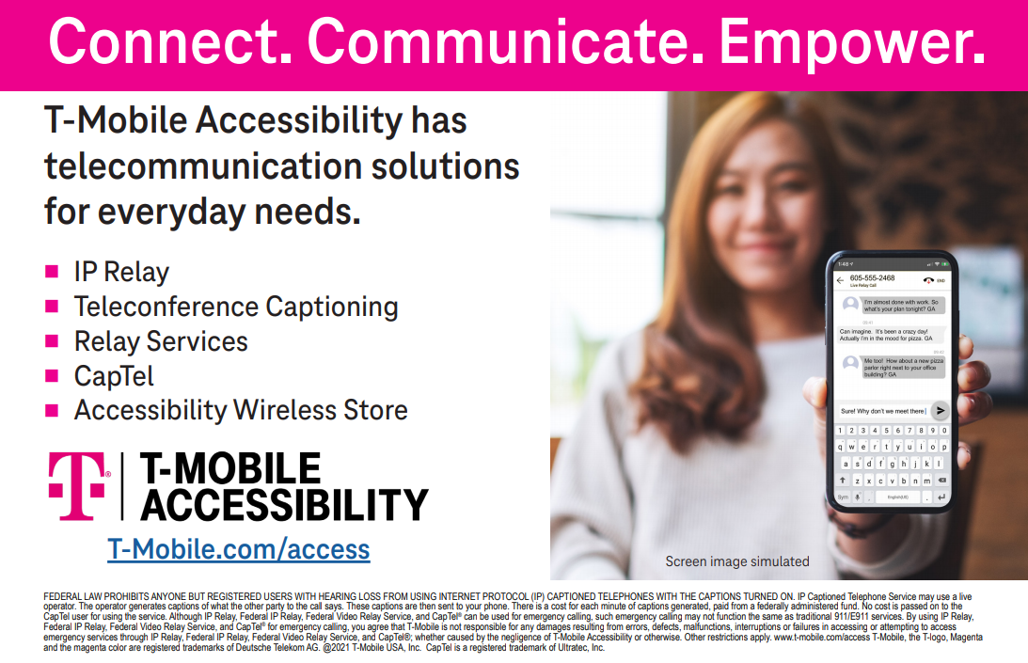
T

