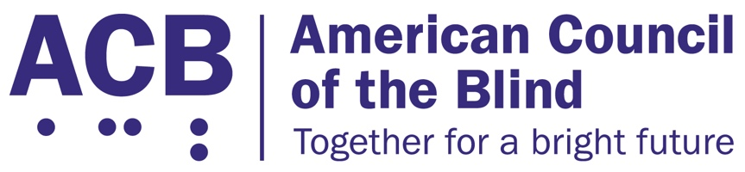
1703 N. Beauregard St., Suite 420

Alexandria, VA 22311

Tel: (202) 467-5081

Fax: (703) 465-5085

The Websites and Software Applications Accessibility Act

Background

Access to websites, applications and online services impacts most aspects of everyday life, and the COVID-19 pandemic has made digital inclusion more important than ever. However, the Department of Justice has not finalized enforcement standards that clearly state websites, applications, and online services must be accessible to people who are blind, low vision, and Deafblind. As a result, people who are blind, low vision, and Deafblind face countless barriers when accessing workplace portals, educational platforms, healthcare and public health information, transportation services, shopping, and entertainment over the Internet.

There is a need for clear guidance to the Department of Justice to finalize and implement enforceable online information access standards. These standards must include a strong functional definition of accessibility and should not require any person to exhaust administrative processes or notify website and application owners and operators that their online services are violating the rights of people with disabilities.

In the fall of 2022, Senator Tammy Duckworth (D-IL) introduced The Websites and Software Applications Accessibility Act in the Senate. Representative John Sarbanes (D-MD-03) introduced a version of the bill in the House of Representatives. This bill would establish clear and enforceable accessibility standards for websites and software applications. The bill uses a functional definition of accessibility, ensuring that any regulations created after this bill is passed and signed into law remain evergreen and up to date with new and emerging technology. The “Websites and Software Applications Accessibility Act” would clarify that it is unlawful for the entities currently covered by the ADA to maintain inaccessible websites and applications that exclude or otherwise discriminate against people with disabilities. It would establish a clear, enforceable accessibility standard, and establish a technical assistance center and advisory committee to provide advice and guidance on accessible websites and applications. It would also authorize a study on addressing emerging technologies.

Call to Action

ACB calls on Congress to reintroduce The Websites and Software Applications Accessibility Act in the 118th Congress in both the House of Representatives and in the Senate. When speaking with your Member of Congress, either in person or virtually, be sure to describe your experiences using inaccessible websites and applications in your daily life, and what having access to fully accessible websites and applications would mean for you.

