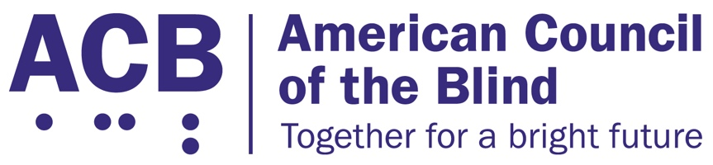1703 N. Beauregard St., Suite 420

Alexandria, VA 22311

Tel: (202) 467-5081

Fax: (703) 465-5085

­

­

Medical Device Nonvisual Accessibility Act Legislative Imperative

Background

The majority of home use medical devices and outpatient equipment utilize digital display interfaces that are inaccessible to people who are blind and low vision. Devices such as glucose monitors, insulin pumps, blood pressure readers, and at-home chemotherapy treatments do not have any non-visual accessibility features such as text to speech output, tactile markings, or audible tones built into the manufactured device. As a result, people who are blind and low vision cannot use them safely, making it significantly more difficult for these individuals to manage their health privately and independently.

According to the Centers for Disease Control and Prevention, adults with vision loss are at a higher risk for further health complications and co-morbid conditions. Diabetes and diabetic retinopathy are the leading cause of vision loss in the United States, with the latter putting them at high risk for further complications. It is therefore imperative that blind and visually impaired individuals have access to the equipment and devices necessary to manage their health and prevent further health complications, and that the equipment and devices are accessible with speech output and tactile markings. The COVID-19 pandemic has also underscored the need for accessible medical equipment and the need for blind and visually impaired individuals to be able to manage their health and wellness safely and independently, especially during a public health emergency.

Solution

In 2021, Representative Jan Schakowsky (D-IL) introduced the Medical Device Nonvisual Accessibility Act (H.R. 4853) in the House of Representatives. This bipartisan bill aims to make home use medical equipment and diagnostic equipment accessible to people who are blind and low vision. The bill would amend the federal Food, Drug, and Cosmetic Act to establish non-visual accessibility standards for Class II and III devices with digital interfaces. The FDA will, in consultation with the U.S. Access Board, set regulations and a final rule according to those standards. This bill is supported by both parties in the House of Representatives and has no companion in the Senate.

Call to Action

ACB urges members of Congress in the House of Representatives to co-sponsor and pass the bipartisan Medical Device Nonvisual Accessibility Act, H.R. 4853. Also, we urge members of the Senate to introduce and support a companion bill to H.R. 4853. By passing this legislation, Congress would provide people who are blind and low vision the tools necessary to take charge of our health and to do so with the privacy and independence guaranteed to all other people in the United States. When meeting with your member of Congress, be sure to share with them your personal experiences with inaccessible durable medical equipment and diagnostic devices, and explain to them what it would mean to you to have the tools and resources necessary to manage your own healthcare and medical conditions. If meeting with your representative, tell them to co-sponsor and support the passage of the Medical Device Nonvisual Accessibility Act, and if meeting with your Senators, urge them to support the introduction of a companion bill to H.R. 4853.

For additional information related to this legislative imperative, please contact ACB’s Director of Advocacy and Governmental Affairs, Clark Rachfal, or ACB’s Advocacy and Outreach Specialist, Swatha Nandhakumar, by emailing [advocacy@acb.org](mailto:advocacy@acb.org), or by calling (202) 467-5081.