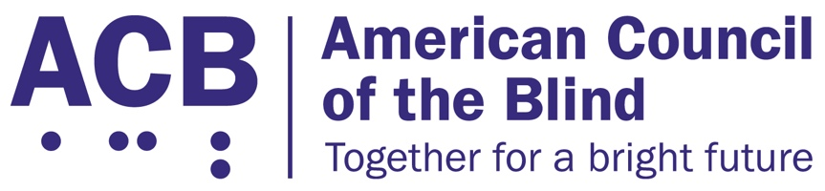
1703 N. Beauregard St., Suite 420

Alexandria, VA 22311

Tel: (202) 467-5081

Fax: (703) 465-5085

Communications and Video Accessibility Amendments Act Legislative Imperative

Background

The Twenty-First Century Communications and Video Accessibility Act (CVAA) guaranteed access for people with disabilities to advanced communications services, telecommunications hardware and software, accessible video displays and user interfaces and digital apparatuses, and required the delivery of audio-described content. For more than ten years, ACB and its members have worked to implement and enforce the CVAA, and in several key aspects, we have reached the limits of what the CVAA is able to enforce through regulation.

Twelve years since the passage of the CVAA, not all people in the United States are able to receive audio-described content from their local broadcast television stations. Despite every broadcast network being required to support accessible emergency alerts, which use the same technology as audio description, only 80 of the 210 broadcast designated market areas are required to pass through audio-described content to consumers.

The Federal Communications Commission has maximized the amount of audio-described content it may require broadcasters and cable programmers to provide at 87.5 hours per quarter, or roughly one hour per day of audio-described content.
The CVAA was implemented prior to online streaming video becoming a routine part of video entertainment. As a result, the CVAA audio description requirements only apply to broadcast and cable programming.
The CVAA implemented accessibility requirements for text and audio advanced communications services; however, video communications services remain undefined and do not have corresponding accessibility requirements.

Solution

It is time for Congress to update the accessible video and communications requirements of the CVAA. This legislation should ensure that all video programming is audio-described, whether enjoyed via over-the-air broadcast television, as part of cable programming, or video content delivered by streaming services over the Internet.

Congress must ensure that everyone in the United States may receive audio-described content from their local broadcaster utilizing the technology already required to deliver accessible emergency alerts, and ensure that accessible user interface and audio-described content requirements are modernized to reflect the shifting landscape to Internet protocol and online delivered video content.

Any legislation should require the Federal Communications Commission to ensure that all video communications services, including those used for video conferencing, telehealth, and distance learning, are accessible to people with disabilities, including people who are blind, low vision, and Deafblind.

Call to Action

ACB urges the House and Senate to support the introduction of a Communication and Video Accessibility Amendments Act to ensure that video entertainment and communications are accessible to everyone. When meeting with your member of Congress, please share with them the difficulties that you have in locating and watching audio-described content on broadcast television, cable, and when streaming video content online. Please share with them what it would mean for you to have access to all video content with audio description, and what it would mean for you to be able to access audio-described content independently through accessible user interfaces for online video services. And finally, tell your members of Congress that the Federal Communications Commission must ensure accessible access to video communications services, as they have for text and audio advanced communications services. Tell your member of Congress that you want them to support and co-sponsor a Communications and Video Accessibility Amendments Act, once introduced.

For additional information related to this legislative imperative, please contact ACB’s Director of Advocacy and Governmental Affairs, Clark Rachfal, or ACB’s Advocacy and Outreach Specialist, Swatha Nandhakumar, by emailing advocacy@acb.org, or by calling (202) 467-5081.

