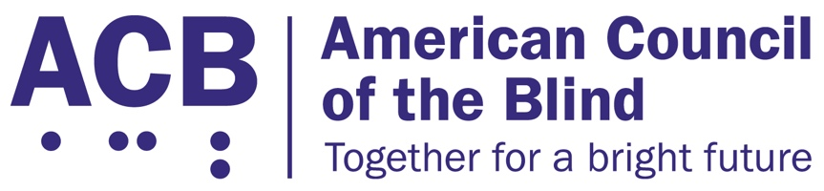
1703 N. Beauregard St., Suite 420

Alexandria, VA 22311

Tel: (202) 467-5081

Fax: (703) 465-5085

The Exercise and Fitness for All Act

Background

Physical activity plays an important role in maintaining health, well-being, and quality of life. According to the Physical Activity Guidelines for Americans, 2nd edition, physical activity can help control weight, improve mental health, and lower the risk for early death, heart disease, type 2 diabetes, and some cancers. Physical activity can also improve mental health by reducing depression and anxiety.

According to the Centers for Disease Control and Prevention (CDC), one in four U.S. adults is living with a disability, including 93 million Americans who are at high risk for severe vision loss. Adults with disabilities are more likely to have obesity, heart disease, stroke, diabetes, or cancer than adults without disabilities. Physical activity can reduce the risk and help manage these chronic conditions while improving daily living activities and independence. Physical activity can also reduce the risk of increased functional limitations.

The CDC recommends engaging in physical activity outdoors, such as walking, to improve physical and mental health. However, adults with disabilities report fewer accessible environmental supports, such as sidewalks, accessible pedestrian signals, public/paratransit and walkable shops, and more barriers, such as traffic, crime, and animals, for walking than those without disabilities. An alternative to outdoor physical activity is indoor exercise at a gym, fitness facility, or in a person’s home. However, the CDC also found that the inaccessibility of many fitness facilities creates barriers for those with a disability to exercise due to the lack of accessible space, instruction, and equipment.

Sen. Tammy Duckworth (D-IL), along with Senators Bob Casey (D-PA), Dianne Feinstein (D-CA), and Richard Blumenthal (D-CT), introduced the Exercise and Fitness for All Act (S. 2504) in the 117th Congress in 2021. The goal of this bill was to make exercise equipment and fitness instruction fully accessible to people with disabilities. A version of the bill was introduced in the House as H.R. 4756 by Representatives Mark DeSaulnier (D-CA) and Don Young (R-AK). Rep. Dina Titus (D-NV) was also a co-sponsor. If passed, the bill would require the U.S. Access Board to establish guidelines relating to the number and types of accessible fitness equipment gyms and other fitness facilities are required to have, require the DOJ to publish regulations relating to the guidelines requiring fitness facilities to provide accessible equipment and classes, and would ensure that there is at least one staff member at the facility that is trained in providing assistance to a person with a disability and in operating the accessible equipment.

Call to Action

ACB urges the House and Senate to reintroduce the Exercise and Fitness for All Act in the 118th Congress. When meeting with your member of Congress, be sure to describe the challenges that you have faced when attempting to use exercise and fitness equipment and explain what having access to accessible fitness facilities and equipment would mean to you as a person who is blind or experiencing vision loss.

