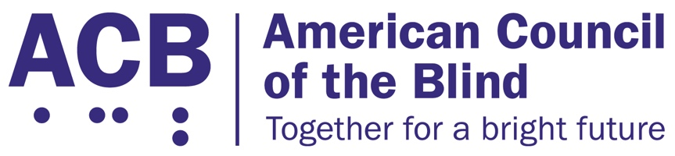
225 Reinekers Ln., Suite 660

Alexandria, VA 22314

Tel: (202) 467-5081

Fax: (703) 465-5085

Ms. Barbara Millicent Roberts
Willows, WI

July 30, 2024

Dear Blind Barbie®:

Your recent debut has been an inspiration to individuals who are blind or living with vision challenges. The public perception of people who are blind is often that we are different in how we want to live or in some way “mysterious,” since many people do not have the opportunity to interact with someone who is blind. The stylish nature of your presentation, rocking those high heels and having snazzy sunglasses at the ready, helps people, young and seasoned, envision blindness from a new perspective.

It is with tremendous joy that the American Council of the Blind (ACB) awards you an honorary membership. Our 8,000 members and many more supporters enthusiastically welcome you to our organization. In fact, we are busily planning which committees best fit your skillset. Your membership fee is covered for this year, and if any of your friends would like to support ACB’s ongoing work, they can visit www.acb.org to help us serve more individuals moving forward. We applaud Mattel and the American Foundation for the Blind for helping to make you a reality.

Sincerely,
T. Scott Thornhill
Executive Director
American Council of the Blind

