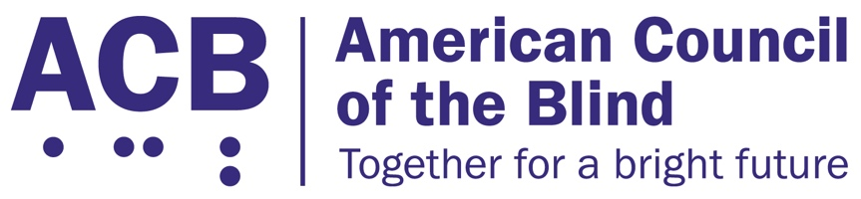
1703 N. Beauregard St., Suite 420

Alexandria, VA 22311

Tel: (202) 467-5081

Fax: (703) 465-5085

August 7, 2020

Dear Leaders McConnell, Schumer and McCarthy and Speaker Pelosi:

I am writing on behalf of the American Council of the Blind. ACB is a member-based organization of people who are blind and visually impaired that strives to increase the independence, security, equality of opportunity, and to improve quality of life for all blind and visually impaired people. Our organization is reaching out in response to the recently proposed Safeguarding America’s Frontline Employees to Offer Work Opportunities Required to Kickstart the Economy (SAFE TO WORK) Act. We urge Congress not to adopt the act. This act will have a detrimental effect on the Americans with Disabilities Act (ADA) and the rights of people with disabilities.

The SAFE TO WORK Act chips away at important protections of individuals with disabilities. It undermines imperative protections for these individuals by limiting liability claims against any unlawful conduct and puts their safety at great risk. In other words, if people with disabilities have no recourse to challenge the unsafe conditions of a public service or business, such entities can easily neglect the safety of patrons with disabilities.

Implementation of the SAFE TO WORK Act could allow a business or employer to fail to provide reasonable accommodations to individuals with disabilities who may be impacted by COVID-19. The business or employer could simply use the act to claim that the accommodation request is holding them liable for the virus and refuse to provide any needed services. Furthermore, the business could easily neglect a customer and hide behind the act when asked why the customer was not cared for. The abuse of the act could clearly be seen in numerous situations. This abuse fundamentally begins to alter the ADA. Consequently, it would not only impact people with disabilities in the immediate future, but could have long-lasting effects on the ADA itself.

Additionally, if an employer or other business owner truly felt that accommodating a person with a disability proposed a threat to the health and safety of others that might trigger a liability claim, the business owner could utilize the direct threat provision of the ADA. Under the direct threat provision of the ADA, an accommodation or modification can be denied if accommodating the person with a disability would pose a direct threat to the person with a disability or others in the workplace. Thus, a safeguard for businesses already exists. Also, the U.S. Equal Employment Opportunity Commission (EEOC) has recently issued guidance on the ADA and COVID-19. The guidance clarifies the wide range of measures that employers are permitted to take to keep workplaces safe during the COVID-19 pandemic.

Thank you for your continued work to guide the nation through the COVID-19 pandemic. As we commemorate the 30th anniversary of the ADA, we look forward to collaborating with you to ensure that people with disabilities are not inadvertent casualties of policies intended to heal our nation. If you have any questions or wish to discuss these issues further, please feel free to contact Claire Stanley, ACB’s Advocacy and Outreach Specialist, at cstanley@acb.org or (202) 467-5081.

Sincerely,

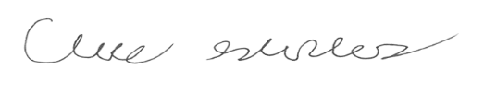

Claire Stanley
Advocacy and Outreach Specialist

