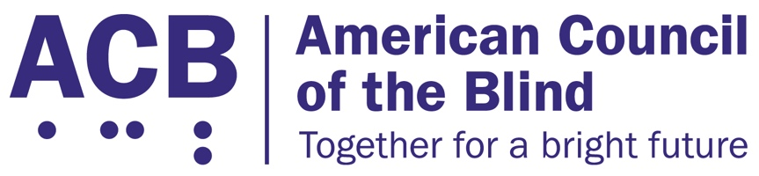225 Reinekers Ln., Suite 660

Alexandria, VA 22314

Tel: (202) 467-5081

Fax: (703) 465-5085

­

# The Websites and Software Applications Accessibility Act

Background

Access to websites, applications and online services impacts most aspects of everyday life, and the COVID-19 pandemic has made digital inclusion more important than ever. There is a need for enforcement standards that clearly state websites, applications, and online services must be accessible to people with disabilities. People who are blind, low vision, and DeafBlind face countless barriers when accessing workplace portals, educational platforms, healthcare and public health information, transportation services, shopping, and entertainment over the Internet.

Call to Action

ACB calls on Congress to support and pass the Websites and Software Applications Accessibility Act. In the last session of Congress, Sen. Tammy Duckworth (D-IL) introduced this legislation (S. 4998), and Rep. John Sarbanes (D-MD) along with Rep. Pete Sessions (R-TX) introduced a version of the bill in the House of Representatives (H.R. 9021). We are hopeful it will quickly be reintroduced. This bill would establish clear and enforceable accessibility standards for websites and software applications. The Websites and Software Applications Accessibility Act would set clear, enforceable accessibility standards, and establish a technical assistance center and advisory committee to provide advice and guidance on accessible websites and applications. It would also authorize a study on addressing emerging technologies.

Senate offices wishing to support this bill should contact Stephanie Deluca in Sen. Duckworth’s office.