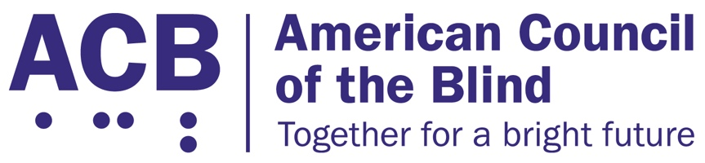225 Reinekers Ln., Suite 660

Alexandria, VA 22314

Tel: (202) 467-5081

Fax: (703) 465-5085

­

# The Medical Device Nonvisual Accessibility Act

**Background**

The majority of home use medical devices and outpatient equipment utilizes digital display interfaces that are inaccessible to blind, low vision, and DeafBlind users. Class 2 and Class 3 medical devices such as glucose monitors, blood pressure readers, and at-home chemotherapy treatments do not have any non-visual accessibility features like text to speech output, tactile markings, or audible tones built in. As a result, people who are blind, low vision, and DeafBlind cannot independently manage their health from the privacy of their own homes in the same ways as people who are not disabled.

**Call to Action**

ACB calls on Congress to support and pass the Medical Device Nonvisual Accessibility Act. In the last session of congress, this bipartisan piece of legislation was introduced in both the House and Senate by Rep. Jan Schakowsky (D-IL) and Senators Mike Braun (R-IN) and Maggie Hassan (D-NH), to ensure that medical equipment with a digital display is accessible and that people with disabilities can take back control of their health. We are hopeful it will quickly be reintroduced. This legislation would require the Food and Drug Administration to consider non-visual accessibility when approving Class 2 and Class 3 medical equipment and devices with a digital display to ensure access for patients with disabilities.

Offices in the House of Representatives interested in supporting the bipartisan Medical Device Nonvisual Accessibility Act (H.R.1328) should contact Michelle Paucar in the office of Rep. Schakowsky (D-IL). Offices in the Senate that are interested in co-sponsoring S. 3621 should contact Emily Kane in Sen. Hassan’s office.