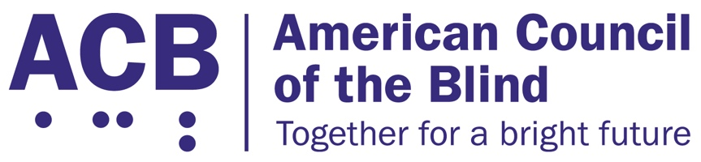225 Reinekers Ln., Suite 660

Alexandria, VA 22314

Tel: (202) 467-5081

Fax: (703) 465-5085

­

2025 ACB Legislative Imperatives

The American Council of the Blind is the nation’s leading member-driven organization for individuals who are blind and experiencing vision loss. With 66 state and special- interest affiliates across the country, ACB is committed to increasing the security, independence, quality of life, and economic opportunity for people who are blind and low vision in the United States, and ACB stands committed to advocacy that lifts up our values.

The following legislative imperatives represent several key issues that were pieces of legislation in the 118th Congress that ACB seeks to have reintroduced and passed in the 119th Congress. These bills will help ACB members in furthering independence and bettering quality of life.

# The Medical Device Nonvisual Accessibility Act

The majority of home use medical devices and outpatient equipment utilizes digital display interfaces that are inaccessible to blind, low vision, and DeafBlind users. Class 2 and Class 3 medical devices such as glucose monitors, blood pressure readers, and at-home chemotherapy treatments do not have any non-visual accessibility features like text to speech output, tactile markings, or audible tones built in. As a result, people who are blind, low vision, and DeafBlind cannot independently manage their health from the privacy of their own homes in the same ways as people who are not disabled.

ACB calls on Congress to support and pass the Medical Device Nonvisual Accessibility Act. In the last session of congress, this bipartisan piece of legislation was introduced in both the House and Senate by Rep. Jan Schakowsky (D-IL) and Senators Mike Braun (R-IN) and Maggie Hassan (D-NH), to ensure that medical equipment with a digital display is accessible and that people with disabilities can take back control of their health. We are hopeful it will quickly be reintroduced. This legislation would require the Food and Drug Administration to consider non-visual accessibility when approving Class 2 and Class 3 medical equipment and devices with a digital display to ensure access for patients with disabilities.

Offices in the House of Representatives interested in supporting the bipartisan Medical Device Nonvisual Accessibility Act (H.R.1328) should contact Michelle Paucar in the office of Rep. Schakowsky (D-IL). Offices in the Senate that are interested in co-sponsoring S. 3621 should contact Emily Kane in Sen. Hassan’s office.

# The Websites and Software Applications Accessibility Act

Access to websites, applications and online services impacts most aspects of everyday life, and the COVID-19 pandemic has made digital inclusion more important than ever. There is a need for enforcement standards that clearly state websites, applications, and online services must be accessible to people with disabilities. People who are blind, low vision, and DeafBlind face countless barriers when accessing workplace portals, educational platforms, healthcare and public health information, transportation services, shopping, and entertainment over the Internet.

ACB calls on Congress to support and pass the Websites and Software Applications Accessibility Act. In the last session of Congress, Sen. Tammy Duckworth (D-IL) introduced this legislation (S. 4998), and Rep. John Sarbanes (D-MD) along with Rep. Pete Sessions (R-TX) introduced a version of the bill in the House of Representatives (H.R. 9021). We are hopeful it will quickly be reintroduced. This bill would establish clear and enforceable accessibility standards for websites and software applications. The Websites and Software Applications Accessibility Act would set clear, enforceable accessibility standards, and establish a technical assistance center and advisory committee to provide advice and guidance on accessible websites and applications. It would also authorize a study on addressing emerging technologies.

Senate offices wishing to support this bill should contact Stephanie Deluca in Sen. Duckworth’s office.

# The Communications, Video, and Technology Accessibility Act

The 21st Century Communications and Video Accessibility Act (CVAA) guaranteed access for people with disabilities to advanced communications services, telecommunications hardware and software, accessible video displays and user interfaces and digital apparatuses, and required the delivery of audio-described content. For more than ten years, ACB and its members have worked to implement and enforce the CVAA, and in several key aspects, we have reached the limits of what the CVAA is able to enforce.

It is time for Congress to update the accessible video and communications requirements of the CVAA. Sen. Edward J. Markey (D-MA) and Rep. Anna G. Eshoo (D-CA) introduced the Communications, Video, and Technology Accessibility (CVTA) Act (H.R. 9333 and S. 5121). The CVTA reaffirms our nation’s commitment to accessible communications and video technologies for people who are blind, low vision, and DeafBlind. Once passed, this legislation will update existing requirements for accessible media, video user interfaces, and video conferencing services. ACB urges Congress to support and pass the CVTA in the 119th Congress. Offices interested in supporting the CVTA should contact Ireland Lesley in Sen. Markey’s office.

For questions or further information on the 2025 ACB Legislative Imperatives, please contact Claire Stanley, ACB’s Director of Advocacy and Governmental Affairs,

[cstanley@acb.org,](mailto:cstanley@acb.org) or by calling (202) 467-5081.

The American Council of the Blind greatly appreciates your support on these critical issues for 2025, and we look forward to working with you during the remainder of the 119th Congress.