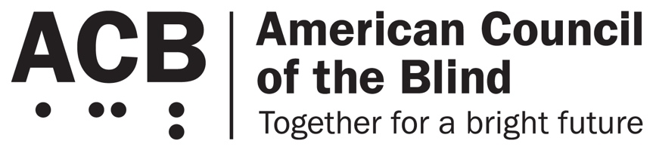
1703 N. Beauregard St., Suite 420

Alexandria, VA 22311

Tel: (202) 467-5081

Fax: (703) 465-5085

Imperative 1: Fixing America’s Surface Transportation Act

Background

The Fixing America’s Surface Transportation (FAST) Act must be reauthorized by Congress by September of 2020. The bill was first enacted in September of 2015, and it was considered to be the first comprehensive, long-term piece of surface transportation legislation since 2005. The FAST Act fulfills the constitutional directive that dictates that investment in transportation and infrastructure is a core federal responsibility. It oversees the development and maintenance of roads, bridges, public transit, and rails. More specifically, the FAST Act strengthens transportation programs, refocuses on national priorities, provides long-term certainty and flexibility for states and local governments, streamlines project approval processes, and maintains a strong commitment to safety. In the Senate, the Environmental and Public Works (EPW) Committee is charged with developing the new bill. In the House of Representatives, the responsibility falls to the Transportation and Infrastructure Committee.

Call to Action

The re-introduction of this bill enables the blind and visually impaired community to highlight transportation and infrastructure issues that need to be addressed to allow for access and safety in their communities. As the language of the new bill is developed, language that would positively impact the transportation options and safety for the blind community should be included. Below are just a few examples of issues that should be included in the language of the FAST Act.

One of the priorities behind the FAST Act is the promotion of safety for people while commuting and interacting with roads and other infrastructure. One significant example of this is the need for safe intersections for people who are blind and visually impaired. Leading pedestrian interval (LPI) signalization provides pedestrians several extra seconds to begin crossing in the crosswalk before vehicles get the green light to enter the intersection. This promotes the safety of pedestrians because, once a person has entered the intersection ahead of the cars, he or she becomes more visible to turning cars. Through orientation and mobility (O&M) training, blind and visually impaired people learn how to cross a street independently by listening to the traffic patterns of an intersection. However, blind and visually impaired pedestrians are unable to take advantage of LPI signals; they cannot be detected by reading the flow of traffic. Consequently, a tool that could be helpful to the safety of blind and visually impaired pedestrians is lost. But, if an intersection with LPI signalization includes accessible pedestrian signals (APS), the increasing number of Americans with vision loss may equally benefit from the safety benefits of the LPI. For this reason, Congress should require the installation of APS whenever LPI signalization is utilized.

A second issue that needs to be examined to promote safer travel for people who are blind and visually impaired is the significant increase in the use of micro mobility services, such as e-bicycles and e-scooters. Those who use such devices often utilize them to finish the beginning and final legs of a trip, such as from a subway stop to an office building. People who utilize such micro mobility businesses are charged with parking the device in a location outside the path of general travel. Unfortunately, many micro mobility users fail to comply with such policies. E-scooters are routinely left in random locations, for example, blocking ramps, sidewalks, entryways and emergency exits, where they become a safety hazard. As a result, the free travel of people with disabilities has been impeded. When e-scooters are left randomly in the middle of the sidewalk, blind and visually impaired individuals are more likely to trip over the devices. ACB has heard numerous anecdotal stories of people who have fallen or been confined to certain locations because of poorly parked scooters. Under the FAST Act, communities need to build infrastructure to create designated parking locations for such vehicles. Designated parking areas would help to keep the devices off sidewalks and other common routes of travel. Additionally, municipalities should explore other policies to alleviate some of these problems. For instance, should local policies be implemented to prohibit such vehicles in designated areas, or should micro mobility devices be required to be locked to a fixed structure outside of the public right-of-way? Other groups have explored the effectiveness of monetary fines for users who fail to appropriately park the e-scooter. It is clear that more must be done to find ways to address this problem.

Finally, an important provider of transportation for people who are blind and visually impaired that needs to be explored and better funded is the use of on-demand ride-share services. In numerous cities, such as the greater Boston, Massachusetts area, local transportation providers have begun to adopt pilot programs where disabled passengers are permitted to use an on-demand transit service in place of other transportation systems. To use such a system, a blind or visually impaired person can call the transit provider the day of the trip and request a ride. The town or municipality contracts with taxicab companies or ride-share companies such as Lyft or Uber. The local municipality pays an initial flat rate, and the blind or visually impaired person pays any additional fee that exceeds the initial sum. These transportation models have become extremely popular. They enable people to be more mobile; they can request a ride the day of a trip. Furthermore, they are not burdened by the steep prices of some ride-share services like Lyft or Uber, whose charges quickly add up. The FAST Act should include language to fund such programs at a local, municipal level. These programs will save municipalities money. It has been shown that they cost less than a more traditional form of transportation for individuals with disabilities such as paratransit services. Access to transportation for Americans who are blind and visually impaired continues to be one of the most significant issues facing this community. By implementing such programs, the FAST Act would fulfill its responsibility to strengthen transportation programs.

ACB encourages members to share these multi-faceted safety and traffic challenges with their members of Congress. These are just a few of the issues that need to be considered in updating the language of the FAST Act before it is reauthorized in the fall of 2020. You may have faced other issues with transportation; if so, please share these with your senators and representatives as well. The blind and visually impaired community continues to face transportation and infrastructure-related issues that create safety risks and lack of transportation access for people who are blind. The addition of the above language can work to eliminate some of these challenges.

For more information on this issue, contact Claire Stanley, ACB’s Advocacy and Outreach Specialist: cstanley@acb.org, (202) 467-5081.

