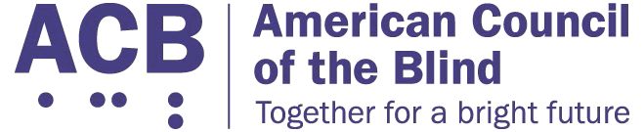
American Council of the Blind

DC Leadership Meetings
(President & Legislative Meetings)

February 23 - 25, 2020

Holiday Inn & Suites
625 First Street
Alexandria, VA 22314
(703) 548-6300

Registration Form

The registration form with payment needs to be mailed by February 7, 2020.

Name: _________________________________________
Address: _______________________________________
City: _____________________________
State: _____ Zip: ______________
Phone: ____________________________
Email: _____________________________________
Name of ACB Affiliate you are representing? __________________________________________
Reading Preference for materials:
⭘ Large Print
⭘ Braille
⭘ email

Do you plan on attending the Presidents’ meeting February 23, 2020?
⭘ Yes
⭘ No

Would you like lunch? Late registrations will be an additional $5
⭘ Yes - $35 ($5 registration fee + $30 lunch)
⭘ No - $5 - ($5 registration fee)

If you are paying for the Presidents’ lunch, please choose one of the following lunch options:
⭘ Meat
⭘ Vegetarian
⭘ Special dietary requirements - email kgasque@acb.org

Do you plan on attending the Legislative meeting February 24-25, 2020?
⭘ Yes
⭘ No

Would you like lunch? Late registrations will be an additional $5
⭘ Yes - $40 ($5 registration fee + $35 for lunch)
⭘ No - $5 ($5 registration fee)

If you are paying for the lunch on February 25th, please choose one of the following lunch options:
⭘ Meat
⭘ Vegetarian
⭘ Special dietary requirements - email kgasque@acb.org

Will you need sighted guide assistance on Capitol Hill?
⭘ Yes
⭘ No

Check any reasonable accommodations needed
⭘ Assistive listening device
⭘ Sighted guide
⭘ Guide dog relief area
⭘ None

DC Leadership Attendance
⭘ This is my first time attending the DC Leadership meetings
⭘ I have not attended the DC leadership meetings recently
⭘ I have attended the DC leadership meetings

Make checks payable to: American Council of the Blind

Mail to: American Council of the Blind
6300 Shingle Creek Parkway, Suite 195
Brooklyn Center, MN 55430

Questions? Contact Kelly Gasque at kgasque@acb.org or 202-467-5081

