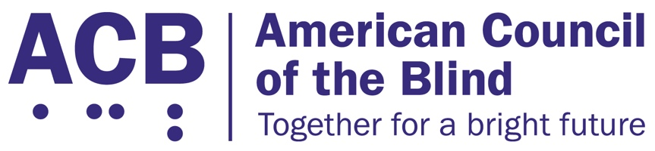
1703 N. Beauregard St., Suite 420

Alexandria, VA 22311

Tel: (202) 467-5081

Fax: (703) 465-5085

Exercise and Fitness for All Act Legislative Imperative

Background
Physical activity plays an important role in maintaining health, well-being, and quality of life. According to the Physical Activity Guidelines for Americans, 2nd edition, physical activity can help control weight, improve mental health, and lower the risk for early death, heart disease, type 2 diabetes, and some cancers. Physical activity can also improve mental health by reducing depression and anxiety.
According to the Centers for Disease Control and Prevention (CDC), one in four U.S. adults is living with a disability, including 93 million Americans who are at high risk for severe vision loss. Adults with disabilities are more likely to have obesity, heart disease, stroke, diabetes, or cancer than adults without disabilities. Physical activity can reduce the risk and help manage these chronic conditions while improving daily living activities and independence.
The CDC recommends engaging in physical activity outdoors, such as walking, to improve physical and mental health. However, adults with disabilities report fewer accessible environmental supports, such as sidewalks, accessible pedestrian signals, public/paratransit and walkable shops, and more barriers, such as traffic, crime and animals, for walking than those without disabilities.
An alternative to outdoor physical activity is indoor exercise at a gym, fitness facility, or in a person’s home. However, the CDC also found that the inaccessibility of many fitness facilities creates barriers for those with a disability to exercise due to the lack of accessible space, instruction, and equipment.

Call to Action
ACB urges Congress to reintroduce the Exercise and Fitness for All Act on a bipartisan basis in both the House and Senate for the 117th Congress. The Exercise and Fitness for All Act would promote the provision of exercise or fitness equipment, and exercise or fitness classes and instruction, that are accessible to individuals with disabilities. Social isolation due to the COVID-19 pandemic has underscored what ACB and our members already knew – that the lack of access to accessible exercise and fitness equipment and instruction are a persistent barrier to equal access and results in deteriorating physical and mental health.
In the 116th Congress, Sens. Duckworth (D-IL), Casey (D-PA), and Blumenthal (D-CT) introduced the Exercise and Fitness for All Act in the Senate (S. 1244), and Reps. DeSaulnier (D-CA-11) and Young (R-AK-At Large) introduced a companion bill in the House (H.R. 4561). The Exercise and Fitness for All Act would:
- Require the U.S. Access Board to develop and publish guidelines for implementation by the U.S. Department of Justice for exercise or fitness service providers regarding the provision of accessible exercise or fitness equipment as described by the American Society of Testing and Materials allowing for the independent use by a person with a disability, including audible output and an accessible user interface;
- Ensure that exercise or fitness classes and instruction offered by the service provider are accessible to individuals with disabilities; and
- Ensure that the service provider makes available at least one employee who is able to assist individuals with disabilities in their use of accessible exercise or fitness equipment.

When meeting with your members of Congress, be sure to share your personal experiences when attempting use fitness or exercise equipment at public facilities. Share with them what it would mean to you to have equal and independent access to the tools and resources to take charge of your health. And encourage them to support reintroduction of the Exercise and Fitness for All Act.
For more information on this issue, contact Clark Rachfal, ACB’s Director of Advocacy and Governmental Affairs: crachfal@acb.org, (202) 467-5081.

