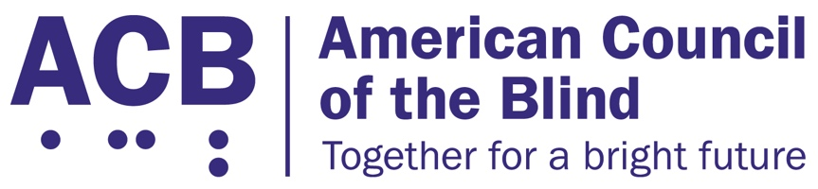
1703 N. Beauregard St., Suite 420

Alexandria, VA 22311

Tel: (202) 467-5081

Fax: (703) 465-5085

Disability Access to Transportation Act Legislative Imperative

Background
The Fixing America’s Surface Transportation (FAST) Act was scheduled to be reauthorized by Congress by September of 2020. The bill was first enacted in September of 2015, and it was considered to be the first comprehensive, long-term piece of surface transportation legislation since 2005. The FAST Act fulfills the constitutional directive that dictates that investment in transportation and infrastructure is a core federal responsibility. It oversees the development and maintenance of roads, bridges, public transit, and rails. More specifically, the FAST Act strengthens transportation programs, refocuses on national priorities, provides long-term certainty and flexibility for states and local governments, streamlines project approval processes, and maintains a strong commitment to safety.
In 2020, one of ACB’s legislative imperatives was advocating for measures to improve transportation and environmental access through inclusion of provisions in the FAST Act reauthorization. Through collaboration with the cross-disability community, the efforts of ACB and our members lead to the bipartisan introduction of the Disability Access to Transportation Act, or DATA Act, by Reps. Langevin (D-RI-02), Katko (R-NY-24), and Titus (D-NV-01). The bill number for the DATA Act was H.R. 6248, and the provisions of this bill were included in the House version of the FAST Act.
Unfortunately, Congress did not reauthorize the FAST Act by the deadline, Sept. 30, 2020. Instead Congress passed a continuing resolution, which was signed by President Trump, that funded existing transportation programs for an additional year, until Sept. 30, 2021.

Call to Action
ACB urges Congress to re-introduce the bipartisan Disability Access to Transportation Act, the DATA Act, and to pass this legislation as part of the reauthorization of the FAST Act. The re-introduction of this bill enables the blind and visually impaired community to address transportation and infrastructure issues that allow for access and safety in their communities. The DATA Act would:
- Create and fund a five-year paratransit pilot program allowing passengers to make one stop during their trip for purposes including: child care, groceries, pharmacies, and financial institutions;
- Require the Department of Transportation and the U.S. Access Board to create guidelines setting forth minimum standards for pedestrian facilities in the public right-of-way;
- Provide greater access for individuals to file complaints regarding paratransit service with the Department of Transportation Civil Rights Office;
- Create an Accessibility Data Pilot Program to assist local communities in identifying gaps in transportation and methods to improve service to low-income, minority, older and disabled populations; and
- Increase funding levels for Section 5310 grants that fill gaps in services for older adults and people with disabilities.
The blind and visually impaired community continues to face a lack of accessible transportation options and infrastructure-related safety risks. When meeting with your representatives, please share your personal experiences with paratransit and inaccessible transportation infrastructure. The passage of the DATA Act will improve transportation access and help alleviate environmental access barriers, which will allow people who are blind and experiencing vision loss to live more independently in their community with greater opportunities for economic growth, and by including the DATA Act in the reauthorization of the FAST act, the FAST Act would fulfill its responsibility to strengthen transportation programs for all Americans.
For more information on this issue, contact Clark Rachfal, ACB’s Director of Advocacy and Governmental Affairs: crachfal@acb.org, (202) 467-5081.

