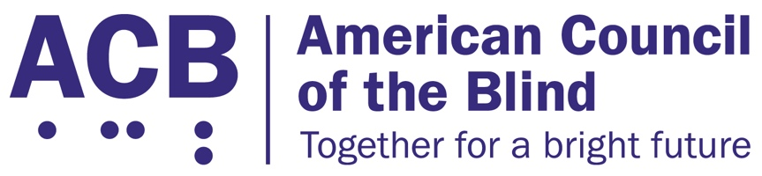
1703 N. Beauregard St., Suite 420

Alexandria, VA 22311

Tel: (202) 467-5081

Fax: (703) 465-5085

2021 ACB Legislative Imperatives
The American Council of the Blind is the nation’s leading member-driven organization for individuals who are blind and experiencing vision loss. With over 65 state and special-interest affiliates across the country, ACB is committed to increasing the security, independence, quality of life, and economic opportunity for Americans who are blind and visually impaired, and ACB stands committed to advocacy that lifts up our values.
The following legislative imperatives represent several key issues in the 117th Congress that ACB believes will help us on our road to full independence and participation in our society.

Secure Independence for Seniors and Medicare Beneficiaries
For more than a decade now, Medicare has refused to cover the cost of low-vision aids, due to an eyeglasses exclusion that prohibits the purchase of any durable medical good with a lens. While the regulatory exclusion was seen as cost-saving by not covering eyeglasses, it has had a negative impact on those who, through the use of special low-vision aids, could significantly increase their independence in the home. ACB believes that adaptive low-vision aids can have a significant impact on an individual’s ability to remain independent in the home. Such personal independence can have long-lasting effects toward aging in place, rather than necessitating costlier institutional services.
ACB calls on Congress to reintroduce the Medicare Demonstration of Coverage for Low Vision Devices Act, which would measure the various costs and benefits of removing the Medicare eyeglass exclusion. This bipartisan legislation is a smart approach to finding workable solutions that help seniors age in place. Offices in the House of Representatives interested in supporting reintroduction of this legislation should contact Danielle Sumner in the office of Rep. Maloney (D-NY-12), or Shayne Woods in the office of Rep. Bilirakis (R-NY-12).

The Disability Access to Transportation Act
Congress must reauthorize the Fixing America’s Surface Transportation (FAST) Act by September of 2021. The FAST Act fulfills the constitutional directive that dictates that investment in transportation and infrastructure is a core federal responsibility. It oversees the development and maintenance of roads, bridges, public transit, and rails. As the language of the new bill is developed, language that would positively impact the transportation options and safety for the blind community must be included.
Specifically, ACB calls for the reintroduction and inclusion of the Disability Access to Transportation Act, or DATA Act. The DATA Act would provide greater flexibility in paratransit services to increase the independence and economic opportunity of disabled passengers; increase accessibility for pedestrian infrastructure; and modernize the U.S. Department of Transportation complaint process for consumers with disabilities. Offices interested in supporting the DATA Act, and including it in the FAST Act reauthorization, should contact Katherine Lee in the office of Rep. Langevin (D-RI-02).

The Exercise and Fitness for All Act
For the quarter of Americans with a disability, equal access to fitness or exercise equipment and instruction remains elusive. As a result, people with disabilities are more likely to suffer from chronic health conditions including heart disease, diabetes, and obesity.
ACB calls for the reintroduction of the Exercise and Fitness for All Act. This legislation would require exercise and fitness facilities to provide a base level of accessibility for disabled consumers, both in the equipment as well as the instruction they provide. Offices interested to support the Exercise and Fitness for All Act should contact Kalina Thompson in the office of Sen. Duckworth (D-IL) in the Senate, and Sarah Jackson in the office of Rep. DeSaulnier (D-CA-11), or Kevin Swanson in the office of Rep. Young (R-AK-At Large) in the House.
For questions or further information on the 2021 ACB Legislative Imperatives, please contact Clark Rachfal, ACB’s Director of Advocacy and Governmental Affairs, crachfal@acb.org, or by calling (202) 467-5081.
The American Council of the Blind greatly appreciates your support on these critical issues for 2021, and we look forward to working with you during the remainder of the 117th Congress.

