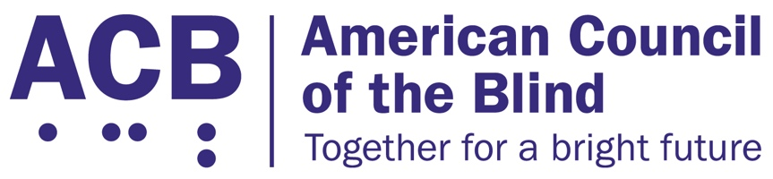
1703 N. Beauregard St., Suite 420

Alexandria, VA 22311

Tel: (202) 467-5081

Fax: (703) 465-5085

Durable Medical Equipment Legislative Imperative

Background

Technological advances have brought about a myriad of new medical equipment that can be used independently at home by users. For instance, individuals who require dialysis can now receive the treatment at home through a portable device. Specifically, people with diabetes now have access to several medical devices that can both read their sugar levels and take in needed insulin. Consumers can choose from a plethora of models according to their needs or desires.

However, a large number of the medical devices remain inaccessible for blind users. Some models of glucometers are accessible for people who are blind or visually impaired. But there are a limited number of models available. While sighted individuals can choose from numerous models to fit their needs, people who are blind are forced to use one of the very limited number of accessible devices. Additionally, when models are accessible, blind or visually impaired users may be able to use some but not all of the many tasks the device can carry out. This is an ongoing issue experienced by blind and visually impaired glucometer users that presents a host of potential health ramifications. Untreated or poorly treated diabetes can lead to a wide variety of other health problems. And when people develop other health conditions, other medical devices may be required. Yet, many of the other medical devices also remain inaccessible.

Smartphone applications have been developed to help remedy some of the problems associated with inaccessible medical equipment. For instance, the Libre, a new insulin device, can be linked to a smartphone to read results. Such applications have helped to bridge the gap for some services. But the app may be accessible only for a fraction of the functions. And smart devices are expensive. As a result, those who cannot afford the technology are kept from obtaining the resources they need. In addition, insurance coverage for such products – or lack thereof – has played a role in people’s ability to get accessible medical devices. Congress needs to be made aware of such inequality in consumer products.

Call to Action

Congress must develop legislation to require manufacturers to make durable medical equipment accessible for blind and visually impaired users right out of the box. Instead of such consumers finding ways to work around the problem, users should be able to access the product immediately, just like all other customers. Additionally, manufacturers must develop accessible devices absent the presence of smart devices. Although many users utilize smartphones, not all people have access to expensive technology. Thus, accessible equipment must exist for all users.

Below is draft language that can be presented to Congress members.

To Further Guarantee Equal Access of Medical Devices by Patients Who Are Blind and Visually Impaired under Section 1557 of the Patient Protection and Affordable Care Act of 2010

In the House of Representatives
{DATE}

Introduced by {SPONSOR/CO-SPONSORS}

A bill to further guarantee equal access of medical devices by patients who are blind and visually impaired under Section 1557 of the Patient Protection and Affordable Care Act of 2010.

SECTION 1 — SHORT TITLE
This Act may be cited as the “Accessibility of Medical Devices Act of 2019.”

SECTION 2 — CONSTITUTIONAL AUTHORITY
The constitutional authority upon which this Act rests is the power of the Congress to provide for the general welfare, to regulate commerce, and to make all laws which shall be necessary and proper for carrying into execution Federal powers, as enumerated in Section 8 of Article I of the Constitution of the United States.

SECTION 3 — DEFINITION OF BLINDNESS
For purposes of this Act, blindness is in line with the current definition under Section 1614(a)(2) of the Social Security Act, 42 USC §1382(c).

SECTION 4 — SAFEGUARDING ACCESS TO MEDICAL DEVICES BY THE BLIND
(a) Pursuant to 42 USC §18116(1)(c), the Secretary shall provide further promulgation of regulations under the Department’s non-discrimination clause, 45 CFR 92 et seq, that will assure the Centers for Medicare and Medicaid Services shall require any medical devices used to convey vital health data or information to individuals or other medical devices meet all necessary standards under Section 508 of the Rehabilitation Act of 1973 as amended.
(b) The Secretary shall take additional steps to prohibit any refusal of coverage by the Centers for Medicaid and Medicare Services of any medical device or secondary software application operating on a mobile device that is used to provide a reasonable accommodation toward accessing vital communications in the form of health data and information guaranteed under Section 1557 of the Patient Protection and Affordable Care Act of 2010, 42 USC §18116, and Section 504 of the Rehabilitation Act of 1973 as amended, 29 USC §794.

SECTION 5 — ACCESSIBILITY GUIDELINES FOR DIABETES MEDICAL DEVICES
Within one year of enactment of this Act, the United States Access Board shall issue guidance outlining necessary compliance for diabetes-related medical devices under the existing guidelines pursuant to 29 USC §798 for any stand-alone diabetes-related medical devices or any auxiliary wireless or mobile devices and applications that provide access to vital health data and information.

SECTION 6 — CONTINUED APPLICATION OF LAWS
Nothing in this title (or an amendment made by this title) shall be construed to invalidate or limit the rights, remedies, procedures, or legal standards available to individuals aggrieved under Title VI of the Civil Rights Act of 1964 (42 USC 2000d, et seq.), Title VII of the Civil Rights Act of 1964 (42 USC 2000e et seq.), Titles II and III of the Americans with Disabilities Act (42 USC 12131 et seq.; 42 USC 12181 et seq.), Section 794 of Title 29, or Section 798 of Title 29; or to supersede state laws that provide additional protections against discrimination on any basis described in this Act.

