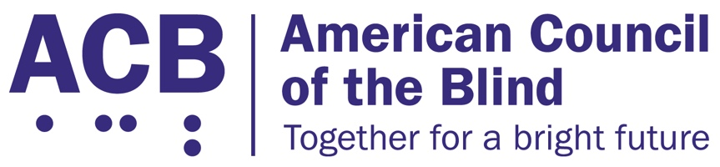
1703 N. Beauregard St., Suite 420

Alexandria, VA 22311

Tel: (202) 467-5081

Fax: (703) 465-5085

Secure Independence for Seniors and Medicare Beneficiaries Legislative Imperative

Background

In November of 2008, the Centers for Medicare and Medicaid Services (CMS) promulgated a regulation that has had a detrimental impact on the lives of countless individuals who are blind or visually impaired. The Durable Medical Equipment, Prosthetics, Orthotics, and Supplies (DMEPOS) Competitive Acquisition Rule contains a provision entitled “Low Vision Aid Exclusion” which states that all devices, “irrespective of their size, form, or technological features that use one or more lens to aid vision or provide magnification of images for impaired vision” are excluded from Medicare coverage based on the statutory eyeglass exclusion. ACB believes this extremely restrictive reading of the eyeglass exclusion has resulted in the denial of vital assistive devices for seniors and other Medicare beneficiaries that offers solutions for sustaining independence in the home.

This proposal has had a significant impact on beneficiaries with vision impairments who depend on assistive technology that incorporates one or more lenses to aid in their vision. The expansion of the eyeglass exclusion has prevented access to devices such as handheld magnifiers, video monitors, and a wide array of technologies that utilize lenses to assist individuals in overcoming the obstacles impeding their independence. These tools are often essential for individuals with low vision who, without the aid of assistive technology, cannot read prescriptions, medicine bottles, and other important materials containing content that is vital to their personal health and safety.

In short, these devices allow individuals with low vision to live independently and safely. Such a poor regulatory policy serves as a pre-emptive and unwarranted coverage denial for any new technology designed to assist individuals with vision loss. Knowing its influence in the medical devices marketplace, innovation and competition will be curtailed if Medicare continues to maintain this coverage exclusion. The unwanted side effects include sacrificing personal independence for more costly residential assistive living, which in the long run ends up putting greater strain on our entitlement programs.

Call to Action

ACB urges all members of Congress to co-sponsor and support the bipartisan Medicare Demonstration of Coverage for Low Vision Devices Act. In the House of Representatives, this bill was reintroduced by Reps. Maloney (D-NY-12) and Bilirakis (R-FL-12) as H.R. 4129 on July 30, 2019. The House bill has additional bipartisan co-sponsors, including Reps. Cohen (D-TN-09), Fitzpatrick (R-PA-01), Schiff (D-CA-28), Wagner (R-MO-02), and Wild (D-PA-07). We are working closely with staff for Sen. Gillibrand (D-NY) to introduce a bipartisan Senate companion bill that will be identical to H.R. 4129, and we will update all members with our progress.

This legislation would evaluate, through a five-year national demonstration project administered by the Department of Health and Human Services, the fiscal impact of a permanent change to the Social Security Act. This legislation would allow reimbursement for certain low-vision devices that are the most function-rich that sustain daily independent living. The devices would be considered durable medical equipment.

Individuals will be eligible to participate in the demonstration project only after completing a clinical evaluation performed by an ophthalmologist or optometrist who would then deem a low-vision device as medically necessary. The data from the demonstration would provide valuable insight into how the eyeglasses exclusion impacts independence for senior citizens and other Medicare beneficiaries. As Americans continue to live longer into their retirement, the Centers for Disease Control (CDC) projects through their Vision Health Initiative (VHI) that severe vision loss will be a leading chronic health condition for the next 30 years, based on an increasingly aging population and demographic changes in our country. According to CDC’s VHI, blindness increases the incidence of other chronic health conditions, depression, and morbidity. Therefore, it is vital that Congress identify solutions that can sustain quality of life as Americans get older.

For more information on this issue, contact Clark Rachfal, ACB’s Director of Advocacy and Governmental Affairs: crachfal@acb.org, (202) 467-5081.

