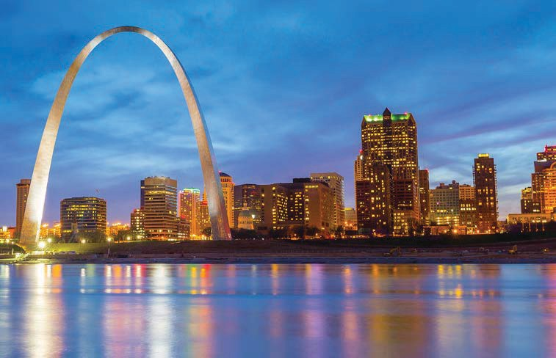
ACB – Gateway to Success
57th Annual National Conference & Convention American Council of the Blind and Special-Interest Affiliates

Union Station Hotel, St. Louis, MO June 29 – July 6, 2018

Kim Charlson, President Hosted by Missouri Council of the Blind
Denny Huff, President

LARGE PRINT VOLUME 2

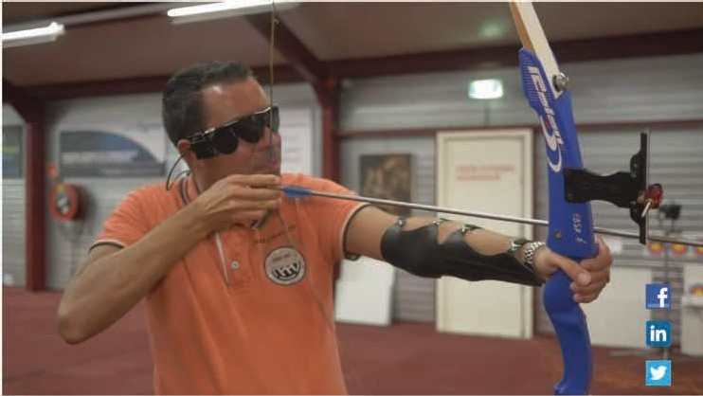

,.
I
,
Second Siqht

Rrqus ®II
Retinal Prosthesis S4stem

The World's only FDA approved retinal prosthesis for the treatment of end stage RP
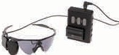
,,t)

For more information about the Argus II
Call Second Sight Medical Products
(888) 826·2695
www.secondsight.com

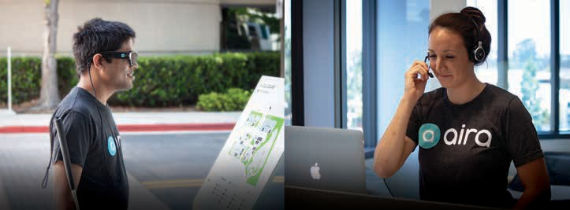

OUR EXPLORERS OUR AGENTS

Aira provides access to visual information that works for you. Because when it really matters, you’ll want to experience every detail.

Become an Explorer today
www.aira.io or 800-835-1934

Come visit us at booth 44

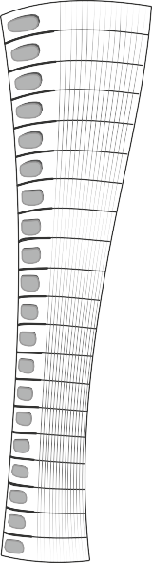
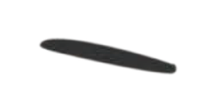
There’s a New Super-Notetaker on the Block!
BrailleSense Polaris MINI
Full-featured, Google-certified, 20-cell Braille Notetaker
— with HALF the Size & Weight!
- 20 cell - crisp, high quality Braille
- Access to 1000’s of apps on the Google Play Store
- Optimized apps for Google Drive, Classroom, Docs, Sheets, Slides & APH Nearby Explorer
- Mac and iOS compatible, with upgradable Android OS
- 13 Megapixel Camera
— great for OCR
- 64 GB Flash Memory — 3 GB RAM
- Weighs in at LESS THAN 15 ounces!

Need More Muscle?
Check out the original BrailleSense Polaris,
our bigger, badder powerhouse notetaker!

Call 888-520-4467 for a FREE Demonstration!
Or visit www.hims-inc.com to Learn More

Amazon’s familyLooremfipasucmcessible devices: Fire TV, Fire Tablets, Kindle, Echo & more
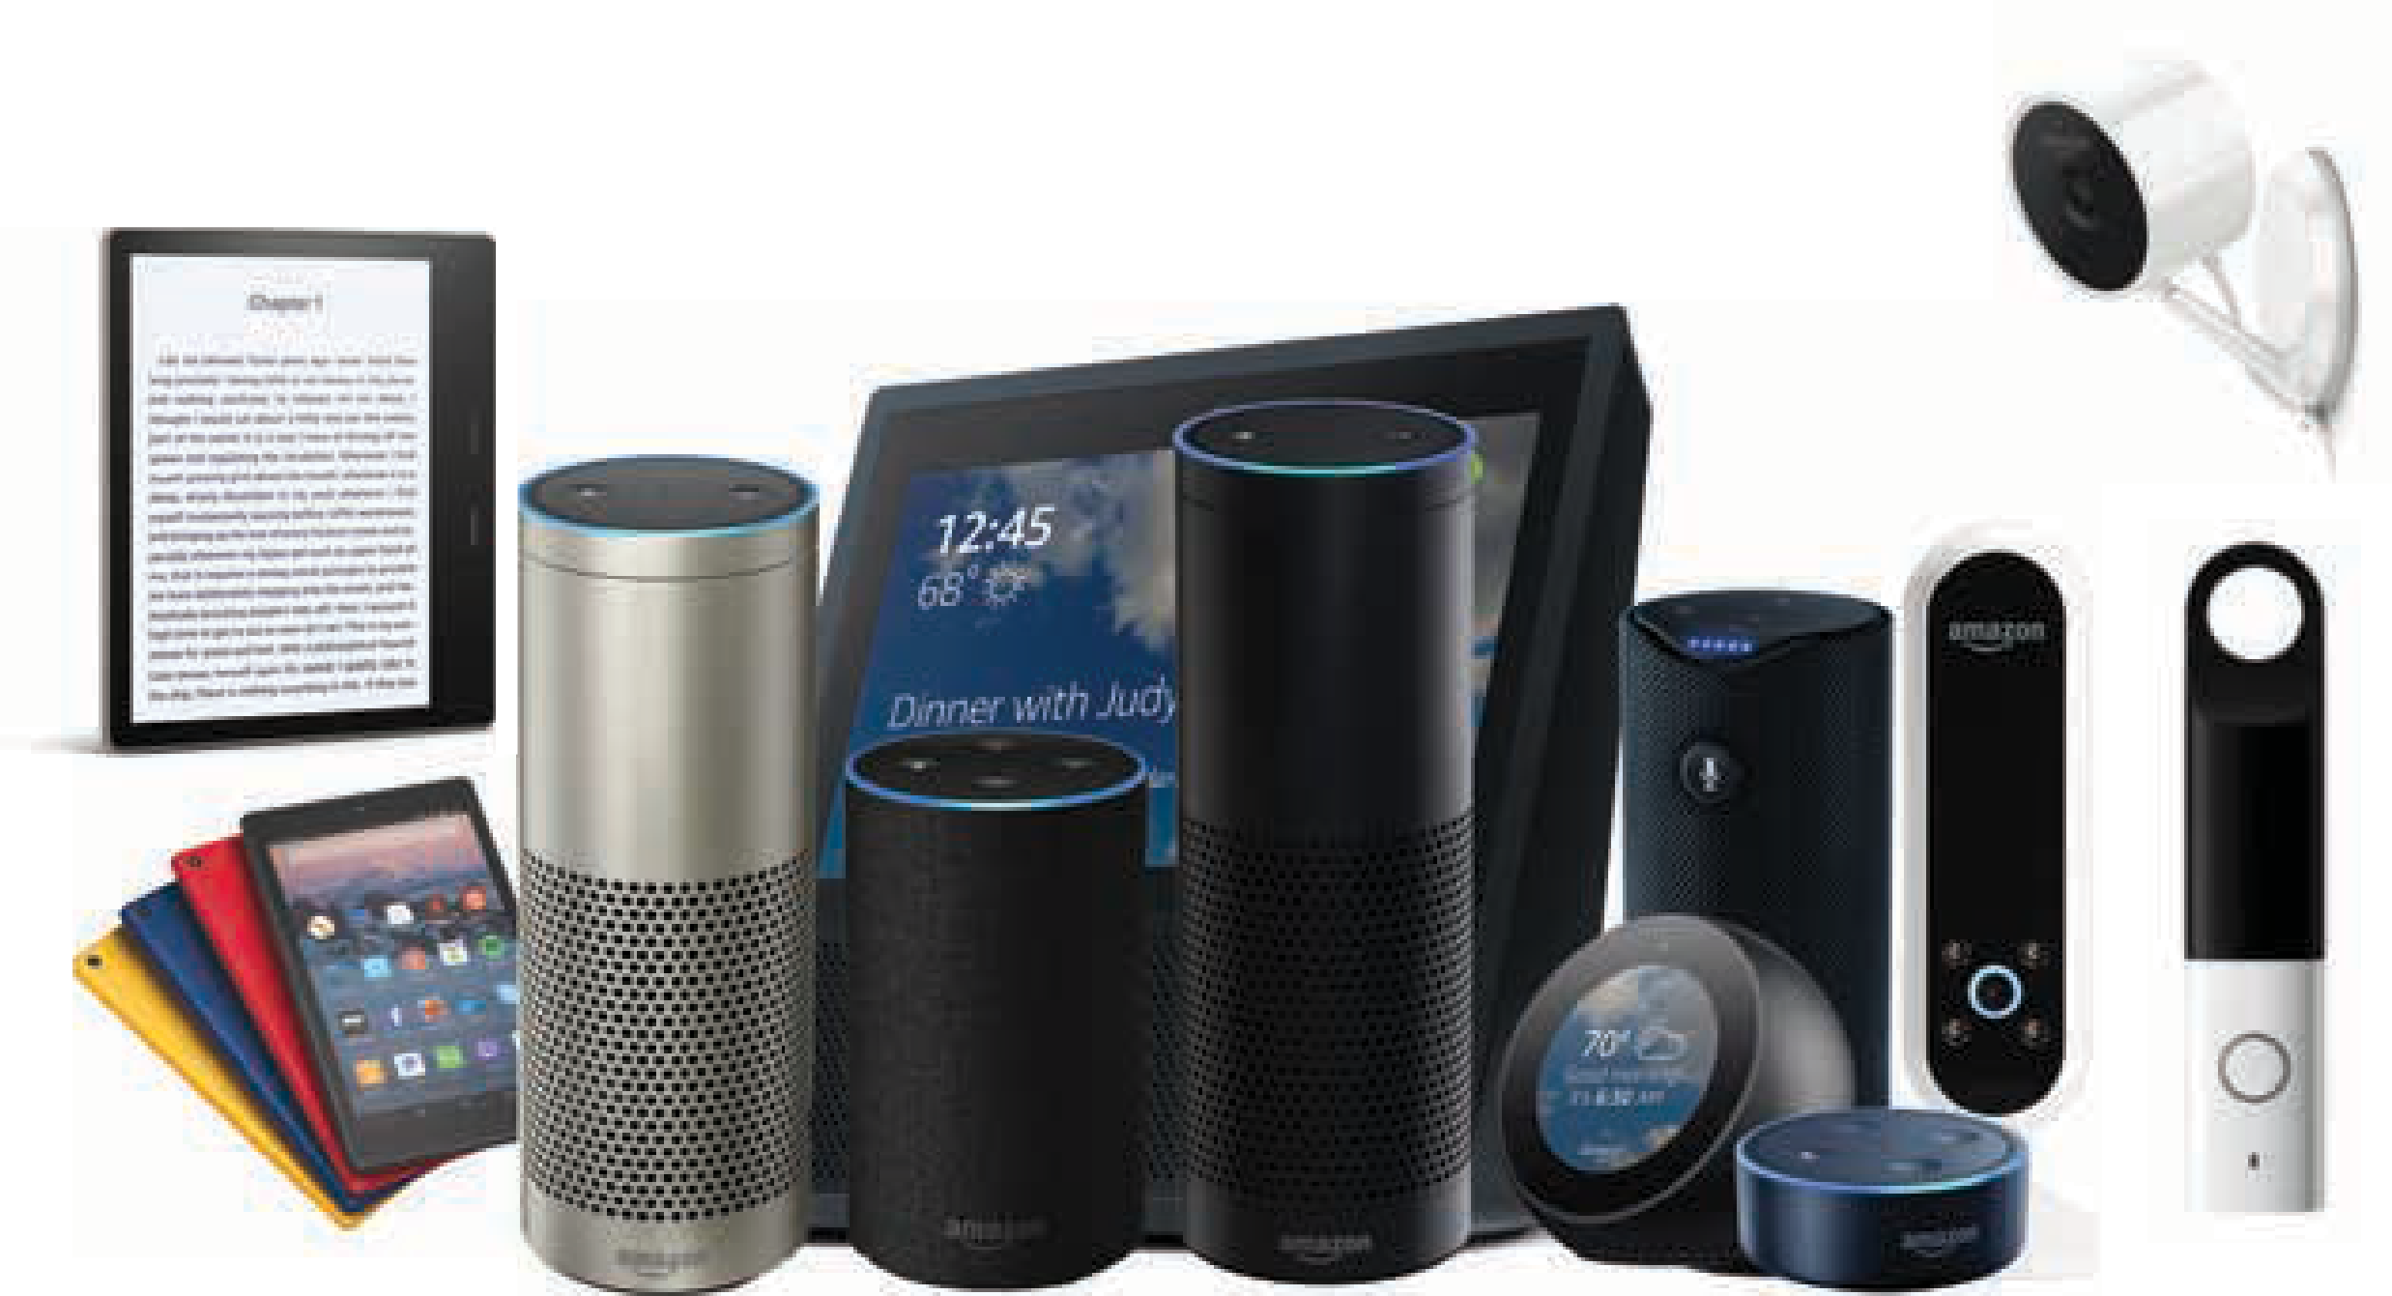

Amazon supports accessible experiences for shopping, reading, and entertainment on any device our customers choose
http://www.amazon.com/accessibility

Charter Communications is proud to support the American Council of the

Blind and its 57th
and Convention.
Annual Conference

By collaborating with the blind and visually impaired community, Charter Communications can enhance technology and service to better meet the needs of all our customers.

© 2018 Charter Communications | policy.charter.com

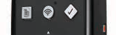
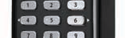
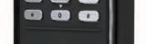
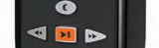
ORIENTATION & ENTERTAINMENT IN ONE MOBILE
PACKAGE

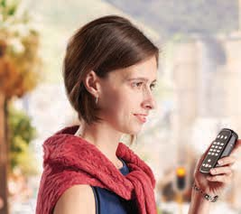
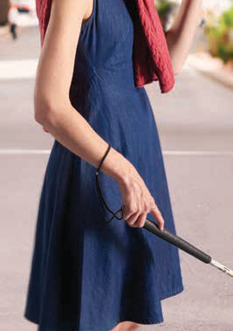
VictorReader Trek
Imagine a device that gives you the best of both worlds: the confidence to get where you’re going easily and the freedom to enjoy entertainment on the go. That’s the magic of the VictorReader Trek, the multiuse handheld device designed to make mobility easy and enjoyable.

Orientation mode
Book reading and playback
The freedom to travel your way

Visit our booth and join us at our Trek user group to learn more about what the VictorReader Trek can do for you.

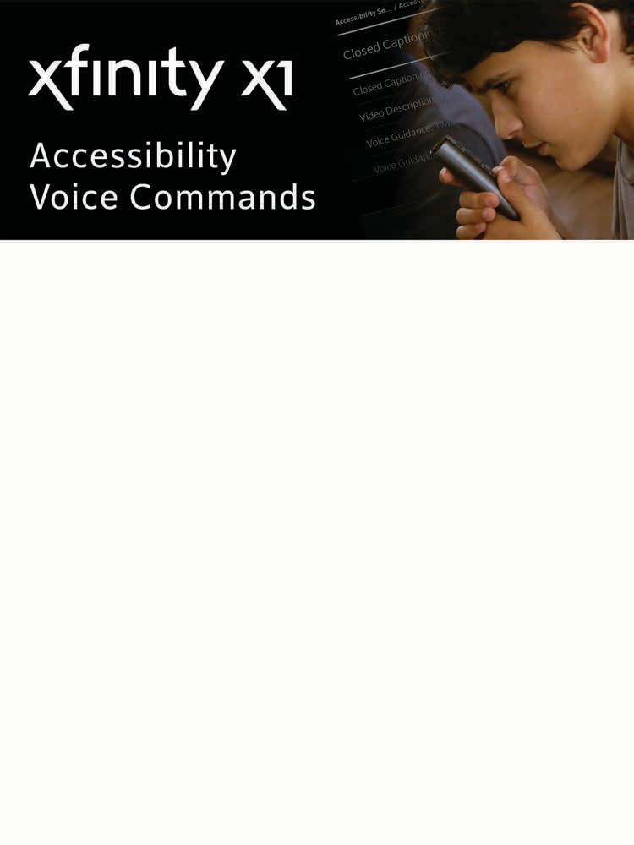
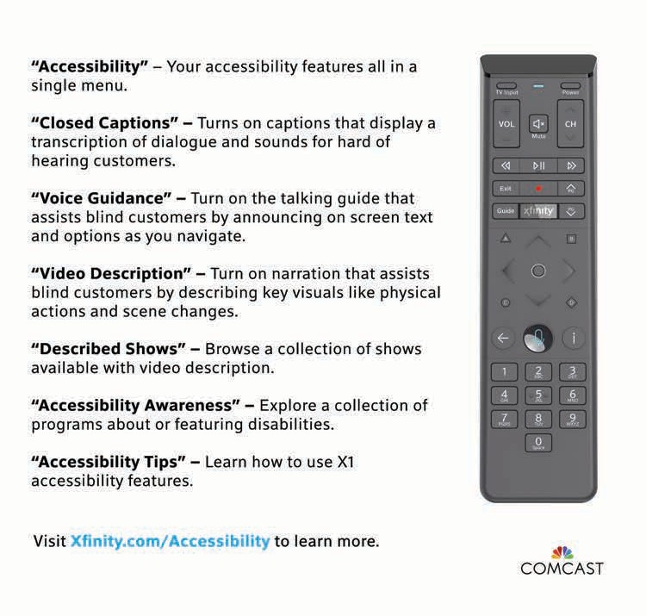

Conference & Convention Calendar..12 Conference Gems 46

President's Message 52

Abbreviations 55

Indoor Navigation 57

ACB Convention Café 58

Registration Information 59

Communication Center Services 66

Digital Information & Internet 71

ACB Photography 73

Medical Information 74

Guide Dog User Information 75

Veterinary Care 77

Religious Activities 78

Convention Standing Rules 79

General Session Agenda 85

ACB Boards & Committees 118

2018 ACB Exhibitors 121

ACB Marketplace 126

ACB Fundraisers 127

Special-Interest Affiliate Meetings 10 ACB Committee Meetings 69
Other ACB Meetings 89
Other Meetings & Programs 91
More Convention Entertainment ... 113 2018 Tours 117
Kids' Explorers Club 134
Board of Directors 138
ACBES 140
ACB Staff and Consultants 140
Convention Coordinating Committee 141 Convention Program Committee... 142 Local Host Committee 143

Special-Interest Affiliate Meetings

American Association of Blind Teachers
President: Susan Glass Program Chair: Carla Hayes Registration: $10, ($12)

Saturday, June 30, New York Central 8:00AM - 10:15AM: AABT
Breakfast/Program/Business Meeting,
$28 ($30)
8:00AM: Welcome, Susan Glass, AABT President, Saratoga, CA. Breakfast.

8:45AM: Food for Thought. Share a book or quote that has shaped your teaching or saved your sanity.

9:30AM: Break

9:35AM-10:15AM: AABT Business
Meeting.

Tuesday, July 3, Midway 7
1:15PM - 2:30PM: Transitioning from High School to College, $5 ($7)
An analysis of effective transition planning for students with disabilities. Presenter, Amber Steet, Student Representative, American Association of Blind Teachers, Kutztown, PA.

American Association of Visually Impaired Attorneys
President: Charles Nabarrete Registration: $38 ($40)

Saturday, June 30, Midway 7 1:15PM – 5:30PM: Program
1:30PM: The role of policy and law in improving the health of disabled people. Presenter: Professor Elizabeth Pendo, Law Professor, St. Louis University School of Law, St. Louis, MO.

2:30PM: A visually impaired attorney working in an Independent Living Center. Presenter: Kimberly Lackey Esq., Paraquad ILC, St. Louis, MO.

4:00PM: Traversing the Legal Academy as a Visually Impaired Law Professor.
Presenter: Professor Cynthia G. Hawkins, Law Professor, Stetson

University College of Law, Tampa Bay, FL.

Sunday, July 1, Midway 7 1:15PM – 5:30PM: Program
1:30PM: Legal update regarding Accessible Information and Web Design. Presenter: Ken Nakata, Esq., Director, Accessibility Consulting Practice, Cyxtera, Seattle, WA.

2:45PM: Presentation by American Printing House, Louisville, KY. Products to enhance the lives of the visually impaired.

4:00PM: Comments from a leading nationally recognized employment

litigator. Presenter: Mary Ann Sedey, Esq., Sedey, Harper, Westhoff, PC, St. Louis, MO.

Monday, July 2, Midway 1 & 2
12:15PM – 4:00PM: AAVIA Luncheon, $32
($35). John Simon, Esq., President of the Metropolitan St. Louis Bar Association, Simon Law Firm, St. Louis, MO.

Tuesday, July 3, 1:15PM
1:15PM - 4:30PM: The Old Courthouse Tour, Dred Scott moot trial (see description under 2018 tours)

Alliance on Aging and Vision Loss President: John Huffman Registration: $10 ($10)

Sunday, July 1, Jeffersonian & Knickerbocker
12:15PM – 2:30PM: AAVL luncheon and business meeting, $34 ($37). Lunch, annual meeting & presentations by Rick and Sandy Troiano, Back into Life Again, helping seniors with disabilities involved in social and recreational activities.

Monday, July 2, Midway 3 & 4 2:45PM - 5:00PM: AAVL/CCLVI Joint
Program - Lighting Your Way to Independence, $7 ($10) (in CCLVI pkg). Strategies for utilizing natural and artificial lighting in your environment.
Following the presentation, adjourn to the CCLVI Suite to learn about the LuxIQ, an assessment tool to assist with measuring

lighting needs for daily tasks. Presenters: Danny Wayne Beemer, Manager, and Dee Dodd, Assistant, Older Blind Program, Wabash Independent Living & Learning Center, Terre Haute, IN.

Tuesday, July 3, FIA Suite
4:15PM - 5:45PM: AAVL Mixer, $12 ($15)
Refreshments, music, conversation and raffles: a friendly atmosphere open to all.

ACB Diabetics in Action President: Dee Clayton Registration: $12 ($15)

Saturday, June 30, Midway 8
1:15PM - 4:00PM: ACBDA Seminar, $8

($10). Can I exchange my insulin pen for a pump? Presenter: April Shinholster Martin, CVRP, Kalamazoo, MI.

Monday, July 2, Executive Director’s Suite 4:15PM – 5:30PM: ACBDA Mixer, $15
($18). Join diabetics and supporters of diabetics for friendly chat and snacks.

Tuesday, July 3, Jeffersonian & Knickerbocker
12:15PM – 2:30PM: ACBDA Luncheon and business meeting, $31 ($33)

American Council of Blind Families
President: Leslie Thom Registration: $8 ($10)

Monday, July 2,
7:00AM – 8:15AM: Breakfast with ACB Families and Alexa, $23 ($28), Regency
B. Whether hosting a game of Jeopardy, ordering dog food, checking the weather, or broadcasting ACB Radio, Alexa (aka the Amazon Echo) has found her way into the homes and hearts of millions. Join ACB Families for our annual business meeting and stick around for fun and games with Alexa. We will demonstrate her more useful and interesting skills, and we will present one of you with an Amazon Echo Dot.

7:15PM – 8:45PM: Bingo – it’s a Families tradition, $7 ($10), Midway 6. Join ACB Families for Bingo. We’ve got braille and

large print cards —and the prizes! All you need to bring is the fun. All ages welcome.

ACB Government Employees President: Renee Zelickson Registration: $10 ($10)

Wednesday, July 4, Midway 7 1:15PM – 2:30PM: ACBGE business
meeting and elections

2:45PM – 4:00PM: Job Readiness Strategies. Learn job readiness skills, strategies on resume writing, and soft skills you’ll need to be an effective employee.

ACB Lions
President: Carla Ruschival Registration: $10 ($12)

Wednesday, July 4
12:15PM – 2:30PM: ACBL Lunch/reverse visit, $35 ($38), New York Central. The Maple Grove Lions Club visits ACB Lions and shares news of its club activities.
ACBL will review the past year, look ahead to 2019, and elect officers.

9:00PM – 11:00PM: Milly's Place Pin Swap, $15 ($18), President's Suite. Share stories about your local Lions Club activities. All Lions, friends of Lions, and anyone interested in becoming a Lion is welcome.

ACB Radio Amateurs
President: John Glass Registration: $5 ($7)

Wednesday, July 4, Jeffersonian & Knickerbocker
1:15PM – 2:30PM: ACBRA program and meeting

American Council of Blind Students
President: Minh Ha
Program Chair: Tamara Lomax Registration: $5 ($7)

Friday, June 29, New York Central 8:00PM – 11:00PM: ACBS Office Hours,

$16 ($18). Mingle with members, friends, & our supporters in an evening full of refreshments & tabletop games!

Saturday, June 30, Midway 10 12:15PM – 1:45PM: ACBS Scholarship
Luncheon, $32 ($35). Join ACB Students & Randolph-Sheppard Vendors of America to celebrate the achievements, success, and future endeavors of our 2018 scholarship winners.

1:45PM – 3:00PM: ACBS business meeting.

Sunday, July 1, Missouri Pacific 1:15PM – 2:30PM: ACBS speed
networking. A swift meet and greet with

the best of ACB! We want to introduce you to friends old and mentors new; who knows, perhaps a professional partnership will ensue!

Monday, July 2, Conductor 1:15PM – 2:30PM: ACBS business meeting.

8:00PM – 11:00PM: ACBS and BPI
Present: Story Slam! $5 ($8), Midway 1 and 2. Unwind, tell us a tale, or simply listen in as others share personal stories meant to entertain, engage and inspire.
Tonight is yours. Cash bar available.

Tuesday, July 3
2:45PM – 4:00PM: Off the Press & At Your Fingertips, $5 ($7), Midway 8. Join ACBS for a discussion of the latest technologies and services for feeding your inner e- bookworm. Special emphasis on newly accessible mainstream solutions.

Wednesday, July 4, Midway 6
9:15PM – 11:15PM: ACBS Comedy Night,
$12 ($15). Join ACBS for a night of laughs – cash bar available. Pre- registration gets you an automatic entry into the drawing for our grand prize. You must be present to win.

Blind Information Technology Specialists

President: Tom Jones
Program Chair: Earlene Hughes Registration: $20 ($20) or BITS Package (all BITS events, $67 ($72))

Saturday, June 30, Midway 9 10:00AM - 12:00PM: Amazon Locker,
Alexa, Kindle, Fire Tablets, Fire TV, and More! Presenter: Peter Korn, Director of Accessibility, Amazon Lab126, Sunnyvale, CA.

1:15PM - 4:00PM: In Your Home and On the Go, Navigating a New Frontier. APH Nearby Explorer and the Indoor Explorer project: Keith Creasy, Programmer and Technical Lead, Louisville, KY. What is New with Victor: Peter Tucic, Brand Ambassador, Blindness Products, Chicago IL. Aira, Instant Access to Information:

Kelly M. Lovett, Director, Aira, San Diego, CA; and Michael Hingson, Director of Active Programs, La Jolla, CA.

Sunday, July 1
12:15PM - 2:30PM: BITS Luncheon (in BITS pkg), $35 ($40), Midway 10.
Product Update from Microsoft: Brett Humphrey, Senior Program Manager, Redmond, WA; and Jeff Bishop, Program Manager, Redmond, WA.

8:00PM - 11:00PM: BITS Mixer (in BITS
pkg), $15 ($20), President’s Suite

Braille Revival League President: Paul Edwards Registration: $10 ($12)

Saturday, June 30, Jeffersonian & Knickerbocker
1:15PM – 2:30PM: BRL Orienteering, $7 ($10). Compete for prizes as you follow clues and answer questions as you go around the hotel. Must be a braille reader and writer to participate.

Monday, July 2
7:00AM – 8:15AM: BRL International Breakfast, $30, ($35), New York Central. Learn how our brothers and sisters from around the world benefit from using, reading and writing braille. Our featured

speaker, Jose Maria Viera, CEO, World Blind Union, Toronto, Ontario, Canada will share braille initiatives from around the world.

1:15PM - 4:30PM BRL program, Midway 9 1:15: Welcome and introductions, Paul Edwards, BRL President, Miami, FL.

1:30: The Uses of Braille:
Explore how braille is now being used and how we can persuade more people to use it. Presenters: Paul Edwards, Miami, FL; Judy Jackson, Stuarts Draft, VA.

2:30: Break

2:45: BRL business meeting

4:15PM – 5:30PM: Games with Ralph, $7 ($10), Midway 9. Use braille to play a number of games; prizes will be awarded. See how good you are at braille and words.

Tuesday, July 3, Midway 9
1:15PM – 4:00PM: LUA/BRL/FIA/IAC
Program
1:15PM: Welcome to the LUA/ BRL/AABT/FIA/IAC Joint Session. Brian Charlson, President, Library Users of America, Watertown, MA; Paul Edwards, President, Braille Revival League, Miami, FL; and others provide a welcome and give those present a chance to introduce themselves.

1:30PM: Braille and the iPhone. Judy Dixon, Consumer Relations Officer, National Library Service for the Blind and Physically Handicapped, Library of Congress, Washington, D.C. This session will feature approaches to reading and writing braille as well as apps for the iPhone that relate to these functions.

2:30PM: Break

2:45PM: Meet the Talking Book Narrator: Get up close and personal with Laura Giannarelli, NLS Talking Book Narrator, Washington, D.C., who presented during the morning ACB general session.

Blind LGBT Pride International
President: Will Burley
Program Chair: Gabriel Lopez Kafati
Registration: $10 ($12), or BPI Pkg (all BPI events including one wine tasting,
$80 ($85))

Saturday, June 30
11:30AM – 3:00PM meet in lobby Bubbles and Mingles. Join BPI’s Board of Directors for brunch! Chat and mingle with directors, members, and friends.
Take advantage of this opportunity to share your thoughts about our organization’s future in an informal setting.

Sunday, July 1

1:15PM – 4:00PM: Matinee with Audio Description: Love Simon, $5 ($7), Midway
8. In this 2018 film, Simon keeps a huge secret from everyone he knows: he's gay. When that secret is threatened, Simon must face the truth about his identity.

4:00PM – 6:00PM: BPI business meeting and elections, Midway 8.

8:30PM: “Show Me” St. Louis with BPI. Off-site event. Meet in BPI Suite. Exciting as always! Full of surprises as usual! “Show Me” St. Louis will take you into town as we mingle and share an awesome time.

Monday, July 2
1:15PM – 2:30PM: BPI Sound Therapy (in BPI pkg), $12 ($14), Midway 8. Visions emerge through sound. The resonant structure and the sound patterns of Pati’s singing bowls will provide an opportunity for the logical mind to recede, thus allowing the brain to shift into deeper states. Presenter: Pati Pellerito LMT, CSH Center of Sound, St. Louis, MO.

2:45PM - 4:00PM: For the White Wine Lover, $20 ($20), BPI Suite. Sparkling to woody; dry to sweet! A Wine Consultant led tasting will give 12 guests an opportunity to learn about, experience and order exclusive, artisan white wines handcrafted and available nowhere else.

The Napa Valley wine tasting lifestyle brought directly to you!

4:15PM - 5:30PM: Mixed Monday: Reds & Whites, $20 ($20), BPI suite. Reds & Whites; Best of Both Worlds. A Wine Consultant led wine tasting will give up to 12 guests an opportunity to learn about, experience and order exclusive artisan wines handcrafted and available nowhere else. The Napa Valley wine tasting lifestyle brought directly to you!

5:45PM - 7:00PM: For the Red Wine Lover, $20 ($20), BPI suite. Lite to oaky; fruity to tannic! A Wine Consultant led tasting will give up to 12 guests an opportunity to learn about, experience

and order exclusive artisan red wines handcrafted and available nowhere else. The Napa Valley wine tasting lifestyle brought directly to you!

8:00PM -11:00PM: ACBS and BPI Present:
Story Slam! (in BPI pkg), $5 ($8), Midway 1 & 2. Unwind, tell us a tale, or simply listen in as others share personal stories meant to entertain, engage and inspire.
Cash bar available.

Tuesday, July 3
1:15PM – 2:30PM: Healing Touch (in BPI pkg), $12 ($14), Midway 8. Expel pain and anxiety through Reiki. This Japanese technique uses your own energy for stress reduction and relaxation. It also

promotes healing. Presenter: Tom Tessereau, Reiki Master, Owner, The Healing Arts Center, St. Louis, MO.

2:45PM - 4:00PM: For the White Wine Lover, $20 ($20), BPI suite. Sparkling to woody; dry to sweet! A Wine Consultant led tasting will give 12 guests an opportunity to learn about, experience and order exclusive, artisan white wines handcrafted and available nowhere else. The Napa Valley wine tasting lifestyle brought directly to you!

4:15PM – 5:30PM: Tuesday Toast: Reds & Whites, $20 ($20), BPI suite. Reds & Whites; Best of Both Worlds. A Wine Consultant led wine tasting will give up to

12 guests an opportunity to learn about, experience and order exclusive artisan wines handcrafted and available nowhere else. The Napa Valley wine tasting lifestyle brought directly to you!

5:45PM - 7:00PM: For the Red Wine Lover, $20 $20), BPI suite. Lite to oaky; fruity to tannic! A Wine Consultant led tasting will give up to 12 guests an opportunity to learn about, experience and order exclusive artisan red wines handcrafted and available nowhere else.

8:00PM - 10:00PM: BPI Audio-Described Movie (in BPI pkg), $5 ($7), Midway 8. “Call Me by Your Name” is an Oscar- nominated film! Northern Italy, summer

1983, a sensual tale of first love.

Wednesday, July 4
1:15PM - 2:30PM: BPI Aroma Therapy (in BPI pkg), $12 ($14), Midway 8. For every ailment, there's an oil. Essential oils are the life force of the plant. These extracts can shield our bodies in the same way they protect the plant. Heal your body through the aromatic energy of essential oils. Presenter: Radiance Float + Wellness, St. Louis, MO.

10:00PM – 1:00AM: Dare to Share (in BPI pkg), $10 ($12), BPI suite. The night falls … secret conversations arise! Share a daring story. Listen to adult jokes. This intimate space will seat a max of 16

guests. Crazy door prizes!

Council of Citizens with Low Vision International
CCLVI: Gateway — Low Vision! President: Leslie Spoone Registration: $20 ($25)
CCLVI Package Price: $99 ($123)

Sunday, July 1
1:15PM - 2:30PM: Low Vision Vendor Showcase, Midway 3 & 4. See what is new as exhibitors demonstrate the latest in low vision technological advances.

4:00PM - 6:00PM: CCLVI Mixer, $15 ($20)
(in CCLVI pkg), President’s Suite. Reacquaint with old friends and meet new

people; meet the 2018 Fred Scheigert scholarship winners.

8:00PM - 11:00PM: Sunday Night Boogie
— Let's Dance, $15 ($20) (in CCLVI pkg) Gothic Corridor. Get down and shake your groove thing as we dance to the beat of music from yesterday and today, provided by ACB’s very own Larry Turnbull. Practice your moves! Door prizes, cash bar.

Monday, July 2, Midway 3 & 4
12:15PM – 2:30PM: CCLVI Luncheon, $35
($38) (in CCLVI pkg). Challenges and Triumphs: A Young Blind Attorney. An aspiring up and coming lawyer discusses overcoming many obstacles, triumphs and

challenges. Learn how she dealt with low vision throughout life and school. Expect
- be empowered - take on your own obstacles. Presenter: Sara J. Conrad, J.D., University of Wisconsin Law School, Fitchburg, WI.

2:45PM - 5:00PM: AAVL/CCLVI Joint
Program - Lighting Your Way to Independence, $7 ($10) (in CCLVI pkg). Strategies for utilizing natural and artificial lighting in your environment.
Following the presentation, adjourn to the CCLVI Suite to learn about the LuxIQ, an assessment tool to assist with evaluation to measure lighting needs for daily tasks.
Presenters: Danny Wayne Beemer, Manager, and Dee Dodd, Assistant, Older

Blind Program, Wabash Independent Living & Learning Center, Terre Haute, IN.

Tuesday, July 3, Midway 3 & 4. 1:15PM - 4:00PM: CCLVI Annual
Membership Meeting, including elections and adoption of proposed constitutional amendments, bylaws and resolutions.

Wednesday, July 4
1:15PM - 2:30PM: Traveling Through the Ages, $7 ($10) (in CCLVI pkg), Midway 3 & 4. Insights in traveling the world with vision loss. Trip planning, setting up guided tours and navigating vast global transit systems. For all ages, low vision
travel will be thoroughly explored.

Presenters: Beth Corley, Food Service Manager, Nashville, TN, Dr. Catherine Schmitt-Whitaker, E.D., Executive Director, Accessible Technology, California State Polytechnic University, Diamond Bar, CA, and Richard Rueda, Consultant, Transition Services, Society for the Blind, Sacramento, CA.

4:00PM - 6:00PM: CCLVI Open House,
CCLVI Suite. Meet our low vision community and share convention experiences in a relaxed social setting.

Friends-in-Art of ACB
President: Lynn Hedl
Program Chair: Nancy Pendegraph

Registration: $12 ($15)

Saturday, June 30, FIA Suite
7:30AM – 9:30AM: FIA Board Meeting

2:45PM - 5:30PM: Showcase Audition and Rehearsal. Visit the suite to sign up and rehearse your number for the FIA showcase.

Sunday, July 1, New York Central
9:00PM – 11:00PM: Prose and Poetry Reading, $6, ($8). Writers are invited to read their original works to a receptive audience. Moderator: Carla Hayes, McMurray, PA.

Monday, July 2
12:15PM — 2:30PM: FIA Luncheon and Business Meeting, $33 ($33), New York Central. Speaker: Judy Redlich, TV/Radio talk show host, speaker, coach and disability advocate, St. Louis, MO. Discover that “It is not what you accomplish, it is learning how to climb out of disappointments and keep marching that makes you a winner.” Hear some of her experiences and discover a few tips Judy uses in moments of disappointment.

2:45PM - 4:00PM: Writers’ Workshop,
$6 ($8), New York Central. Explore the art of creative writing. Use basic exercises to focus on key components used in the construction of fiction, poetry,

and drama. By the end of this program, attendees will be sensitized to some of the major building blocks of creative writing, including dialogue, description, and narration; be able to recognize these techniques in the work of established authors; and be able to apply these techniques to their own writing.
Appropriate for beginning, intermediate, and advanced creative writers. Attendees are encouraged to bring a short sample of their own writing (no more than 250 words) and writing equipment.
Presenter: Dr. Herbert Guggenheim, published novelist and poet, Rockville, MD.

7:30PM – 10:30PM: Showcase of the

Performing Arts, $12 ($15), Regency C. Experience our annual top-quality show, featuring the best talent ACB offers.
Enjoy a drink from the cash bar while you dance to the music of Archway Lights, a band of local blind musicians.

Tuesday, July 3, Midway 9
1:15PM: LUA/BRL/FIA/IAC Program 1:15PM: Welcome to the LUA/ BRAILLE/AABT/FIA/IAC Joint Session. Brian Charlson, President, Library Users of America, Watertown, MA; Paul Edwards, President, Braille Revival League, Miami, FL; and others provide a welcome and give those present a chance to introduce themselves.

1:30PM: Braille and the iPhone. Judy Dixon, Consumer Relations Officer, National Library Service for the Blind and Physically Handicapped, Library of Congress, Washington, D.C. This session will feature approaches to reading and writing braille as well as apps for the iPhone that relate to these functions.

2:30PM: Break

2:45PM: Meet the Talking Book Narrator: Get up close and personal with Laura Giannarelli, NLS Talking Book Narrator, Washington, D.C., who presented during the morning ACB general session.

Guide Dog Users, Inc. President: Penny Reeder Program Chair: Andrea Giudice Registration: $15 ($15)

Quick courtesy reminders from Anders the guide dog: Thanks for reading these, they will make my job so much easier to do! Always keep your guide on a short leash when out and about in the hotel.
Please give us guides a chance to relieve at least twice as often as at home and always pick up after us. I am so embarrassed by what my mom says when she steps in poop! Remember that convention is one of the most stressful working environments for us, so give us every opportunity to be successful!

GDUI Raffle: Remember, Mo, 2018's pick of the litter, can be yours. Get your raffle tickets to win the right to bring home this fabulous plush yellow lab in harness.

GDUI Suite (Barkalounge) hours: The Barkalounge is located in Station Master and is open:
  - Sunday, July 1, noon to 5:00PM.
  - Monday-Tuesday, July 2 - 3, 10:00AM to 5:00PM.
  - Wednesday, July 4, 9:00AM to 12PM. Kick back and enjoy; socialize, purchase cool products, have ears and nails attended to, get your guide a restorative canine massage, and best of all, the lovely Louisville Ladies (Miss Jane and Miss Connie) the queens of the

BarkaLounge, will be there to help. Even if we totally know they are there because of our dogs we are beyond grateful to have them!

To schedule a massage for your guide, during convention, call Carla at (650) 678-0884.

Sunday, July 1
6:45AM - 8:15AM: GDUI Munch Bunch-
Join the pack for a “community run” to Maggie O'Brien's (2000 Market St.) for kibbles and coffee! All are welcome. Meet in hotel lobby.

12:15PM - 1:15PM: Help Your Dog Adjust to Convention Life, Regency A. Presenter:

Becky Barnes Davidson, Consumer Outreach, Guiding Eyes for the Blind, Yorktown Heights, NY. First convention? Back after a long time? This is for you.
Get tips on dealing with the relief areas, other guide teams, canes, finding help, and conquering convention chaos!

1:15PM - 2:30PM: GDUI Hotel Orientation, meet in GDUI Suite. Note: For guide dog users only. Learning the hotel layout will reduce stress. Hotel orientation provided by guide dog school staff and trained volunteers.

3:00PM - 4:15PM: Aira - Through the Looking Glasses, Regency A. Presenter: Prof. Nicholas A. Giudice, Ph.D.,

University of Maine, Orono, ME.
Accessing visual information when/where you need it! Longtime Aira user and scientific advisor discusses how it works, pros and cons, answers questions, and provides a live demonstration.

4:30PM - 5:30PM: GDUI board meeting and annual report, Regency A.

7:00PM – 9:00PM: GDUI Live Auction!!
Regency A. Where to be Sunday evening? The GDUI Live Auction, of course! It will have all the things you love about auctions - a vast array of items to encourage bidding battles, a cash bar … don't miss the fun!

9:00PM-11:00PM: Talent Unleashed! Regency A. Are you a singer, musician, comedian, something else? Well come and strut your stuff at the GDUI open mic event. Oh yes, if it helps, there is a cash bar!

Monday, July 2
6:45AM - 8:15AM: GDUI Munch Bunch-
Join the pack for a “community run” to Maggie O'Brien's (2000 Market St.) for kibbles and coffee! All are welcome.

7:30AM - 8:30AM: GDUI Hotel Orientation, meet in GDUI suite. For guide dog users only. Learning the hotel layout will reduce stress. Hotel orientation provided by guide dog school staff and trained volunteers.

1:15PM - 5:30PM GDUI program, Regency A 1:15PM - 2:30PM: Welcome,
Introductions, and Announcements. Give a quick intro for yourself and your dog, learn which friends have returned for another year, and hear important announcements regarding the GDUI convention.

2:45PM - 4:00PM: Guide Dog School Tales. Right from the dog's mouth!
Hear from guide dog school representatives about how they do what it is that we are so grateful they do!

4:15PM - 5:30PM: Guides – from Down Under to the Great White North.

Presenter: Marc Gillard, Orientation & Mobility Services Manager, Guide Dogs for the Blind, San Rafael, CA. Marc Gillard has worked in the guide dog field for 26 years. Originally from Australia, he received a graduate diploma in Orientation and Mobility from La Trobe University, Melbourne.
Mark has worked in more countries than can be listed. What stories this international phenom will have!

6:30PM - 7:45PM: Canine Massage Techniques ($10-$12), Regency A. Presenter: Carla Campbell, Quadrassage, Menlo Park, CA. Carla, a professional canine massage therapist and long-time guide dog handler, has massaged over

200 guides at conventions since 2001. Helping guides cope with convention chaos is always the highlight of her year. Sign up soon for this hands-on workshop. Limit 20.

Tuesday, July 3
6:45AM - 8:15AM: GDUI Munch Bunch -
Join the pack for a “community run” to Maggie O'Brien's (2000 Market St) for kibbles and coffee! All are welcome.

1:15PM – 5:30PM: GDUI program,
Regency A
1:15PM - 2:30PM: Days of our dogs. Presenter: To Be Announced.

2:45PM - 4:00PM: Doctor who says

what? Presenter: Veterinarian- To Be Announced.

4:15PM - 5:30PM: Legal Beagle. Presenter: To Be Announced

Wednesday, July 4, Regency A
12:15PM - 2:30PM: GDUI Lunch, speaker, & awards presentation, $33, ($35).
Speaker: Paul L. Mimms, MSW, Kansas City, MO. A navy veteran, an innovative leader, and a fierce advocate for change on the local and national level.

2:45PM - 4:00PM: Tips and Tricks. Presenter: To Be Announced

4:15PM - 5:30PM: GDUI Business Meeting & Caucus

Independent Visually Impaired Entrepreneurs
President: Ardis Bazyn Program Chair: Carla Hayes Registration: $6 ($8)

Saturday, June 30, Midway 1 & 2 10:00PM-12:00AM: RSVA/IVIE Mixer
$20, ($25).

Tuesday, July 3
12:15PM - 2:30PM: IVIE Luncheon/
Program/Business Meeting, $34, ($37), Missouri Pacific
12:15PM: Welcome - Ardis Bazyn, Burbank, CA.

1:00PM: “From Employee to

Entrepreneur,” Advantages and disadvantages of moving from a job to having your own business. Mitch Pomerantz, Independent ADA Consultant/Trainer, Pasadena, CA.

1:40PM: Business Meeting

2:45PM-5:30PM: IVIE Business Expo, Wabash Cannonball. Blind and visually impaired business owners showcase their products and answer your questions.

Library Users of America President: Brian Charlson Registration: $10 ($12)

Sunday, July 1
1:15PM – 4:00PM: LUA program, Midway 9 1:15PM: Welcome and Introductions: Brian Charlson, President, Library Users of America, Watertown, MA.

1:25PM: Initiatives and Issues at NLS Karen Keninger, Director, National Library Service for the Blind and Physically Handicapped, Washington, DC.

2:30PM: Break

2:45PM: Exciting Activities at the Wolfner Library. Presenter: Donna Riegel, Library Director, The Wolfner Braille and Talking Book Library, Jefferson City, MO.

3:15PM: Business meeting and elections

5:45PM – 7:00PM: New Approaches from Familiar Places, $7 ($10), Midway 9.
Judy Dixon, Consumer Relations Officer, National Library Service for the Blind and Physically Handicapped, Library of Congress, Washington, D.C., will discuss and demonstrate BARD Express from NLS and speakers to be announced will outline recent developments at Bookshare and Learning Ally in this session jointly moderated by Brian Charlson, Watertown, MA, and Paul Edwards, Miami FL.

Tuesday, July 3, Midway 9
1:15PM – 4:00PM: LUA/BRL/FIA/IAC
Program

1:15PM: Welcome to the LUA/ BRL/AABT/FIA/IAC Joint Session. Brian Charlson, President, Library Users of America, Watertown, MA; Paul Edwards, President, Braille Revival League, Miami, FL; and others provide a welcome and give those present a chance to introduce themselves.

1:30PM: Braille and the iPhone. Judy Dixon, Consumer Relations Officer, National Library Service for the Blind and Physically Handicapped, Library of Congress, Washington, D.C. This session will feature approaches to reading and writing braille as well as

apps for the iPhone that relate to these functions.

2:30PM: Break

2:45PM: Meet the Talking Book Narrator: Get up close and personal with Laura Giannarelli, NLS Talking Book Narrator, Washington, D.C., who presented during the morning ACB general session.

Randolph-Sheppard Vendors of America (RSVA®)
President: Dan Sippl Convention Chair: Scott Eggen
ACB Program Liaison: Ardis Bazyn Registration: $20 ($20)

RSVA Package (all RSVA events, $130 ($140))

Friday, June 29, Midway 1 & 2
9:00PM – 12:00AM: Members only mixer

Saturday, June 30
10:00AM – 12:00PM: RSVA Board
meeting, Conductor

1:30PM - 5:30PM: RSVA Program, Midway 1 & 2. Celebrating fifty years of achievement and advocacy.
1:30PM: Welcome, Dan Sippl, RSVA President, Eau Claire, WI.

1:35PM: Roll call of affiliates: Donna Seliger, RSVA Secretary, West Des Moines, IA.

1:40PM: First reading of Constitution and Bylaws and Resolutions

1:55PM: "All about the Missouri Business Enterprise Program." Panel 1: Missouri BEP vendors. Panel 2: Brenda Manasco, Assistant Supervisor, Missouri Business Enterprise Program.
Speakers discuss how RSVA works in Missouri.

2:40PM: Thinking outside the box to grow your profits: Moderator Michael Talley, RSVA Convention Committee Member, Hueytown, AL.

3:10PM: Break

3:25PM: History of Randolph-Sheppard Vendors of America: Panel -
National Challenges to Randolph- Sheppard.

4:15PM: Strategic plan to strengthen RSVA. Moderator: Randy Hauth, RSVA Board Member, Portland, OR.

5:00PM: RSVA nominating committee

10:00PM – 12:00AM: RSVA/IVIE Mixer
$20 ($25), Midway 1 & 2. Join RSVA & IVIE for fun and refreshments. Everyone welcome!

Sunday, July 1
12:15PM – 5:30PM RSVA 50th

Anniversary Awards Luncheon, Midway 1 & 2. Speaker: Jennings Randolph Jr., St. Louis, MO.

2:45PM - 5:30PM: RSVA business meeting

7:30PM – 8:45PM RSVA Comedy Night
$15 ($20), Midway 10. Laugh with comedian David Graham.

9:00PM – 12:00AM: RSVA Karaoke (in
RSVA pkg), $15 ($20), Midway 10

Monday, July 2

6:15PM – 12:00AM: RSVA Casino Night
$25 ($28). Join RSVA for an evening of fun at Lumiere Place Casino; all are welcome.

Visually Impaired Veterans of America
President: David Dowland Registration: $10 ($10)

Tuesday, July 3, Conductor
12:15PM – 2:30PM: VIVA luncheon and business meeting, $31 ($33)
ACB Committee Meetings

Audio Description Project
Chair: Joel Snyder
Program Chair: Jo Lynn Bailey-Page

Sunday, July 1, Midway 6
1:00PM – 6:00PM: Audio Description Project Conference. Get the most out of the ADP website; audio description in St. Louis; the latest on the 21st Century

Communications and Video Accessibility Act. Hear from representatives from Charter Communications, Comcast, Actiview, Amazon, Fox and the FTC. End the session with "mentorship" program: sighted attendees will be paired with a blind or visually impaired mentor.

Monday, July 2, Midway 6
1:30PM – 4:45PM: Audio Description Project Conference. The National Park Service and Audio Description. Are you a CAD (Certified Audio Describer)? Learn all about certification from a panel of experts.

Tuesday, July 3, Midway 6
1:00PM – 6:00PM: Audio Description

Project Conference. Guest speaker; 2018 ACB-ADP Awards presentation; a panel of professionals discuss audio description in the classroom and beyond; evaluations of excerpts from audio-described films.

Wednesday, July 4, Midway 1 & 2
Thursday, July 5, Midway 1 & 2
Friday, July 6, Midway 1 & 2
9:00AM – 4:00PM: Audio Description Institute

DKM First-Timers Committee
Chair: Kenneth Semien Sr.

Wednesday, July 4, President's Suite 5:30PM – 7:00PM: DKM First-Timers Reception & Reunion Celebration, $15

($18). Join the July 4th party! A reunion of DKM First-Timers celebrating the legacy of ACB’s founding father, Durward
K. McDaniel, will be a captivating experience.

Environmental Access Committee
Chair: Becky Barnes Davidson

Saturday, June 30, Midway 5
2:45PM – 5:30PM: Riding Uber, Lyft, Cab or Something Else: Where are we with autonomous vehicles and Aira? New ride services are launching almost daily. A panel of ACB members, including Robyn Wallen, St. Louis, MO, and Gail Wilt, Phoenix, AZ, will share the pros and cons

of services like Uber, Lyft, taxicabs and a service called GoGoGrandparent. Next, will get an update on what is happening with autonomous vehicles and Aira from a panel discussion by Anthony Stephens, ACB Director of Advocacy & Governmental Affairs, Alexandria, VA; an industry representative; and Paul W. Schroeder, Director, Public Policy and Strategic Alliances, Aira, Washington,
D.C. Co-sponsored by EAC and Transportation Committee.

Information Access Committee
Chair: Brian Charlson

Saturday, June 30, Regency A
1:15PM – 4:00PM: 411 from the IAC $5

($7). Learn from Brian Charlson, Director of Technology, The Carroll Center for the Blind, Watertown, MA how to use Zoom Cloud Meeting to conduct meetings and webinars with any or all your members, whether they are Windows, iOS, Android or Mac users, not to mention all of those who find using a simple phone works for them. You will also learn from Larry Turnbull how to take full advantage of ACB Link on your iPhone or, if things work out between now and the ACB Conference and Convention, on an Android phone.

Sunday, July 1
5:45PM – 7:00PM: New Approaches from Familiar Places. $7 ($10), Midway 9.
Judy Dixon, Consumer Relations Officer,

National Library Service for the Blind and Physically Handicapped, Library of Congress, Washington, D.C., will discuss and demonstrate BARD Express from NLS. Speakers to be announced will outline recent developments at Bookshare and Learning Ally in this session jointly moderated by Brian Charlson, Watertown, MA and Paul Edwards, Miami, FL.

Tuesday, July 3, Midway 9
1:15PM – 4:00PM: LUA/BRL/FIA/IAC
Program
1:15PM: Welcome to the LUA/ BRAILLE/AABT/FIA/IAC Joint Session. Brian Charlson, President, Library Users of America, Watertown, MA; Paul Edwards, President, Braille

Revival League, Miami, FL; and others provide a welcome and give those present a chance to introduce themselves.

1:30PM: Braille and the iPhone. Judy Dixon, Consumer Relations Officer, National Library Service for the Blind and Physically Handicapped, Library of Congress, Washington, D.C. This session will feature approaches to reading and writing braille as well as apps for the iPhone that relate to these functions.

2:30PM: Break

2:45PM: Meet the Talking Book Narrator: Get up close and personal with Laura Giannarelli, NLS Talking Book Narrator, Washington, D.C., who presented during the morning ACB general session.

International Relations Committee
Chair: Sandra Sermons

Monday, July 2, Regency B
12:15PM –2:30PM: Voices from Around the World Luncheon, $30 ($35). Welcome our international guests, and plan for our future.

Leadership Institute Committee

Chair: Cindy Van Winkle

Saturday, June 30, Midway 6 4:00PM - 5:15PM The Leadership Junction, $6 ($8). Take part in the
Leadership Institute as together we share how to stay on the express track to success and leave with tools for a smooth post-election transition.

Membership Committee
Chair: Ardis Bazyn

Saturday, June 30, Regency A 6:00PM – 7:00PM: Keys to the Convention. ACB invites all first-time participants and those who have not attended a convention recently for an

overview of convention week. After the session, join the membership committee and attend opening general session.

Wednesday, July 4, Midway 5 2:45PM – 4:00PM: 2018 Membership
Seminar: "Using the best features of ACB to build membership."
2:45PM: Welcome and Introductions 2:55PM: Panel: "How Can your Purpose, Mission, and Vision Increase Your Membership?" Speakers: Kim Charlson, Watertown, MA; George Holliday, Philadelphia, PA; John Huffman, Indianapolis, IN.

3:20PM: Panel: "How Can Advocacy — Self-Advocacy and Group Advocacy —

Strengthen your Membership?" Speakers: Jeff Thom, Sacramento, CA; Jim Kracht, Miami, FL; David Dowland, Tulsa, OK.

3:45PM: ACB Membership Growth Awards Announcement.

3:55PM: Hand-outs and door prizes

Multicultural Affairs Committee
Chair: Peggy Garrett

Sunday, July 1, New York Central 12:15PM – 1:15PM: MCAC Luncheon, $33
($33). The MCAC theme this year is "What Is the Message of America.” The luncheon keynote speaker is Jose Maria Viera, CEO, World Blind Union, Toronto, Canada.

1:30PM – 2:30PM: MCAC afternoon program. MCAC’s afternoon program features a panel of individuals of diverse ethnicities from various geographical locations, focusing on the theme “What Is the Message of America.” Panelists include: Michael Alvarez, Portland, OR; Lisa Brooks, ACB Families, Phoenix, AZ; Wilma Chestnut, St. Louis, MO; and Minh Ha, ACB Students, Brighton, MA.

Tuesday, July 3, President’s Suite 5:00PM – 6:15PM: Mid-week Social, $18
($20). This is an opportunity to relax and socialize with old friends and meet new folks. Join us for fun, food, music and door prizes.

Rehab Issues Task Force
Chair: Doug Powell

Sunday, July 1, Midway 5 2:45PM – 5:30PM: Program
2:45PM: Pre-Employment Services: residential and public schools, rehab agencies, students and employers compare programs/results.

4:15PM: Residential and Public-School Partnership: How public-school—based TVI programs utilize schools for the blind resources.

Scholarship Committee
Chair: Denise Colley

Friday, June 29, Frisco
6:30PM – 8:00PM: ACB Scholarship Dinner (by invitation only). Sponsored by RSVA.

Saturday, June 30, Midway 10 12:15PM – 1:45PM: ACBS Scholarship Lunch, $28 ($32). Join ACB Students &
Randolph-Sheppard Vendors of America for a celebratory meal to honor the achievements, success, and future endeavors of our 2018 scholarship winners. Glimpse the future of ACB!

Monday, July 2
9:15AM: 2018 ACB Scholarship Presentations, Grand Ballroom

5:45PM – 7:00PM: ACB Scholarship

Winners' Reception, President’s Suite. Each affiliate is invited to send two representatives to meet the 2018 scholarship winners.

Sight and Sound Impaired Committee
Chair: Karyn Campbell

Sunday, July 1, Executive Director’s Suite 8:00PM – 10:00PM: Get Social with SASI
$13 ($15). Meet people who share your unique issues and learn various ways to communicate in a relaxed atmosphere.

Monday, July 2, Midway 7
2:45PM – 4:00PM: How to Connect with I Can Connect $8 ($10). Learn the latest from Missouri I Can Connect (ICC) and get information on alerting systems for

those with dual sensory loss. Presenter: Brenda Whitlock, Missouri Deaf-Blind Equipment Distribution, Blue Springs, MO. Program Coordinator TAP for Internet/iCanConnect (Deaf/Blind)

Special Education/Schools for the Blind Task Force
Chair: Debbie Grubb

Sunday, July 1, Midway 5 2:45PM – 5:30PM: Program
2:45PM: Pre-Employment Services: residential and public schools, rehab agencies, students and employers compare programs/results.

4:15PM Residential and Public-School Partnership: How public-school—based TVI programs utilize schools for the blind resources.

Transportation Committee
Chair: Alice Ritchhart

Saturday, June 30, Midway 5
2:45PM – 5:30PM: Riding Uber, Lyft, Cab or Something Else: Where are we with autonomous vehicles and Aira? New ride services are launching almost daily. A panel of ACB members, including Robyn Wallen, St. Louis, MO, and Gail Wilt, Phoenix, AZ, will share the pros and cons of services like Uber, Lyft, taxicabs and a service called GoGoGrandparent. Next,

will get an update on what is happening with autonomous vehicles and Aira from a panel discussion by Anthony Stephens, ACB Director of Advocacy & Governmental Affairs, Alexandria, VA; an industry representative; and Paul W. Schroeder, Director, Public Policy and Strategic Alliances, Aira, Washington,
D.C. Co-sponsored by EAC and Transportation Committee.

Voting Task Force
Chair: Jeff Thom

Saturday, June 30, Midway 5
1:30PM – 2:30PM: Remote Voting Task Force Conversation: Findings and Group Discussion. Mock election results,

constitutional amendments and process changes. Jeff Thom, Sacramento, CA; Mitch Pomerantz, Pasadena, CA; Patrick Sheehan, Silver Spring, MD; Kim Charlson, Watertown, MA.

Women's Concerns Committee
Chair: Lori Scharff

Wednesday, July 4
7:00AM - 8:15AM: Sister Power Breakfast, $27($30), Midway 10. Susan Glass, Saratoga, CA, and Ellen Telker, Milford, CT, tell us about their lives as women who are blind. Both are energetic members of ACB and lead active lives in their home communities.

5:45PM – 7:00PM: Yoga and Pilates with Leslie Spoone, Missouri Pacific. AFAA Certified Aerobics Instructor Leslie Spoone, Orlando, FL, will show beginners and work with advanced students on yoga and Pilates. This event is co-sponsored by the Recreation Zone and Women’s Concerns Committee.

Other ACB Meetings

Saturday, June 30
11:00AM – 12:00PM: ACB Committee
Chairs Meeting, Midway 5. An important meeting with ACB President Kim Charlson. Every committee should be represented, either by its chair or a designated committee member.

5:30PM – 6:30PM: ACB Exhibitors Reception (by invitation only), President's Suite

Wednesday, July 4, Midway 6
4:15PM – 5:30PM: Affiliate Presidents' Meeting

1:15PM – 4:00PM: Advocacy Boot Camp, Midway 6. Mobilizing campaigns to leveraging social media, learn the ins and outs of being an effective grassroots advocate. This hands-on workshop is led by Tony Stephens, ACB's Director of Advocacy & Governmental Affairs, and Claire Stanley, ACB's Advocacy & Outreach Specialist.

Other Meetings and Programs

Career Development

Monday, July 2, Regency C
7:00AM – 8:15AM: Guide Dogs for the Blind Alumni Breakfast. GDB grads connect with friends and staff; those considering the guide dog lifestyle welcome.

Tuesday, July 3, Regency B
7:00AM – 8:15AM: NIB Breakfast $10 ($15). Join National Industries for the Blind for a discussion about employment and the AbilityOne program.

Advocacy Issues

Sunday, July 1, Regency C
7:00AM - 8:15AM: AFB Breakfast $10 ($12). The American Foundation for the Blind (AFB) cordially invites you to attend its annual breakfast meeting.

Technology

Saturday, June 30, Midway 1 & 2 9:00AM — 11:00AM: VFO User Group
Meeting. For JAWS and ZoomText customers from the past, present, and future. Join Eric Damery and Scott Moore to discuss all the special Home Use pricing opportunities for ACB membership. Demonstration of major

feature changes and interesting options in JAWS and ZoomText to improve your day to day access on the Internet, email, and applications from Office 365 and Google Docs.

10:00AM - 11:00AM: Finally, Something New in a Braille Display! Midway 7. Join HIMS for a comprehensive review of braille display technology.

11:00AM - 12:00PM: APH session, Midway 3 & 4. Highlighting a number of our most popular products, including the latest on the Orbit Reader 20, the first truly affordable braille display. We will demonstrate some of the coolest features of the Graphiti, our multi-line graphing

braille display, and our talking graphing calculator, the Orion TI-84. We'll show off the Matt Connect, developed through our partnership with HumanWare, and see our handheld video magnifier, the Video Mag HD, developed with our partners at VFO. We'll highlight some low-tech gadgets as well. Plenty of opportunities for Q & A.

2:00PM - 3:15PM: Microsoft Accessibility, Grand A. Microsoft's commitment to accessibility is that we will create and deliver technology that is accessible and functional for all people, while we push the boundaries of what technology can do to empower every person on the planet.
In line with our guiding principles to be

transparent, hold ourselves accountable, and grow an inclusive culture, this session will highlight where we are on this journey and how customer feedback has impacted products in market today.
We will demonstrate how you can use Narrator and the other Microsoft Ease of Access features today to collaborate with colleagues and friends in Office apps like Forms and OneNote. Bring your questions about Microsoft accessibility and leave this session with skills you can put to use today. Presenter: Crystal Jones, Accessibility Escalation Engineer

3:30PM – 4:45PM: Microsoft Accessibility Office Hours, Grand A. Questions about Microsoft accessibility? Want hands-on

experience with the latest Microsoft technology? This is your opportunity to speak with Microsoft’s Disability Answer Desk. Hosted by Crystal Jones and Jeff Bishop.

Sunday, July 1
4:15PM - 5:30PM: Microsoft Accessibility in Windows, Grand A. The Windows Team will share accessibility features in Windows 10, including features recently introduced in the April Update.
Presenter: Brett Humphrey, Senior Program Manager.

4:15PM - 5:15PM: Google Home & Assistant, Grand B & C. Speaker: Kiran Kaja. Join us for updates on new features

in Google Home and Google Assistant, and learn about new products that run the Google Assistant.

5:30PM - 6:30PM: Google G Suite Accessibility Updates, Grand B & C. Speaker: Roger Benz. Come learn about accessibility updates to G Suite apps over the past year, including Google Calendar, Drive, Docs, Gmail, and more.

5:45PM - 7:00PM: HumanWare BrailleNote Touch/Brailliant BI14, Midway 3 & 4. The BrailleNote Touch is the first and only Google-certified Braille tablet that blends powerful and intuitive apps for managing, accessing and creating information from KeySoft with

millions of apps that can be downloaded from the Google Play Store. Join us as we review new features such as full QWERTY support, the ability to directly emboss graphics, as well as the implementation of one-handed operation in addition to many new and exciting features. We will also have the opportunity to discuss the much anticipated Brailliant BI14, which is now shipping. Time will also be set aside for your questions and feedback.

5:45PM – 7:00PM: Microsoft Accessibility Office Hours, Grand A. Questions about Microsoft accessibility? Want hands-on experience with the latest Microsoft technology? This is your opportunity to speak with Microsoft’s Disability Answer

Desk. Hosted by Crystal Jones and Jeff Bishop.

Monday, July 2
9:00AM - 5:00PM: JPMorgan Chase & Co. sessions, (by appointment only), Link.
JPMorgan Chase & Co. is committed to meeting the banking and financial services needs of all our customers.
Members of our digital team will be on site to show you how we make digital products accessible and usable by all. We would like your input on our mobile banking app. For this study, we are seeking iPhone Voice Over users. In
these sessions of 1-1 user testing, we will ask you to complete common banking tasks on the Chase app using test devices

to get your feedback. The study will not require you to log into your personal phone. Your personal information will remain protected. Sessions are expected to last one hour. To attend one of the sessions, contact Marc Kwok at Marc.Kwok@chase.com.

2:45PM - 4:00PM: Android and Chrome OS Accessibility Updates, Grand B & C. Join members of the Google accessibility team to learn about some of the recent accessibility updates on Android phones and tablets, as well as on Chromebooks.

4:15PM - 7:00PM: Microsoft Soundscape Training, Grand A. Microsoft Soundscape uses 3D audio technology to enhance

your awareness of what is around you, and thereby help you get around and explore your surroundings. Soundscape will place audio cues and labels in 3D space such that they sound like they are coming from the direction of the points of interest, parks, roads and other features in your surroundings. We will split this session into two parts. Part one will provide an overview of Soundscape and describe the thinking and rationale behind the experience that is designed to enable people, particularly those with blindness or low vision, to build a richer awareness of their surroundings. Part 2 will consist of a hands-on training session on how to use Soundscape and get the best out of it in a range of different

scenarios and settings. All that is required is an iPhone 5S and above with the Soundscape app and a pair of stereo headsets that you feel comfortable wearing outdoors. Presenter: Amos Miller.

5:45PM - 7:00PM: HumanWare "What is new with Victor? A Trek/Stream discussion," Midway 3 & 4. Success of the Victor Reader Trek and Stream marches on into 2018! Join HumanWare at the annual Stream User Forum. Share stories and tips on downloading and playing back books and periodicals.
Learn what is new with both the Stream and Trek. Includes demonstrations of new features; time for Q & A.

Tuesday, July 3
9:00AM - 5:00PM: JPMorgan Chase & Co. sessions, (by appointment only), Link.
JPMorgan Chase & Co. is committed to meeting the banking and financial services needs of all our customers.
Members of our digital team will be on site to show you how we make digital products accessible and usable by all. We would like your input on our mobile banking app. For this study, we are seeking iPhone Voice Over users. In
these sessions of 1-1 user testing, we will ask you to complete common banking tasks on the Chase app using test devices to get your feedback. The study will not require you to log into your personal phone. Your personal information will

remain protected. Sessions are expected to last one hour. To attend one of the sessions, contact Marc Kwok at Marc.Kwok@chase.com.

1:00PM – 5:00PM: Charter
Communications Testing, Midway 1,
(by appointment only). Visit the Charter Spectrum team and give feedback on our Spectrum TV Video App for iOS with VoiceOver. This app allows our video customers to take their live TV and On Demand experience anywhere. Contact us at DL-UsabilityTesting@charter.com if you would like to participate. Include the best way to reach you to schedule your session. Participants will receive a fun gift in exchange for participation.

5:45PM — 7:00PM: Bookshare office hours, New York Central. Hear about the latest Bookshare updates; get answers to your Bookshare-related questions.

Wednesday, July 4
4:15PM – 5:30PM: Accessibility at Apple – Innovating for All, Regency B. For more than 30 years, Apple has provided new and innovative accessibility solutions, allowing all users to access and enjoy interacting with the Mac, iPhone, iPad, Apple Watch and other Apple technology. Apple includes groundbreaking assistive technology in its products (such as VoiceOver and Zoom), as standard features, at no additional cost. Find out more about how Apple’s award-winning

technology is changing the way people live their lives.

Self-Improvement

1Touch Self Defense, $12 ($15), Missouri Pacific. Designed specifically for the blind; real-life situations with practical applications. Hands-on workshops open to all:
Sunday, July 1 and Monday, July 2 5:45PM – 7:15PM: 1Touch Self Defense (beginner level).

7:30PM – 9:00PM: 1Touch Self Defense (intermediate level-must have completed a beginner level class).

Medical Advances

Saturday, June 30
9:00AM - 11:00AM: Second Sight, Midway
8. For the first time, Second Sight Medical Products, global leader in artificial vision and creator of the Argus 2 Retinal Prosthesis System, will be presenting at this year's ACB National Convention in St. Louis, MO. Hear about the latest developments in artificial vision speak to company representatives and users of the technology. Find out how this technology has helped hundreds of profoundly blind people. Second Sight will also be available in the exhibit hall to answer any questions you may have.

Monday, July 2
4:15PM - 5:30PM: Accessible Prescriptions Labels — Past, Present and Future, Midway 7. Join En-Vision America’s Amanda Tolson as she takes you through the long history of accessible prescription labels and where it is headed. Joining will be Jamie Revelle from Express Scripts Pharmacy to discuss the importance of pharmacies offering accessible prescriptions labels.

5:45PM - 6:15PM: Express Scripts: On a Journey to Inclusivity, Midway 7. Express Scripts provides integrated pharmacy benefit management services. Serving more than 83 million Americans, they make practicing pharmacy smarter so

that better health is more affordable and accessible. Jamie Revelle, User Experience Research & Accessibility Lead, will describe how a focus on the belief that “good accessibility is better usability for all” is shaping Express Scripts’ journey to improved inclusivity.

6:45PM - 7:30PM: Talking Bar Codes — Why an App Just Doesn’t Cut It, Midway
7. Join En-Vision America’s Amanda Tolson as she explores why phone apps are not always the answer to quality information from bar codes. Learn how data is important and the bar code is just a means to the information.

Tuesday, July 3
4:15PM - 5:15PM: Passing Accessible Prescription Laws in Your State, Midway
- NV ACB President, Rick Kuhlmey is calling all state and chapter presidents who are ready to take the next step to making changes to your state laws. Understand what was involved in making accessible prescriptions the law in NV. Come away from the national convention with a plan and even get a jump start on writing your state's resolution.

5:30PM - 6:00PM: Accessible Prescription Advocacy, What Can I Do?, Midway 7.
Calling all advocates! Are you passionate about helping yourself or other people?
Have you always wanted to demo

accessible prescription labels? Join En- Vision America’s Sharla Glass to get set up as a ScripTalk Ambassador, apply for a demonstration kit, and take your advocacy efforts to the next level.

Special Notice 1: En-Vision America to all ACB Members: Accessible Prescription Testimonials. If you’re a user of ScripTalk, ScriptView or Braille prescription labels, we want to hear from you! Would you like to share your experiences with accessible prescription labels in a new En-Vision America video? Schedule a 10-minute videotaped interview session. A release waiver must be signed; you will receive a $10 Visa gift card. Call June Robbins at (941) 348-

5925 or email her at jrobbins@envisionamerica.com. Limited spots available; interviews will be scheduled on Monday and Tuesday between 9:00AM and 3:30PM.

Special Notice 2: Express Scripts is conducting a usability study focused on improving the accessibility of their member website and mobile app. Participants will walk through tasks and provide feedback regarding the experience. Individual sessions will last about an hour and are by appointment only, Monday, July 2nd and Tuesday, July 3rd. To schedule an appointment contact Jamie Revelle, (314) 475-7186 (ext. 327186), or email jrevelle@express-scripts.com.

Miscellaneous:
Bureau of Engraving. The Raised Tactile Feature Project (RTF) will be testing an RTF prototype and we are looking for volunteers to provide feedback on this prototype for future U.S. currency. Each participant will be assigned an individualized appointment time lasting approximately 60 minutes. Individuals will be compensated $50 for their time.
Sign up at the BEP booth, contact Kim Jarvi at kjarvi@mitre.org, or call (703) 983-0686.

More Convention Entertainment

You will be ready for a break and a little fun after all those workshops, seminars

and business meetings. Below are some activities and events that take place at the hotel. For more fun ideas, see 2018 Convention Tours, the Recreation Zone, and the agendas of the many affiliates and groups for more mixers, luncheons and parties.

Friday, June 29, Regency C

8:00PM - 11:00PM: Meet Me in St Louis.
$10 ($12) Let’s get this party started! Timbuktu Band, featuring Steve Schnelle. Music from the '60s to Present
— Classic Rock to Modern Country; snacks and cash bar. Hosted by the Missouri Council of the Blind.

Sunday, July 1, Midway 6
8:00PM – 10:30PM: ACB Double Feature “Dealt” and “NCIS.” “Dealt,” an award- winning, audio-described documentary, features Richard Turner, a master Card Mechanic-Manipulator, popular stage entertainer and Fortune 500 motivational speaker. In 2014 he won the coveted "Close-up Magician of the Year" award.
His skill with a deck of cards has been repeatedly featured on worldwide television. Oh, by the way, Turner is blind. “NCIS” – ACB is pleased to have consulted on the development of the character Annie, a blind attorney played by actress Marilee Talkington on “Sight Unseen,” episode 350 of NCIS. View both

with audio description and meet Richard and Marilee.

Wednesday, July 4

7:00PM – 9:00PM: Regency B: ACB Audio- Described Film, $7 ($10). Join Joel Snyder for the audio-described screening of the Academy Award-winning best picture “The Shape of Water.” At a top- secret research facility in the 1960s, a lonely janitor forms a unique relationship with an amphibious creature that is being held in captivity. Starring Academy Award nominee Sally Hawkins and directed by Academy Award winner Guillermo del Toro. Popcorn and soft drinks included!

2018 Tours

Important Tour Information: Please read the following information completely. It will answer many of your tour related questions and will help you have a more enjoyable tour experience.
  - All tour buses will load and drop off at the 20th Street entrance of the hotel.
  - Bus departure times for each tour are listed in this program. Please be at the bus departure area and ready to board the bus 15 minutes prior to the listed departure times. Arrival times back to the hotel are approximate.
  - The first two rows of seats on both

sides of the bus are reserved for the tour coordinators, volunteers and people with mobility difficulties. If you sit in those seats, you will be asked to move.
  - All buses are fully ADA-equipped. If you have mobility difficulties or use a wheelchair that requires the lift to access the bus, you MUST check the appropriate boxes on the pre- registration form for us to plan the necessary accommodations. If you can transfer from a wheelchair into a bus seat, your chair will be placed under the bus for the duration of the ride.
  - Indoor facilities are air-conditioned unless indicated, but many tours

include significant outdoor time. Dress appropriately and bring sunscreen, insect repellent, hat, and water bottle for your comfort and safety.
  - Space is limited on all tours. ACB reserves the right to cancel a tour should ticket sales fall below required minimums. Tickets will be collected at the bus. Buses will not be delayed while forgotten tickets are retrieved.
  - All return times are approximate. If you have dietary scheduling concerns, bring a light snack in case we are unavoidably delayed. We ask that you board the bus quickly and safely to avoid delays. We plan 15

minutes to load and unload the bus. Please do not schedule back-to-back events based upon the return time of the tour, as we cannot plan for traffic and road condition delays.
  - A limited number of volunteers will accompany each tour. While they will help as much as possible, ACB volunteers are not personal guides or personal care attendants. If you need individual help, plan to attend the tour with a friend who can provide the assistance you need. If you use a wheelchair, you must have someone on the tour with you to push your wheelchair!
  - Most tour destinations are ADA- accessible. Some tours that are NOT

ADA-accessible may include long walks, steps and steep grades.
Please communicate your questions or concerns ahead of time.
  - Some tours may involve strenuous activities. If you have a medical condition that may limit your involvement or participation, please let us know ahead of time and use common sense when making your selections.
  - The tour leader will have a list of all paid attendees and the waiting list for each tour. The leader will be stationed at the door of the bus to take your ticket and record your attendance. Please do not board the bus until the tour leader has

completed this task.
  - If registration for a tour exceeds its capacity, a waiting list is created based on the date and time your order was placed. If you are on a waiting list, you will be asked to stand in a designated area to wait for your name to be called. If you are not present when your name is called, the next person on the waiting list will be called to fill that seat. You may not give your place on the waiting list to another person.
  - If you arrive late with a ticket, or your name has already been called from the waiting list, your ability to secure a seat will be entirely dependent on the number of vacant

seats remaining on the bus. No one who has a ticket or has answered the call from the waiting list will be asked to give up their seat.
  - If there is no waiting list, or if the waiting list has been satisfied, any remaining vacant seats will be sold to walk-up traffic. Such vacant seats will be sold for cash only – a ticket will not be issued. To purchase, you must have a valid name badge, a day pass for the current day or other proof of registration. If you have paid for and are issued a tour ticket and do not appear at the designated time and place, no refund will be made. If you are on a waiting list and are not able to get on the bus,

the tour leader will report this to the registration office and you will be able to secure a refund the next day after the tour. Should you not be present at the convention the day after the tour, or if the convention has ended, please call the Minneapolis office by July 31st to arrange for a refund via check or credit card.

Friday, June 29
7:30AM - 4:00PM: The St. Louis Arch,
$58 ($61). The 630-ft. St. Louis Arch, constructed in 1965, is the best-known landmark in Missouri. At the top, rangers will describe the arch and discuss its history. Spend time in the arch museum,

experience audio-described exhibits, and view a film about the building of the arch. The tour includes a narrated lunch cruise down the Mississippi River. Note: This tour has 80 steps and is not wheelchair- or walker-accessible. Groups with guide dogs may need to be split up for the trip to and from the top.

5:00PM - 10:30PM: Take me out to the ball game!, $67 ($70). At the beautiful Busch Stadium, the St. Louis Cardinals will host the Atlanta Braves. If you grew up listening to Cardinals and Braves games, here's your chance to see them in person. Your ticket does not include a meal; but there are numerous concession stands with a variety of food. The game

will be broadcast on radio station KMOX 1120AM.

Saturday, June 30
8:15AM - 3:30PM: Busch Stadium and Cardinals Museum, $35 ($38). Hear about the rich history of the Cardinals and the Busch family. Visit the press box, the luxury clubs and a section of stadium seats. Become an announcer and try on a World Series ring. Opportunities for souvenir shopping. If time permits, lunch will be on your own at one of the restaurants in Ballpark Village.

10:00AM – 11:30AM: City bus tour with a twist, $18 ($21). Travel by trolley on your guided tour of St. Louis! Immerse

yourself in the rich culture and history of the city. The trolley seats are wooden, and you will feel some bumps as you ride along; however, it is well worth it!

Sunday, July 1
12:45PM - 7:45PM: Blues Museum, $64 ($67). If you enjoy music or history, you'll love the tour of the Blues Museum! Music and memorabilia from the 1920s to the present; docents talk about all the museum has to offer. Afterwards, feast on St. Louis style BBQ. While having dinner there will be a blues concert with cash bar.

1:00PM – 2:30PM: City bus tour with a twist, $18 ($21). Travel by trolley on

your guided tour of St. Louis! Immerse yourself in the rich culture and history of the city. The trolley seats are wooden, and you will feel some bumps as you ride along; however, it is well worth it!

3:30PM – 5:00PM: City bus tour with a twist, $18 ($21). Travel by trolley on your guided tour of St. Louis! Immerse yourself in the rich culture and history of the city. The trolley seats are wooden, and you will feel some bumps as you ride along; however, it is well worth it!

Monday, July 2
12:15PM - 5:00PM: The St. Louis
Botanical Gardens, $64 ($67). Touch the statuary and smell the scents of these

glorious gardens. Visit the Middle Eastern garden, the Japanese garden, and much more. Tour will include lunch and a narrated tram ride through the various gardens. To get the full effect, there is a walking tour of approximately 1 mile.
This is an outdoor venue and could be quite hot; bring sunscreen, a hat and lots of water!

1:00PM - 4:30PM: The Missouri School for the Blind, $35 ($38). Visit the recording studio, recreation area and the library.
Tour some of the classrooms and the dormitories. Staff will tell us about the school and its history.

5:15PM - 11:15PM: The Muny, $95 ($98).
The Muny is an outdoor amphitheater celebrating its 100th anniversary. First, a backstage tour — hear descriptions and touch many of the costumes, props and scenery. After dinner, relax outdoors for an audio-described performance of "Singin' in the Rain," a story of three actors in the '20s dealing with deception, misunderstandings and love in the emerging film industry. Lots of song, dance and drama!

6:15PM – 12:00AM: RSVA Casino Night,
$25 ($28). Join RSVA for an evening of fun at Lumiere Place Casino; all are welcome.

Tuesday, July 3
12:15PM - 3:50PM: Sweet Tooth Tour, $25 ($28). Chocolate Chocolate Chocolate is famous for its hand-made milk chocolate, dark chocolate, caramels, and truffles.
See how candy is made, get 5 free samples, and have plenty of time for shopping.

1:15PM - 4:30PM: The Old Courthouse Tour, $24 ($27). Built in 1849, this courthouse still has the original judge's bench and tables for the plaintiff and defendant. Tour the building and experience a mock trial of the first Dred Scott decision with members of AAVIA acting as judge, attorney and defendant.

2:45PM - 8:30PM: Anheuser-Busch Brewery, $57 ($60). Begin in the two gift shops featuring everything beer and horse related — there is something for everyone! Then spend an hour with the iconic Clydesdale horses — pet these magnificent animals and take lots of pictures! Then it is on to our brewery tour; learn about the history of Busch beer, and have several tasting opportunities.

12:15PM - 2:00PM: Historic Union Station,
$8 ($11). Tour our hotel, the former Union Station, full of history and railroad memorabilia. A must for train lovers and history buffs.

1:00PM – 2:30PM: City bus tour with a twist, $18 ($21). Travel by trolley on your guided tour of St. Louis! Immerse yourself in the rich culture and history of the city. The trolley seats are wooden, and you will feel some bumps as you ride along; however, it is well worth it!

Friday, July 6
5:30AM - 7:00PM: Mark Twain Adventure,
$132 ($135). Visit Hannibal, the birthplace of Mark Twain. Walk through the labyrinth cave featured in Twain’s books. Visit the homes of Becky Thatcher, the Judge and Tom Sawyer, including the famous white picket fence! Re-enactors join us as we visit these nostalgic places. Then it is on to the Mark Twain museum

and a trip on a paddlewheel boat down the mighty Mississippi River. Lunch included, plus lots of great gift shops.

7:30PM - 10:45PM: Haunted History Tour,
$65 ($68). Dinner at Morgan's Brew Pub with a presentation by Dave Riordan, a history buff and storyteller. Dave will regale us with tales about haunted happenings in St. Louis.

Kids and Families: Kids’ Explorers Club
Bring the kids (ages 5 to 13) for a great week of tours and fun in the Kids’ Explorers Club. Each day will include breakfast, lunch, games, crafts, swimming and a daily field trip. Open

Saturday from 6:30PM until 9:00PM, Sunday through Thursday from 7:00AM to 5:00PM, and Thursday evening 6:30PM – 9:00PM.

Participants must register and pay the convention administrative fee before attending any events.

Discounted tickets for events may be purchased on the pre-registration form.

The Rules, Please Read: Parents must accompany kids to their first Kids’ Explorers Club event to sign required permission forms. Necessary medications must be supplied each day. Kids’ Explorers Club cannot accept participants

who are medically fragile. Parents will be expected to remove children who exhibit uncontrollable or highly inappropriate behavior.

Have questions? Contact Janet Dickelman, ACB Convention Chair, at (651) 428-5059.

Kids’ Explorers Club Activities, Frisco Saturday, June 30
6:30PM – 9:00PM: Kids' Explorers Club. Meet Kids' Club leaders and play games. Snacks included.

Sunday, July 1

7:00AM – 5:00PM: Kids’ Explorers Club
$15 ($20). St. Louis Zoo

Monday, July 2

7:00AM – 5:00PM: Kids’ Explorers Club
$15 ($20). St. Louis Science Center

Tuesday, July 3

7:00AM – 5:00PM: Kids’ Explorers Club
$15 ($20). City Museum

Wednesday, July 4

7:00AM – 5:00PM: Kids’ Explorers Club
$15 ($20). Grant’s Farm

Thursday, July 5

7:00AM – 5:00PM: Kids’ Explorers Club
$15 ($20). Gateway Arch

6:30PM: Kids’ Explorers Club farewell party at the Hard Rock Café.

ACB Board of Directors

President: Kim Charlson, Watertown, MA First Vice President: Dan Spoone,
Orlando, FL
Second Vice President: John McCann, Tucson, AZ
Secretary: Ray Campbell, Glen Ellyn, IL Treasurer: David Trott, Talladega, AL Immediate Past President: Mitch Pomerantz, Pasadena, CA

Directors
Jeff Bishop, Kirkland, WA Denise Colley, Lacey, WA

Sara Conrad, Madison, WI Dan Dillon, Hermitage, TN
Katie Frederick, Worthington, OH George Holliday, Philadelphia, PA Allan Peterson, Horace, ND
Doug Powell, Falls Church, VA Patrick Sheehan, Silver Spring, MD Jeff Thom, Sacramento, CA

ACB Board of Publications Ron Brooks, Chair, Phoenix, AZ Donna Brown, Romney, WV Paul Edwards, Miami, FL
Susan Glass, Saratoga, CA Debbie Lewis, Seattle, WA

ACB Enterprises and Services Directors
Michael Garrett, Chair, Missouri City, TX Mike Godino, Malverne, NY
George Holliday, Philadelphia, PA Carla Ruschival, Louisville, KY Dan Spoone, Orlando, FL
Jeff Thom, Sacramento, CA David Trott, Talladega, AL

ACB Office Staff and Consultants
Eric Bridges, Executive Director
Anthony Stephens, Director of Advocacy and Governmental Affairs
Claire Stanley, Advocacy and Outreach Specialist
Kelly Gasque, Executive Assistant and Multimedia Design Specialist

Sharon Lovering, Editor, The ACB Braille Forum
Nancy Marks Becker, Chief Financial Officer
Lori Sarff, Human Resources and Administration
Nancy Christine Feela, Reception and Administration
Lane Waters, Accounting Consultant Tom Tobin, Director of Development Jo Lynn Bailey-Page, Grant Writer
Larry Turnbull, ACB Radio, IT Consultant

2018 Convention Coordinating Committee
Janet Dickelman, Chair, St. Paul, MN Margarine Beaman, Austin, TX
Sally Benjamin, Tallahassee, FL

Danielle (D.J.) McIntyre, Loganville, GA Rick Morin, Waltham, MA
Vicky Prahin, Columbus, OH Michael Smitherman, Jackson, MS Rhonda Trott, Talladega, AL
Kim Charlson, Officer Liaison, Watertown, MA
Lane Waters, Liaison, Minneapolis, MN

2018 Convention Program Committee
Kim Charlson, Chair, Watertown, MA Janet Dickelman, St. Paul, MN
Judy Dixon, Arlington, VA Karen Gourgey, New York, NY Chris Gray, St. Louis, MO John McCann, Tucson, AZ Naomi Soule, St. Louis, MO

Dan Spoone, Orlando, FL
Eric Bridges, Staff Liaison, Alexandria, VA

2018 Local Host Committee
Jesuita Payne Tabor, Chair, St. Louis, MO Peggy Barred-Smith, St. Louis, MO Denny Huff, St. Clair, MO
Chris Gray, St. Louis, MO Mike Keller, St. Louis, MO Sheri Keller, St. Louis, MO Naomi Soule, St. Louis, MO

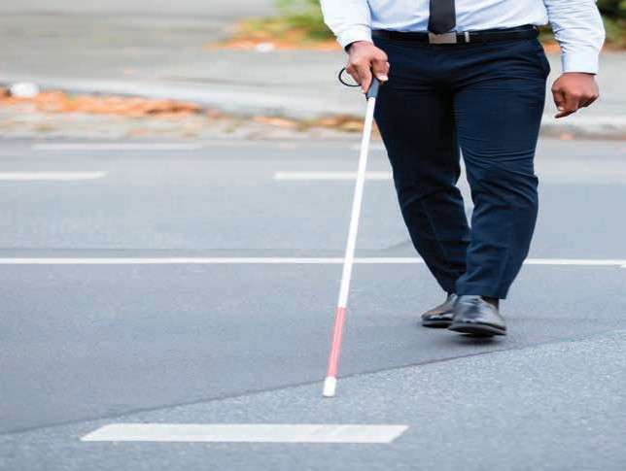

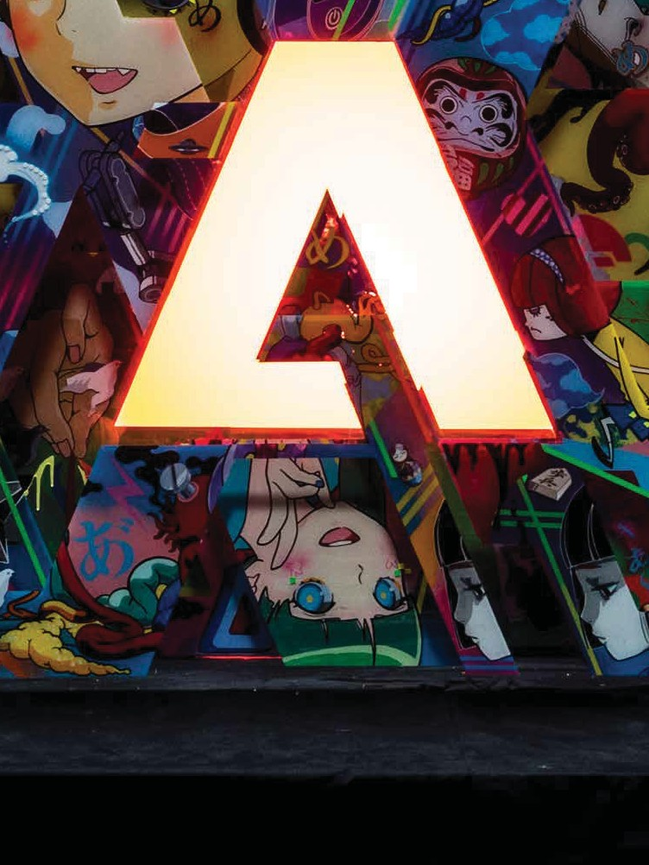
The American Council of the Blind meets people who are blind where they are, and values each and every person for their individual accomplishments.

Adobe congratulates the American Council of the Blind on a successful year and on their 2018 convention.
Learn more about Adobe accessibility at Adobe.com/Accessibility

Adobe and the Adobe logo are either registered trademarks or trademarks of Adobe Systems Incorporated in the United States and/or other countries. © 2017 Adobe Systems Incorporated. All rights reserved.
Verizon proudly supports the ACB National Conference, a critical piece of the ongoing fight for inclusion.

© 2018 JPMorgan Chase & Co.

Commitment to
Access and Inclusion

We proudly support the American Council of the Blind in developing innovative education, technology and training programs that create pathways to independence and success for their constituents.

Cisco at ACB 2018
Committed to accessibility at work
Cisco is proud to sponsor the 2018 American Council of the Blind Annual Conference and Convention.

This year, working in close collaboration with ACB, Cisco introduced the first fully accessible IP telephone for blind and vision-impaired individuals in the workplace. The Cisco 8800 Series IP Phone allows users to easily dial, answer, hold, transfer, and use conference calling features with confidence through the use of voice prompts, with no special software needed.

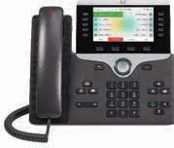
Cisco is proud of our close working relationship with ACB. We are committed to delivering an intuitive, accessible experience across our portfolio of collaborative devices and services.

Visit the Cisco Booth to try it yourself

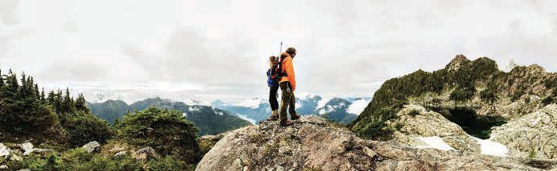
Copyright © 2018 Cisco and/or its affiliates. All rights reserved.

