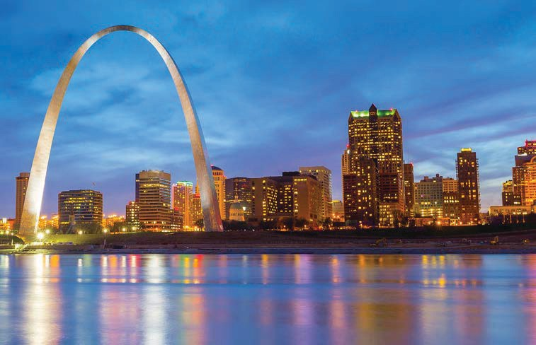
ACB – Gateway to Success
57th Annual National Conference & Convention American Council of the Blind and Special-Interest Affiliates

Union Station Hotel, St. Louis, MO June 29 – July 6, 2018

Kim Charlson, President Hosted by Missouri Council of the Blind
Denny Huff, President

LARGE PRINT VOLUME 1

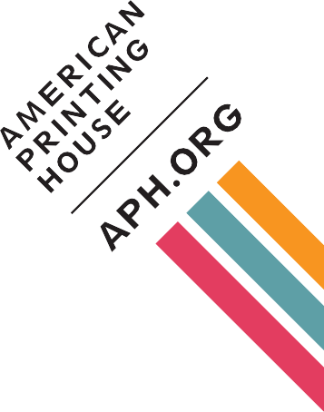
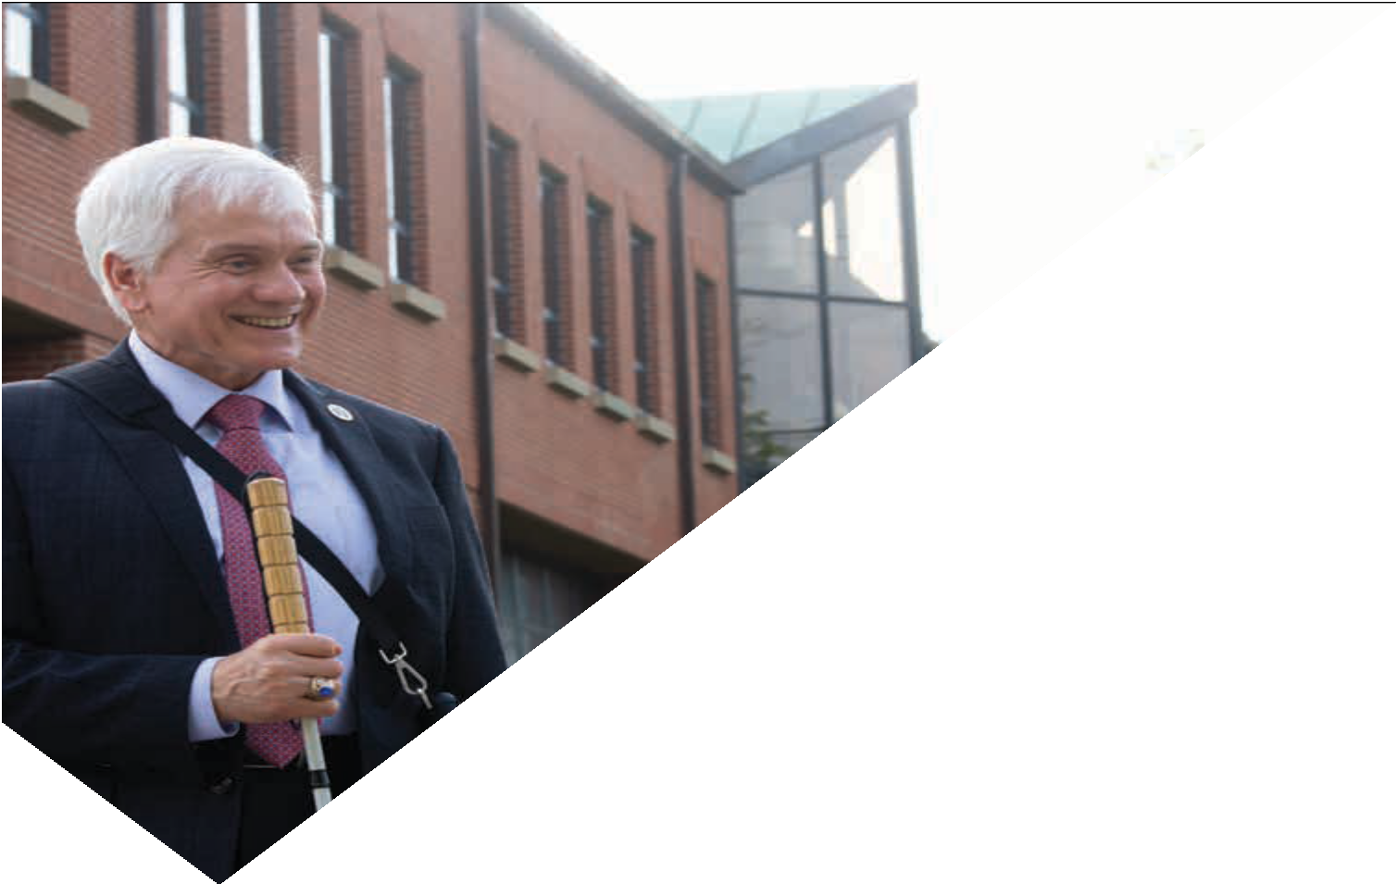
The way we see it,
every day is
independence day.
You grew up
APH
products and we’re still
here for you. We have
for all stages
of life, and you can
learn about them here
at the conference.
WELCOME EVERYONE.
using
products

The American Council of the Blind would like to thank

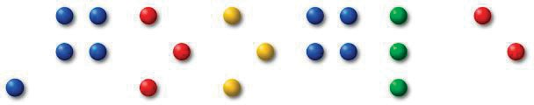

for supporting our

2018 Conference and Convention as a
Double Diamond Sponsor

New Worlds Ateraan
Have you ever read a book and wondered what it would be like to play one of the characters?
Choose your destiny in this intense world of adventure. Live life as a swashbuckling sea farer, become a merchant, a religious cleric, a knight, a daring thief, or learn magic and mysticism as a druid, shaman, or mage.
These roles and dozens of others are available to you in this beautifully scripted world where the environment is dynamic, dangerous, and exciting.
New Worlds Ateraan – where Fantasy and Reality become one.

www.ateraan.com

gm.com ©2017 General Motors. All rights reserved.
EQUAL ACCESS FOR ALL.

General Motors proudly supports the American Council of the Blind and your annual convention. As a leader
in autonomous vehicle development, our goal is to create mobility solutions that are accessible to anyone and provide benefits for everyone.

Convention Highlights
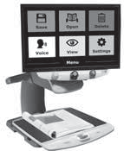
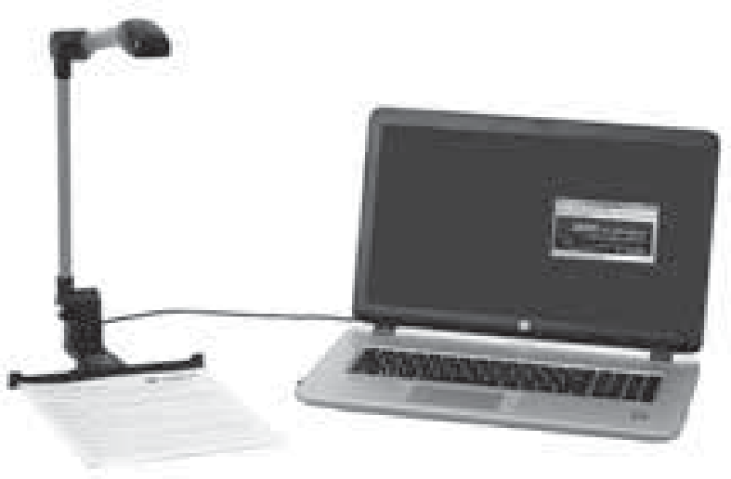
ElBraille 40 Windows® 10 Notetaker with JAWS and Focus Blue
- Access to your favorite Oﬃce® applications • 17-20 hour battery life
- WiFi, Bluetooth® 4.2, 4G and LTE protocols • GPS, Sim Card port, USB and HDMI
Home Use Program
- Signiﬁcant discounts on software
- 20% discount on all hardware
PEARL® Camera
- Compatible with JAWS 2018, Fusion 2018, and OpenBook 9
- Motion sensor to detect new pages for multi-page scanning
- Scan 20 pages per minute while reading
TOPAZ OCR
We’re a proud sponsor of the ACB National Convention
- Magniﬁes and reads aloud any document
- 24-inch touchscreen display with brilliant images

1-800-444-4443

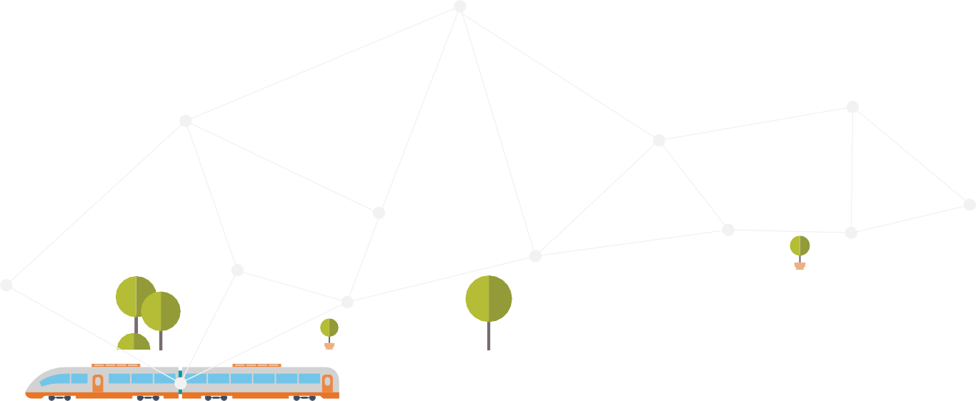

Power of you

We believe in promoting accessible and assistive technologies for all and are proud to support the
American Council of the Blind
57th Annual Conference and Convention.

© 2018 AT&T Intellectual Property. All rights reserved.

WE ARE PROUD TO NOW OFFER THE
SONY ENTERTAINMENT ACCESS SYSTEM
AT REGAL THEATRES NATIONWIDE.

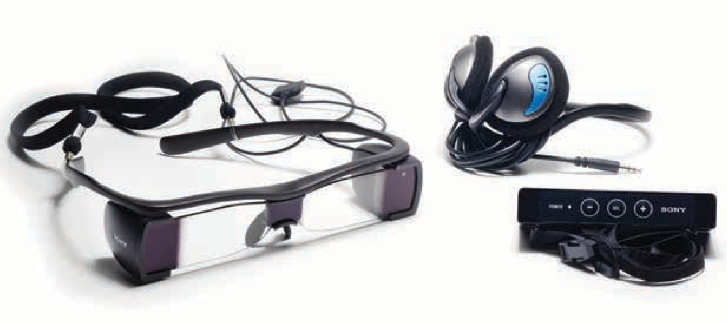

Facebook is a proud sponsor of the
American Council of the Blind
57th Annual Conference and Convention

Table of Contents

Volume 1:

Conference & Convention Calendar..12 Conference Gems 46
President's Message 52
Abbreviations 55
Indoor Navigation 57
ACB Convention Café 58
Registration Information 59
Communication Center Services 66
Digital Information & Internet 71
ACB Photography 73
Medical Information 74
9
Guide Dog User Information 75
Veterinary Care 77
Religious Activities 78
Convention Standing Rules 79
General Session Agenda 85
ACB Boards & Committees 118
2018 ACB Exhibitors 121
ACB Marketplace 126
ACB Fundraisers 127

Volume 2:
Special-Interest Affiliate Meetings 10 ACB Committee Meetings 69
Other ACB Meetings 89
Other Meetings & Programs 91
More Convention Entertainment.. 113 2018 Tours 117
Kids' Explorers Club 134
Board of Directors 138
ACBES 140
ACB Staff and Consultants 140
Convention Coordinating Committee 141 Convention Program Committee ... 142 Local Host Committee 143

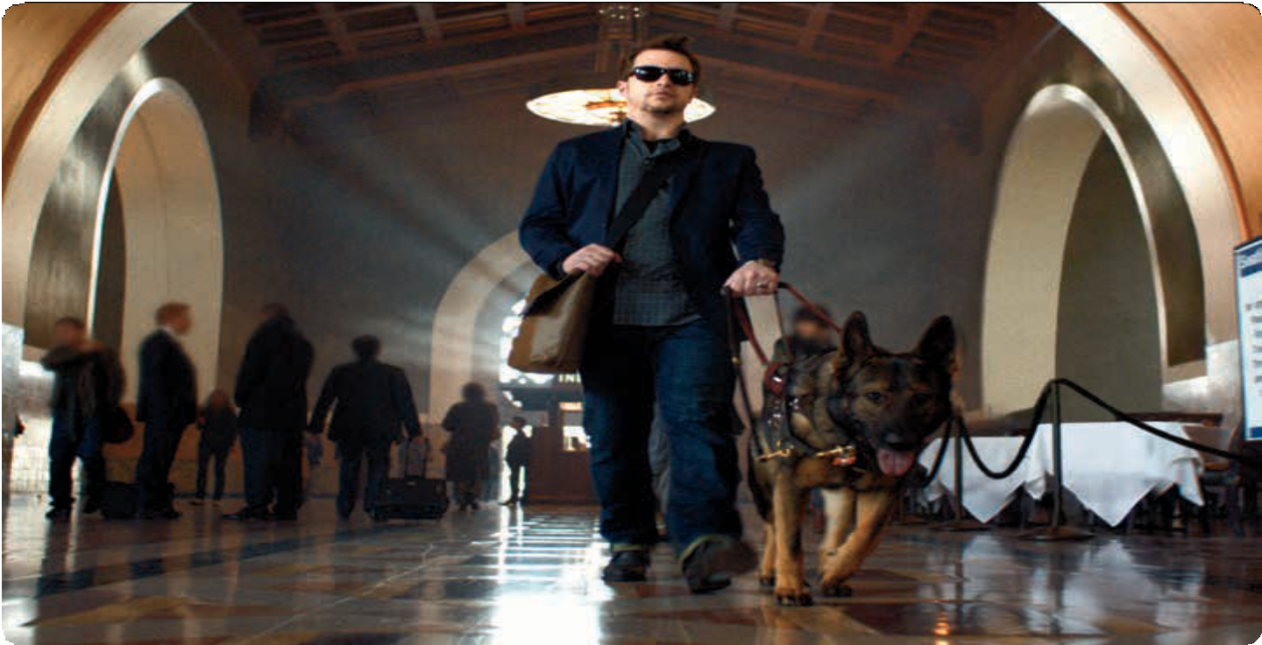
CALENDAR

©2015 All rights reserved. N240298 Printed in the USA 07/15

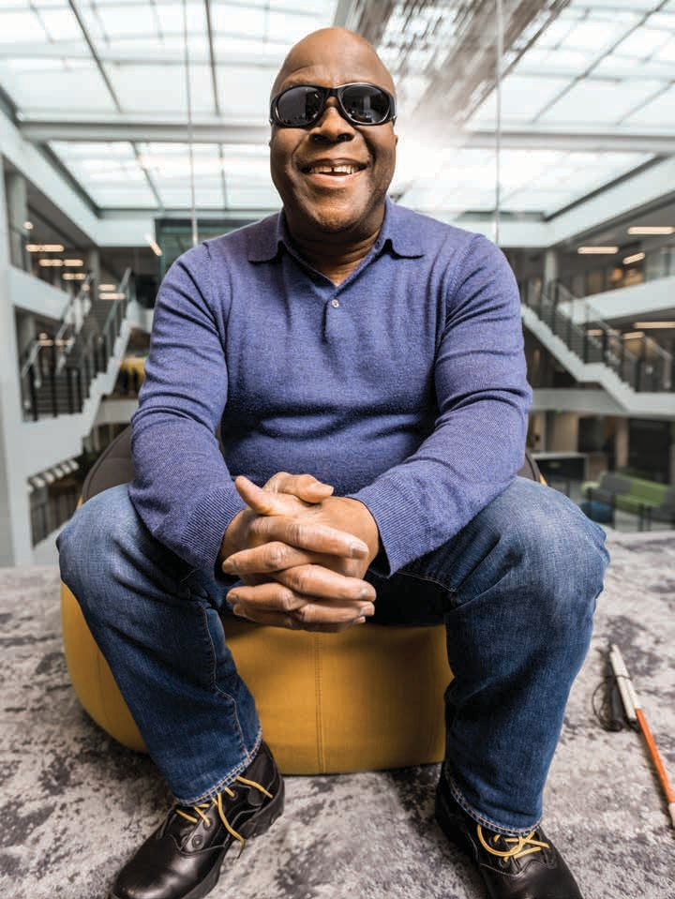
CALENDAR

Empowerment
Microsoft’s mission is to empower every person and every organization on the planet to achieve more. This includes creating and delivering technology that is accessible and functional for everyone.

www.microsoft.com/accessibility

Conference and Convention Calendar

Thursday, June 28
6:00PM - 9:00PM: Registration, Illinois Central

Friday, June 29
7:30AM - 4:00PM: St. Louis Arch

8:00AM - 7:00PM: Registration, Illinois Central

9:00AM - 3:00PM: ACB Preconvention Board Meeting, Jeffersonian/Knickerbocker

4:30PM - 6:00PM: Constitution and Bylaws, Conductor

5:00PM - 10:30PM: Cardinals Game

6:30PM - 8:00PM: Scholarship Winners Dinner (by invitation only), Frisco

8:00PM - 11:00PM: ACB Students Office Hours, New York Central
8:00PM - 11:00PM: Missouri Welcome Party, Regency C

Saturday, June 30
7:00AM - 8:30AM: Brenda Dillon Memorial Walk, Frisco

7:30AM - 9:30AM: FIA Board Meeting, FIA Suite

8:00AM - 7:00PM: Registration, Illinois Central
8:00am - 7:00pm: ACB Café
8:00AM - 10:15AM: AABT Breakfast, New York Central

8:15AM - 3:30PM: Busch Stadium Tour

9:00AM - 11:00AM: VFO Training, Midway 1 & 2
9:00AM - 11:00AM: Second Sight, Midway 8

10:00AM - 12:00PM: BITS Program -
Amazon Locker, Midway 9
10:00AM - 12:00PM: RSVA Board
Meeting, Conductor
10:00AM - 11:30AM: Trolley Tour 10:00AM - 11:00AM: HIMS Session,
Midway 7

10:30AM - 12:00PM: BOP Meeting,
Jeffersonian/Knickerbocker

11:00AM - 12:00PM: ACB Committee
Chairs Meeting, Midway 5 11:00AM - 12:00PM: APH Session,
Midway 3 & 4

11:30AM - 3:00PM: BPI Bubbles and Mingles, Meet in hotel lobby.

12:15PM - 1:45PM: Scholarship Luncheon, Midway 10
1:00PM - 5:00PM: Exhibit Hall Open 1:00PM - 3:00PM: Credentials Committee
Meeting, Conductor

1:15PM - 5:30PM: AAVIA Program,
Midway 7
1:15PM - 4:00PM: ACBDA Seminar,
Midway 8
1:15PM - 4:00PM: BITS Program, Midway 9 1:15PM - 2:30PM: BRL Orienteering,
Jeffersonian/Knickerbocker

1:15PM - 4:00PM: 411 from the IAC,
Regency A

1:30PM - 5:30PM: RSVA Program,
Midway 1 & 2
1:30PM - 2:30PM: Remote Voting Task Force Findings and Group Discussion, Midway 5

1:45PM - 3:00PM: ACBS Business
Meeting, Midway 10

2:00PM - 3:15PM: Microsoft Accessibility, Grand A

2:45PM - 5:30PM: FIA Showcase
Rehearsal, FIA Suite

2:45PM - 5:30PM: Riding Right, Transportation and EAC Program, Midway 5

3:30PM - 4:45PM: Microsoft Accessibility Office Hours, Grand A

4:00PM - 5:15PM: Leadership Junction, Midway 6
4:00PM - 5:00PM: Annual Giving Societies Reception, Regency B
4:00PM - 5:00PM: Interdenominational Church Service, Midway 3 & 4
4:00PM - 5:00PM: Roman Catholic Mass, New York Central

5:30PM - 6:30PM: ACB Exhibitors Reception (by invitation only), President’s Suite
5:30PM - 7:00PM: ACB Marketplace

6:00PM - 7:00PM: Keys to the Convention, Regency A

6:30PM - 9:00PM: Kids' Explorers Club, Frisco

7:00PM - 11:00PM: ACB Opening Session, Grand Ballroom

10:00PM - 12:00AM: RSVA/IVIE Mixer,
Midway 1 & 2

11:00PM - 2:00AM: Resolutions, Conductor

Sunday, July 1
6:45AM - 8:15AM: GDUI Munch Brunch, Offsite

7:00AM - 5:00PM: Kids' Explorers Club, Frisco
7:00AM - 8:15AM: AFB Breakfast,
Regency C

7:30AM - 10:30AM: ACB Marketplace 7:30AM - 7:00PM: ACB Café

8:00AM - 7:00PM: Registration, Illinois Central

8:00AM - 12:00PM: ACB General Session, Grand Ballroom

11:00AM - 5:00PM: Exhibit Hall is Open

12:15PM - 2:30PM: AAVL Luncheon,
Jeffersonian/Knickerbocker 12:15PM - 2:30PM: BITS Luncheon,
Midway 10
12:15PM - 1:15PM: GDUI Help Your Dog
Adjust to Convention Life, Regency A
12:15PM - 5:30PM: RSVA Awards
Luncheon, Midway 1&2
12:15PM - 2:30PM: MCAC Luncheon and Program, New York Central

12:45PM - 7:45PM: Blues Museum

1:00PM - 6:00PM: Audio Description Conference, Midway 6
1:00PM - 2:30PM: Trolley Tour

1:15PM - 5:30PM: AAVIA Program,
Midway 7
1:15PM - 2:30PM: ACBS Speed
Networking, Missouri Pacific
1:15PM - 4:00PM: BPI Matinee, Midway 8 1:15PM - 2:30PM: CCLVI Low Vision
Vendor Showcase, Midway 3 & 4
1:15PM - 2:30PM: GDUI Hotel
Orientation, Meet in GDUI Suite 1:15PM - 4:00PM: LUA Program, Midway 9

2:45PM - 5:30PM: GDUI Program and Board Meeting, Regency A

2:45PM - 5:30PM: Rehab and Special Education, Midway 5

3:00PM - 4:15PM: GDUI/Aira Through the Looking Glasses, Regency A
3:30PM - 5:00PM: Trolley Tour

4:00PM - 6:00PM: BPI Business Meeting, Midway 8
4:00PM - 6:00PM: CCLVI Mixer,
President's Suite

4:15PM - 5:30PM: Constitution and Bylaws, Conductor
4:15PM - 5:30PM: Microsoft Accessibility in Windows, Regency C
4:15PM - 5:15PM: Google Home & Assistant, Grand B & C

5:30PM - 6:30PM: Google G Suite Accessibility Updates, Grand B & C

5:45PM - 8:00PM: ACB Nominating Committee, Regency B
5:45PM - 7:00PM: LUA/IAC New
Approaches from Familiar Places, Midway 9
5:45PM - 7:00PM: HumanWare, Midway 3&4
5:45PM - 7:00PM: Microsoft Accessibility Office Hours, Grand A
5:45PM - 7:15PM: 1Touch Self-Defense (beginner), Missouri Pacific

7:00PM - 9:00PM: GDUI Live Auction, Regency A

7:15PM - 8:30PM: Gospel Sing, Grand Ballroom

7:30PM - 8:45PM: RSVA Comedy Night, Midway 10
7:30PM - 9:00PM: 1Touch Self-Defense, (intermediate), Missouri Pacific

8:00PM - 11:00PM: BITS Mixer,
President's Suite
8:00PM - 11:00PM: CCLVI Dance, Gothic
Corridor
8:00PM - 10:00PM: Get Social with SASI, Executive Director's Suite
8:00PM - 2:00AM: Resolutions, Conductor

8:00PM - 10:15PM: Double Feature: “Dealt” and “NCIS,” Midway 6 8:30PM - 12:00AM: BPI Show me St.
Louis, Meet in BPI Suite
9:00PM - 11:00PM: Prose and Poetry, New York Central
9:00PM - 11:00PM: GDUI Open Mic,
Regency A
9:00PM - 12:00AM: RSVA Karaoke Night, Midway 10

Monday, July 2
6:45AM - 8:15AM: GDUI Munch Brunch, Offsite

7:00AM - 8:15AM: ACBF, Breakfast with Alexa, Regency B

7:00AM - 8:15AM: BRL International Breakfast, New York Central
7:00AM - 8:15AM: GDB Alumni Breakfast, Regency C
7:00AM - 5:00PM: Kids' Explorers Club, Frisco

7:30AM - 8:30AM: GDUI Hotel
Orientation, GDUI Suite
7:30AM - 10:30AM: ACB Marketplace 7:30AM - 7:00PM: ACB Café

8:00AM - 12:00PM: ACB General Session, Grand Ballroom
8:00AM - 3:00PM: Registration, Illinois Central

9:00AM - 5:00PM: JPMorgan Chase & Co. Sessions (by appointment only), Link

11:00AM - 5:00PM: Exhibit Hall is Open

12:15PM - 4:00PM: AAVIA Luncheon,
Midway 1 & 2
12:15PM - 2:30PM: CCLVI Luncheon,
Midway 3 & 4
12:15PM - 2:30PM: FIA Luncheon, New York Central
12:15PM - 2:30PM: Voices from Around the World Luncheon, Regency B
12:15PM - 5:00PM: Botanical Garden Tour

1:00PM - 4:30PM: Missouri School for the Blind Tour

1:15PM - 2:30PM: ACBS Business
Meeting, Conductor
1:15PM - 2:30PM: BPI Sound Therapy, Midway 8
1:15PM - 4:30PM: BRL Program, Midway 9
1:15PM - 5:30PM: GDUI Program,
Regency A

1:30PM - 4:45PM: Audio Description Conference, Midway 6

2:45PM - 5:00PM: AAVL/CCLVI Lighting
Your Way to Independence, Midway 3 & 4

2:45PM - 4:00PM: For the White Wine Lover, BPI Suite
2:45PM - 4:00PM: FIA Writers Workshop, New York Central
2:45PM - 4:00PM: SASI Program, Midway 7
2:45PM - 4:00PM: Google - Android and Chrome OS Accessibility Updates, Grand B & C

4:15PM - 5:30PM: ACBDA Mixer,
Executive Director's Suite
4:15PM - 5:30PM: Mixed Monday, BPI Suite
4:15PM - 5:30PM: Games with Ralph, Midway 9

4:15PM - 5:30PM Accessible Prescription Labels - Past, Present and Future, Midway 7
4:15PM - 7:00PM: Microsoft Soundscape Training, Grand A

5:15PM - 11:15PM: Muny Tour

5:45PM - 6:15PM: Express Scripts: On a Journey to Inclusivity, Midway 7
5:45PM - 7:00PM: For the Red Wine Lover, BPI Suite
5:45PM - 7:00PM: Constitution and Bylaws, Conductor
5:45PM - 7:00PM: Scholarship Winners Reception, President’s Suite

5:45PM - 7:00PM: Water Aerobics, Hotel Pool
5:45PM - 7:00PM: HumanWare, Midway 3 & 4
5:45PM - 7:15PM: 1Touch Self-Defense (beginner), Missouri Pacific

6:15PM - 12:00AM: RSVA Casino Night,
Offsite

6:30PM - 7:45PM: GDUI Canine Massage, Regency A

6:45PM - 7:30PM - Talking Bar Codes … Why an App Just Doesn’t Cut it, Midway 7

7:15PM - 8:45PM: ACBF Bingo, Midway 6

7:30PM - 10:30PM: FIA Performing Arts Showcase, Regency C
7:30PM - 9:00PM: 1Touch Self-Defense (intermediate), Missouri Pacific

8:00PM - 11:00PM: ACBS and BPI Story
Slam, Midway 1 & 2

10:00PM - 2:00AM: Resolutions, Conductor

Tuesday, July 3
6:45AM - 8:15AM: GDUI Munch Brunch, Offsite

7:00AM - 5:00PM: Kids' Explorers Club, Frisco

7:00AM - 8:15AM: NIB Breakfast,
Regency B

7:30AM - 10:30AM: ACB Marketplace 7:30AM - 7:00PM: ACB Café

8:00AM - 12:00PM: ACB General Session, Grand Ballroom
8:00AM - 2:00PM: Registration, Illinois Central

9:00AM - 5:00PM: JPMorgan Chase & Co. Session, (by appointment only), Link

11:00AM - 5:00PM: Exhibit Hall is Open

12:15PM - 2:30PM: ACBDA Luncheon,
Jeffersonian/Knickerbocker

12:15PM - 2:30PM: IVIE Luncheon,
Missouri Pacific
12:15PM - 2:30PM: VIVA Luncheon,
Conductor
12:15PM - 3:50PM: Sweet Tooth Tour

1:00PM - 6:00PM: Audio Description Conference, Midway 6
1:00PM - 5:00PM: Charter
Communications Focus Group, Midway 1

1:15PM - 2:30PM: AABT Transitioning from High School to College, Midway 7
1:15PM - 2:30PM: BPI Healing Touch, Midway 8

1:15PM - 4:00PM: CCLVI Membership Meeting, Midway 3 & 4
1:15PM - 4:00PM: LUA, BRL, FIA and IAC
Program, Midway 9
1:15PM - 5:30PM: GDUI Program,
Regency A
1:15PM - 4:30PM: Old Courthouse Tour

2:45PM - 4:00PM: ACBS Off the Press and at Your Fingertips, Midway 8
2:45PM - 4:00PM: For the White Wine Lovers, BPI Suite
2:45PM - 5:30PM: IVIE Small Business Expo, Wabash Cannonball
2:45PM - 8:00PM: Anheuser Busch Tour

4:15PM - 5:15PM: Passing Accessible Prescription Laws in Your State!, Midway 7
4:15PM - 5:45PM: AAVL Mixer, FIA Suite
4:15PM - 5:30PM: Tuesday Toasts, BPI Suite

5:00PM - 6:15PM: Mid-Week Social, President's Suite

5:30PM - 6:00PM: Accessible Prescription Advocacy, What Can I Do?, Midway 7
5:30PM - 6:00PM: Accessible Prescription Testimonials, Midway 7

5:45PM - 7:00PM: For the Red Wine Lover, BPI Suite

5:45PM - 7:00PM: Bookshare Office Hours, New York Central

7:00PM - 11:00PM: ACB Auction, Regency A, B & C

8:00PM - 10:00PM: BPI Movie, Midway 8

10:00PM - 2:00AM: Resolutions, Conductor

Wednesday, July 4
7:00AM - 8:15AM: Sister Power Breakfast, Midway 10
7:00AM - 5:00PM: Kids' Explorers Club, Frisco

7:30AM - 10:30AM: ACB Marketplace

7:30AM - 7:00PM: ACB Café

8:00AM - 12:00PM: ACB General Session, Grand Ballroom
8:00AM - 2:00PM: Registration, Illinois Central
9:00AM - 1:00PM: Exhibit Hall is Open 9:00AM - 4:00PM: Audio Description
Institute, Midway 1 & 2

12:15PM - 2:30PM: ACB Lions Lunch,
New York Central
12:15PM - 5:30PM: GDUI Lunch and
Meeting, Regency A
12:15PM - 2:00PM: Union Station Walking Tour

1:00PM - 2:30PM: Trolley Tour

1:15PM - 4:00PM: ACB Government Employees Meeting and Job Readiness, Midway 7
1:15PM - 2:30PM: ACB Radio Amateurs Program, Jeffersonian/Knickerbocker
1:15PM - 2:30PM: BPI Aroma Therapy, Midway 8
1:15PM - 2:30PM: CCLVI Traveling
Through the Ages, Midway 3 & 4
1:15PM - 2:30PM: BOP Workshop
Elevating Your Brand, Midway 5
1:15 PM - 4:00PM: Grass Roots Advocacy Boot Camp, Midway 6

2:45PM - 4:00PM: 2018 ACB Membership
Seminar, Midway 5
4:00PM - 6:00PM: CCLVI Open House,
CCLVI Suite
4:15PM - 5:30PM: ACB Affiliate Presidents Meeting, Midway 6
4:15PM - 5:30PM - Accessibility at Apple: Innovating for all, Regency B

5:30PM - 7:00PM: DKM Reception,
President's Suite

5:45PM - 7:00PM: Yogalates, Missouri Pacific

7:15PM - 8:30PM: BOP Town Hall
Meeting, Midway 5

7:00PM - 9:00PM: ACB Movie Night,
Regency C

8:00PM - 2:00AM: Resolutions, Conductor

9:00PM - 11:00PM: ACBL Milly's Place Pin Swap, President’s Suite

9:15PM - 11:15PM: ACBS Comedy Night,
Midway 6

10:00PM - 1:00AM: BPI Dare, BPI Suite

Thursday, July 5
7:30AM - 10:30AM: ACB Marketplace 7:30AM - 3:00PM: ACB Café

8:00AM - 1:00PM: Registration, Illinois Central

8:30AM - 5:00PM: ACB General Session, Grand Ballroom

9:00AM - 4:00PM: ADP Institute, Midway 1 & 2

5:30PM - 6:30PM: ACB Life Member
Reception, Midway 10

6:30PM - 10:00PM: ACB Banquet,
Regency A, B, C

Friday, July 6
5:30AM - 7:00PM: Mark Twain Adventure

9:00AM - 4:00PM: ADP Institute, Midway 1 & 2

7:30PM - 10:45PM: Haunted History Tour, Morgan Street Brewery

ACB Conference Gems

Many, many thanks to our 2018 corporate sponsors. Their continued generous support of the American Council of the Blind and our conference and convention is sincerely appreciated.

Look for the 2018 corporate sponsors on www.acb.org, in the conference and convention program and newspaper, on ACB Radio, on the convention T-shirt, and throughout the week. Be sure to thank them personally for their generous support.

Double Diamond Sponsors:
  - Aira - Educational & Recreational

Events
  - General Motors - Transportation Services & Continuing Education Units
  - Google - ACB Radio Worldwide Broadcast
  - Microsoft - ACB Conference Banquet
  - Vanda Pharmaceuticals - Audio/Visual Services & Brenda Dillon Memorial Walk

Diamond Sponsors:
    - Verizon/Oath - Conference Communication Center & Marketplace

Emerald Sponsors:
  - Cisco Systems - Volunteer Services
  - Comcast – You Day at the

Conference, Tuesday, July 3
  - JPMorgan Chase & Co. - Exhibit Hall
  - Sprint - Information Desk
  - Uber - Conference Registration

Ruby Sponsors:
    - Adobe - ACB Scholarship Mentoring Program
    - AT&T - ACB Café
    - Amazon - Audio Description Project Conference and Training Institute
    - Charter - Interpreter Services for Deaf-Blind Attendees
    - Facebook - ACB Auction & Performing Arts Showcase
    - HIMS - ACB Workshops and Seminar Programming & Future

ACB Leader or Young Professional
    - HumanWare - Official Sponsor of All General Sessions
    - Regal Cinemas - Kids’ Explorers Club and ACB Brenda Dillon Memorial Walk
    - VFO - Official Conference Program

Onyx Sponsors:
    - Buell Fund - ACB Brenda Dillon Memorial Walk and Recreation Zone
    - Cox Communications – Audio- Described Movie & Sponsor a student, future ACB Leader or Young Professional
    - Macular Degeneration Foundation - ACB Brenda Dillon Memorial Walk

    - National Association of Broadcasters
- General Operating Expense

    - National Industries for the Blind - ACB Brenda Dillon Memorial Walk

Topaz Sponsors:
    - ACB Lions - Scholarship Winner Travel

Coral Sponsors:
    - Randolph-Sheppard Vendors of America - Reception for Outstanding Blind Students
    - LightHouse for the Blind & Visually Impaired, San Francisco - General Session, July 2

Pearl Sponsors:
    - Amtrak - ACB Café Day (July 2)

    - Library Users of America - NLS Talking Book Narrator
    - Lighthouse FTC of Seattle - Orientation Dinner for Outstanding Blind Students
    - Maxi Aids - ACB Café Day (July 1)

President’s Message
Dear Conventioneers:
I want to welcome everyone to the 57th annual conference and convention of the American Council of the Blind, in historic St. Louis, Missouri. I am looking forward to presiding over my fifth convention as president of ACB, and to speaking with so many members and guests from across the country and, in fact, from around the world.

The theme of the 2018 convention is "Gateway to Success!" This is a great theme for this year's convention since today’s opportunities represent tomorrow’s successes. Making opportunities turn into successes for

people who are blind or visually impaired is what our work in ACB is all about!

You will hear much more about ACB's successes during what should be our busiest and most information-packed convention ever.

Every ACB convention relies on scores of volunteers who work to make this event possible. I want to personally thank the members of the Convention Committee, ably chaired by Janet Dickelman; the Convention Program Committee, and the Missouri Host Committee for their efforts.

Likewise, let me acknowledge the work of our Alexandria, VA and Minneapolis, MN staff. You are all fabulous!

Finally, a very warm welcome to those of you attending the ACB convention for the first time. Missouri is a very special place that will present you with many new adventures. Whether this is your first trip to Missouri or a return visit, I can assure you that you will leave with many new friends and wonderful memories.

I know your time in St. Louis at the ACB convention will be an especially memorable and fun experience. Plan on joining us in 2019 and come to Rochester, New York.

Enjoy a great convention! Kim Charlson, ACB President

Abbreviations in this Program
ACB - American Council of the Blind
AABT - American Association of Blind Teachers
AAVL - Alliance on Aging and Vision Loss
AAVIA - American Association of Visually Impaired Attorneys
ACBDA - ACB Diabetics in Action ACBF - ACB Families
ACBGE - ACB Government Employees ACBL - ACB Lions
ACBRA - ACB Radio Amateurs ACBS - ACB Students
ADP - Audio Description Project
AFB - American Foundation for the Blind

APH - American Printing House for the Blind
BITS - Blind Information Technology Specialists
BOP - Board of Publications
BPI - Blind LGBT Pride International BRL - Braille Revival League
CCLVI - Council of Citizens with Low Vision International
DKM - Durward K. McDaniel First-Timer FIA - Friends-in-Art of ACB
GDUI - Guide Dog Users, Inc.
IRC - International Relations Committee IVIE - Independent Visually Impaired
Entrepreneurs
KEC - Kids’ Explorers Club

LUA - Library Users of America
MCAC - Multicultural Affairs Committee
NIB - National Industries for the Blind NLS - National Library Service for the
Blind and Physically Handicapped
RSVA - Randolph-Sheppard Vendors of America
SASI - Sight and Sound Impaired Committee VIVA - Visually Impaired Veterans of America WCC - Women's Concerns Committee

Indoor navigation
A message from Dan Roberts, MD Support
Let indoor wayfinding technology be your guide around Union Station Hotel

this year. MD Support is again providing its LowViz Guide app at no cost to you.
Just download it to your iPhone or iPad and let it describe all points of interest and routes throughout the hotel lobby and meeting areas.

ACB Convention Café
Sponsored by AT&T
Café Coupon Sponsors:
- Sunday, July 1, Maxi-Aids
- Monday, July 2, Amtrak

Stop by the ACB Convention Café to grab a quick cup of coffee, pastry, sandwich, salad or snack as you rush from one meeting to another or as you head out on a tour. Meet at the Café to visit with

friends or just rest a while between activities. Located outside the Grand Ballroom; specials will be announced in the newspaper.

Registration Information
Sponsored by Uber

Registration is in Illinois Central on the second floor of the hotel.
Pre-registration packets can be picked up anytime registration is open, but Thursday evening, June 28th from 6:00PM to 9:00PM, and Friday and Saturday from 8:00AM to 11:00AM are reserved exclusively for pre- registration pickup ONLY. Onsite registration will only be from 11:00AM

to 7:00PM on Friday and Saturday.

This will help to better manage the lines during the first days of the convention.
We will also have additional staff in registration Thursday through Saturday to help reduce wait times.

Hours are:
- Thursday: 6:00PM - 9:00PM

- Friday, June 29 and Saturday, June 30: 8:00AM to 11:00AM is for pre- reg pick-up only; 11:00AM to 7:00PM is for pre-reg pick-up and for onsite-registrations.
- Sunday, July 1 and Monday, July 2: 8:00AM to 4:00PM
- Tuesday, July 3 and Wednesday,

July 4: 8:00AM to 3:00PM
- Thursday, July 5: 8:00AM to 2:00PM

When you register, you will receive your convention ID badge, program, and a goody bag filled with information and surprises. You must register to purchase tickets to events and be eligible to win great door prizes. Wear your badge at all times; it admits you to the exhibit area, lets you vote (if you are an ACB member), and helps hotel personnel and volunteers provide better service.
If you are pre-registered, your packet will be waiting for you. You may not pick up a packet for someone else. If you have any questions about your

registration or need to purchase more tickets, go to registration in Illinois Central.
A one-day pass is available for $5; $10 with a program. This pass is color-coded by day, and is good only for the day on which it is purchased. With this pass, you may attend exhibits and other programs and purchase tickets for that day only. If you wish to attend additional days at the convention, you must pay the full administrative fee.
Refunds: ACB will make no refunds for convention administrative and registration fees, sponsorship donations or tickets that you just don't want.
Refunds are not made for events that

you miss for any reason other than extreme illness (see below) or for events that you simply do not enjoy. Refunds will be issued only for meals, events, and tours if:
- An individual has pre-registered and requests the refund in writing to the American Council of the Blind, 6300 Shingle Creek Parkway, Suite 195, Brooklyn Center, MN 55430, or calls (612) 332-3242, on or before June 27, 2018; and
- The individual does not attend any part of the convention.
- In case of illness during the convention which requires you to return home or to be hospitalized,

refunds will be issued only for the meals, events, and tours which take place after your absence begins. If the guarantee has already been given for a meal function or a tour, no refund for that function will be given.
- Refunds for tour tickets are only made under certain conditions. See tour instructions for more information.

Lost tickets: ACB will not replace tickets that are lost during the convention. All ticket packets are checked before they are distributed at the convention, and tickets that are lost or misplaced must be purchased again.

Reselling tickets: Only tour tickets will be accepted for resale. In general, meal functions and social events at the hotel do not sell out. You may wish to explore other methods of selling luncheon, banquet and other such tickets.

ACB is not responsible for notifying you if you have paid for a ticket through pre-registration for an event or tour that is already sold out. Your name will be put on a waiting list in the event of cancellations, or in case additional tickets become available.

Communication Center Services
Sponsored by Verizon/Oath

The Marcia Nigro Dresser Communication Center is in Burlington on the second floor of the hotel and is open from 8:00AM to 5:00PM, Friday, June 29 through Wednesday, July 4.
This is where you can place ads in the paper, make braille or print copies or volunteer to help produce the newspaper.

Convention Newspaper
This year's newspaper is "The Gateway Gazette." It is published each day, Friday through Wednesday, in braille and large print; pick up a copy at the

Information Desk. The paper is also available on the ACB convention email list and via download at the information Desk.

ACB Students (ACBS) will deliver the newspaper to your hotel room door. For $7 (pre-registration) or $10 (registration), your paper will be waiting for you each morning when you wake up. After you sign up for newspaper delivery, activate your service by giving your room number and your format preference to the Information Desk.

Ads and Announcements
Ads and other items for publication

must be in the Communication Center by 2:00PM each day. The BOP allows ads to run for up to three days in order to give important convention announcements more space. Ads must be no longer than 75 words. BOP editorial policy prohibits the production or distribution of campaign materials by the Communication Center.
Cost of advertising in the newspaper is:
  - Individuals, ACB affiliates and blind representatives of MLM companies - $15/day or $40 for 3 days
  - Exhibitors - $40/day or $100 for 3 days
  - All others - $50/day or $125 for

3 days.

Pay for advertising at Registration; show your receipt at the Communication Center when submitting your ad.

Brailling and Photocopying Photocopying is available at the Communication Center for 10 cents/page. Brailling services are available as follows:
  - Individuals, ACB affiliates, and blind representatives of MLM companies, 10 cents/page
  - Small businesses and small nonprofits, 20 cents/page
  - All others, 35 cents/page

If your committee or affiliate needs something in braille or large print, bring files early in the day so we can fit your job between other tasks. A test copy will be printed to let you know the number of pages per copy. Be sure to label your computer card or thumb drive, and tell us how many of each format you need and by what time.
Please make payment at registration.

Thanks to HumanWare for donating the use of the braille embossers and to American Printing House for their generous donation of braille paper.

Please remember that the Communication Center is a working

room. While the convention is a great place to meet and greet, loud conversations make it difficult to hear the speech synthesizers on the computers. Help us help you get the information you need.

Digital Information and Internet ACB Radio — ACB Radio livestreams from all general sessions on the Mainstream channel; sessions are replayed around the clock. Some afternoon committee sessions will be streamed live or recorded for later broadcast. The FIA Performing Arts Showcase, BOP Town Hall meeting, and ACB Banquet are also livestreamed.
Email List — The ACB Convention email

list keeps you up-to-date on all the news. Even if you aren't at the convention, you can receive "The Gateway Gazette” and all
the other information. To subscribe, go to the ACB website at www.acb.org, or send a blank message to acbconvention- subscribe@acblists.org.
File Download Service — Would you like your newspaper, exhibit list, delegate list, or amendments in electronic format for your laptop or notetaker? Stop by the ACB/Sprint Information Desk; a volunteer will download all the latest files onto your thumb drive, SD card or compact flash card.
Complimentary wireless Internet is

available in all guest rooms in the hotel.

ACB Photography
The official ACB photographer for the 2018 conference and convention will be taking pictures and video in the exhibit hall, on selected tours, and at many social events. He will visit committee and affiliate meetings, workshops, general sessions, and at the banquet.
It is understood that all activities and programs scheduled at the 2018 conference and convention are subject to be photographed or videoed. Photos and video are the property of ACB and are for ACB's use.

Medical Information
For medical emergencies, dial 0 on a hotel phone or 911 on any other phone. Stay calm and speak distinctly. Give your name, exact location and a description of the emergency. For medical care, contact:

Downtown Urgent Care 916 Olive St.
Phone: (314) 436-9300
www.stlurgentcare.com
Open Mon through Fri 7:00AM - 7:00PM; Saturday & Sunday 9:00AM - 5:00PM
.8 mile from the hotel

St. Louis University Hospital 3635 Visa Ave.
Phone: (314) 577-8000

www.ssmhealth.com/sluhospital Open 24 hours
2.3 miles from the hotel

Pharmacy:
Walgreens
1530 Lafayette Ave.
Phone: (314) 678-1039
www.walgreens.com
1.2 miles

Guide Dog User Information Guide dog relief areas are built and maintained by Scoop Masters and are located near hotel exits. ACB volunteers and hotel staff will be happy to help you locate the areas.

Please keep in mind that the

convention can be very stressful for your dog; you may need to relieve your dog more often than usual.
Although the relief areas are cleaned at regular intervals, as always, please pick up after your dog. Trash receptacles are located near relief areas. For additional suggestions, see the quick courtesy reminders from Anders the guide dog in the GDUI program.

Should an indoor accident occur, please report it to Scoop Masters at (661) 714-0049. You should remain at the accident location to help alert others while you await assistance. If an accident occurs in your room, you

may be charged for the clean-up.

Veterinary Care Jefferson Animal Hospital 2120 South Jefferson
(314) 772-4438
Mon. - Thurs. 10:00AM - 7:00PM, Fri. 10:00AM - 5:00PM,
Saturday 9:00AM - 3:00PM 2 miles

St. Louis Veterinary Center 1611 South Grand Blvd. (314) 773-6400
Mon. through Fri. 7:30AM - 6:00PM, Saturday 9:00AM - 12:00PM
  - miles

Animal emergency clinic 9937 Big Bend Rd. (314) 822-7600
Open 24 hours

Religious Activities
Saturday, June 30

4:00PM: Interdenominational Service, Midway 3 & 4 Reverend Michael Garrett, Missouri City, TX

4:00PM - 5:00PM: Catholic Mass, New York Central
Shepard Voice: Washington, MO, priest TBA

Sunday, July 2
7:15PM: Gospel Sing, Grand Ballroom

Convention Standing Rules
Adopted by the ACB Board of Directors, May 2009

    - Each debatable issue before the convention shall be limited to approximately twenty (20) minutes with a three-minute time limit per speaker, alternating between affirmative and opposing speakers, unless a majority of the members agree to extend debate for an additional period of time.
      - Motions to close debate will not be recognized by the chair during the first debate period. After the

first debate period, properly moved motions such as "I call for the question" or "I move the previous question" will be handled by the chair and voted on by the assembly.
      - The chair may close debate when no one seeks the floor.
      - Each member is respectfully urged to speak directly to the issue before the assembly and avoid unnecessary and time- consuming dialogue.
      - No member will be recognized a second time to debate until all who wish to debate have been recognized.
      - The parliamentarian will act as

timekeeper.

    - Recognition to speak will be given to those members who properly address the chair using the microphones and giving their names and affiliation. Motions that may interrupt a speaker may be called from your seat, responded to by the chair, and explained by the mover at a microphone if requested by the chair. Examples: Point of Order, Point of Information, Parliamentary Inquiry, Question of Privilege, Call for Orders of the Day, etc.
    - Registration badges are required to be worn at all convention meetings and only those members with the

appropriate colored dot may vote during business meetings.
    - Changes to the published convention program may be proposed to the membership as deemed necessary by the presiding officer or his/her appointee. The presiding officer will explain the reason for such change and inform the assembly of their right to question the recommended modification. After this explanation, if twenty-five (25) or more members object to the proposed change by coming to the microphone and stating their name as placed in objection, the change requires debate and a majority vote

to modify the convention program.

    - Nominating and seconding speeches shall be limited to five minutes per candidate with the speaking time allocated according to the candidate's wishes. A person nominated for an office more than once shall be limited to one minute.
    - When no candidate for office receives a majority vote, the election shall be among the top two candidates. Affiliate votes will be reported in whole or half numbers.
    - Anyone meeting the requirements for voting membership in ACB in accordance with Constitution Article III-A-1 and bylaw 1 is

entitled to vote on any matter coming before the convention, provided that:
      - The person's name appears on an affiliate's certified membership list as submitted on March 15th or has been added to that list prior to the established record date for the convention, which date is thirty (30) days prior to the date of the opening session;
      - No challenges to or questions about, a person's membership status will be considered after the close of registration on the day immediately preceding the final day on which convention

business is to be conducted;
      - No challenges to or questions about, a person's membership status will be considered during the time a record vote is being conducted.

General Session Agenda

Saturday, June 30: Grand Ballroom

6:30PM: Entertainment: Mike Hamm, St.
Louis, MO

7:00PM: Call to Order: Kim Charlson, President, American Council of the Blind, Watertown, MA

Invocation: Denny Huff, President, Missouri Council of the Blind, St. Clair, MO

Presentation of Colors: Boy Scouts of America, Special Needs Troop 724, St.
Louis, MO

"The Star-Spangled Banner": Sung by June Lenk, St. Louis, MO

"The Missouri Waltz”: Missouri Official State Song, Performed by Mike Hamm, Pianist, St. Louis, MO

Welcome to St. Louis: Denny Huff, President, Missouri Council of the Blind, St. Clair, MO

7:25PM: President's Report: Kim Charlson, Watertown, MA

7:45PM: Double Diamond Sponsor Presentation: Microsoft Corporation: Anirudh Koul, Senior Data Scientist, Sunnyvale, CA; and Saqib Shaikh, Senior Software Engineer, London, England - Co-Creators of the Seeing AI App

8:00PM: ACB Award Presentation: Rochelle Hart, Sioux Falls, SD; and Chip Hailey, Joplin, MO, Co-Chairs, ACB Awards Committee

8:05PM: ACB Life Membership Presentations: Kim Charlson, ACB

President, Watertown, MA; and Nancy Becker, ACB Senior Accountant, Brooklyn Center, MN

8:20PM: ACB Angels Recognitions: Dan Spoone, ACB First Vice President, Orlando, FL; and “ACB Angels,” Song Sung by Sweet Adelines, Nashville, TN

8:30PM: Double Diamond Sponsor Presentation: Aira Corporation, Suman Kanuganti, President and CEO, San Diego, CA

8:45PM: ACB First-Timers: Kenneth Semien Sr., Chair, Durward K.

McDaniel First-Timers' Committee, Beaumont, TX

8:55PM: ACB 2018 Leadership Fellows: Eric Bridges, ACB Executive Director, Alexandria, VA

9:10PM: First Credentials Committee Report: Ralph Smitherman, Chair, Brandon, MS

9:15PM: Roll Call of Affiliates: Ray Campbell, ACB Secretary, Glen Ellyn, IL

Sunday, July 1, Grand Ballroom

8:00AM: Entertainment: John Weidlich, St. Louis, MO

8:30AM: Invocation: Chip Hailey, Joplin, MO
Pledge of Allegiance: JPMC/ACB Leadership Fellows: Michael Tally, Bessemer, AL; Debbie Rozear, Allentown, PA; and Marie Brinas, Fairfax, VA

8:35AM: ACB Business:
ACB Sponsor Recognitions: Margarine Beaman, Advertising and Sponsorship Coordinator, Austin, TX

Double Diamond Sponsor Presentation: Google, Eve Andersson, Accessibility Engineering Director, Mountain View, CA

Double Diamond Sponsor Presentation: General Motors (GM), Harry Lightsey, Executive Director, Emerging Technologies, Washington, DC

Ruby Sponsor Presentation: HumanWare, Rick Piper, Vice President of Sales USA, Champlain, NY

Ruby Sponsor Presentation: Amazon, Peter Korn, Director, Accessibility, Amazon Lab 126, Oakland, CA

Adoption of Standing Rules and Program: Kim Charlson, ACB President, Watertown, MA

Final Credentials Committee Report: Ralph Smitherman, Chair, Brandon, MS

Constitution and Bylaws: John Huffman, Chair, Constitution and Bylaws Committee, Indianapolis, IN

ACB Angel Presentation: Teddie-Joy Remhild (1933-2016) - California

ACB Angel Presentation: Robert (Bob) Rushing (1928-2017) - Oregon

Presiding Officer: Dan Spoone, ACB First Vice President, Orlando, FL

9:15AM: “Amazing St. Louis: 250 Years of Great Tales and Curiosities," Charlie Brennan, Author and St. Louis Radio Personality, St. Louis, MO

9:40AM: Richard Turner, San Antonio, TX: Blind Master Card Mechanic- Manipulator, Close-Up Magician of the Year Award Winner, and Subject of the Documentary Film Titled "Dealt," (Winner of the Audience Choice Award at the South by Southwest Film Festival, Austin, TX)

10:25AM: Break

10:40AM: News and Ongoing Progress at NLS: Karen Keninger, Director,

National Library Service for the Blind and Physically Handicapped, Washington, DC

11:10AM: Meet Jose Maria Viera: New World Blind Union Executive Director, Toronto, Ontario, Canada

11:40AM: “Celebrating 50 years of Achievement and Advocacy”: Randolph-Sheppard Vendors of America, Dan Sippl, RSVA President, Eau Claire, WI; and Ardis Bazyn, RSVA Second Vice President, Burbank, CA

11:50AM: Resolutions: Mark Richert, Chair, Arlington, VA

11:55AM: Announcements

Monday, July 2, Grand Ballroom

8:00AM: Entertainment: Robert Vaughn, St. Louis, MO

8:30AM: Invocation: John Weidlich, St.
Louis, MO
Pledge of Allegiance: 2018 Scholarship Winners

8:35AM: ACB Business:
ACB Sponsor Recognitions: Margarine Beaman, Advertising and Sponsorship Coordinator, Austin, TX

Double Diamond Sponsor Presentation: Vanda Pharmaceutical, Wendy O'Steen, RN, Regional Nurse Educator, Anniston, AL

Emerald Sponsor Presentation: Sprint, Kelly Egan, Customer Relations, Blind/Low Vision Outreach Manager, San Diego, CA

Emerald Sponsor Presentation: Cisco Systems Inc., Sanjiv Garg, Accessibility Technical Lead for Hardware, San Jose, CA

Nominating Committee Report: Mitch Pomerantz, Chair, Pasadena, CA

Constitution and Bylaws: John Huffman, Chair, Indianapolis, IN

Resolutions: Mark Richert, Chair, Arlington, VA

ACB Angel Presentation: Hattie Bond (1937-2012) - Tennessee

Presiding Officer: John McCann, ACB Second Vice President, Tucson, AZ

9:15AM: 2018 ACB Scholarship Presentations: Denise Colley, Chair, Scholarship Committee, Lacey, WA

10:15AM: Break

10:30AM: College Success! Working to Make It Happen, Leslie Thatcher, Director, College Success Program, Perkins School for the Blind, Watertown, MA

10:40AM: New Collaborative Strategic Directions at Both the American Foundation for the Blind and the American Printing House for the Blind: Russell Shaffer, Chairman of the Board, American Foundation for the Blind, Bentonville, AR; and Craig Meador, President, and CEO, American Printing House for the Blind, Louisville, KY

11:00AM: Meet Annie Barth from the 350th Episode of NCIS: Marilee Talkington, Professional Low Vision Actress, New York, NY

11:20AM: Now Washing and Drying Clothes Has Never Been So Easy: Inventing the Talking Laundry Module for GE Washers and Dryers, Samuel DuPlessis, Design Leader, FirstBuild; and Jack DuPlessis, Sophomore, DuPont Manual High School, Louisville, KY

11:35AM: Legal Advice and True Partners: The Washington Lawyers' Committee for Civil Rights and Urban Affairs, Jonathan Smith, Executive

Director; Deepa Goraya, Associate Counsel, Disability Rights; and Matthew Handley, Former Director of Litigation, Washington, DC

11:55AM: Announcements

Tuesday, July 3, Grand Ballroom

8:00AM: Entertainment: Karen Eitel, Houston, TX

8:30AM: Invocation: Rabbi Randy Fleischer, Central Reform Congregation, St. Louis, Mo
Pledge of Allegiance: JPMC Leadership Fellows: Darian Slayton

Fleming, Gresham, OR and Debbie Trevino, Newark, DE

8:35AM: ACB Business:
ACB Sponsor Recognitions: Margarine Beaman, Advertising and Sponsorship Coordinator, Austin, TX

Emerald Sponsor Presentation: JPMorgan Chase, Marc Kwok, Vice President, Accessibility Lead, San Francisco, CA; and Chetan Bakhru, Senior Accessibility Specialist, San Francisco, CA

Emerald Sponsor Presentation: Comcast, Tom Wlodkowski, Vice

President of Accessibility, Philadelphia, PA

Ruby Sponsor Presentation: Charter Communications, Petr Kucheryavyy, Senior Manager, Accessibility, Greenwood Village, CO

Emerald Sponsor Presentation: Uber, Malcom Glenn, Public Policy, Washington, DC

Diamond Sponsor Presentation: Verizon, Zachary (Zach) Michael Bastian, Manager, Strategic Alliance and Public Policy, Washington, DC

Ruby Sponsor Presentation: VFO: Matt Ater, Vice President, St. Petersburg, FL

Constitution and Bylaws: John Huffman, Chair, Indianapolis, IN

Resolutions: Mark Richert, Chair, Arlington, VA

ACB Angel Presentation: Jill O'Connell (1922-2017) - California

Presiding Officer: Ray Campbell, ACB Secretary, Glen Ellyn, IL

9:15AM: "Talking for a Living — Growing up as an Audio Book Narrator," Laura

Giannarelli, National Library Service for the Blind and Physically Handicapped, Recording Studio, Washington, DC

9:45AM: New Partnership in Employment Relationship Building: Jill Houghton, Executive Director, USBLN (U.S. Business Leadership Network), Fort Lauderdale, FL

10:15AM: Break

10:30AM: Executive Director's Report: Eric Bridges, Alexandria, VA

11:00AM: The Federal Tax Cuts and Jobs Act (TCJA): What Deductions Still

Exist, Implications for People Who are Blind; Update on ABLE 529 Accounts; and SSI and SSDI Rules Applying to Income, Anthony (Tony) Stephens, Director of Advocacy, Alexandria, VA

11:25AM: Presentation of Affiliate Membership and Growth Awards, Chip Hailey, Co-Chair, ACB Awards Committee, Joplin, MO; Presentation of Ned E. Freeman and Vernon Henley Media Awards: Ron Brooks, Chair, ACB Board of Publications, Phoenix, AZ

11:40AM: The New ACB.ORG Website Rollout: Kelly Gasque, ACB Executive

Assistant and Multimedia Design Specialist, Alexandria, VA

11:55AM: Announcements

Wednesday, July 4, Grand Ballroom

8:00AM: Entertainment: Terry Nord, St.
Louis, MO

8:30AM: Invocation: Rev. Dr. Dave Andrus, Abiding Savior Lutheran Church, St. Louis, MO
Pledge of Allegiance: Richard Kolhish, Visually Impaired Veterans of America (VIVA), St. Louis, MO; and David Dowland, VIVA, Tulsa, OK

8:35AM: ACB Business:
ACB Sponsor Recognitions: Margarine Beaman, Advertising and Sponsorship Coordinator, Austin, TX

Ruby Sponsor Presentation: HIMS Inc., Earle Harrison, Midwest Regional Sales Manager, Columbia Heights, MN

Ruby Sponsor Presentation: Aira, Paul Schroeder, VP of Public Policy and Strategy, Silver Spring, MD

Constitution and Bylaws: John Huffman, Chair, Indianapolis, IN

Resolutions: Mark Richert, Chair, Arlington, VA

ACB Angel Presentation: Susie Weatherford (1946-2016) - Arkansas

Presiding Officer: David Trott, ACB Treasurer, Talladega, AL

9:15AM: National Conference and Convention Report: Janet Dickelman, Chair, Convention Committee, Saint Paul, MN

9:35AM: Treasurer's Report: David Trott, Talladega, AL

9:50AM: ACBES Report: Rev. Michael Garrett, Chair, ACB Enterprises and Services, Missouri City, TX

10:00AM: Furry Friends and Flying Skies: An Update on the State of Air Travel for Guide Dog Handlers, Claire Stanley, ACB Advocacy and Outreach Specialist, Alexandria, VA

10:15 AM: Break

10:30AM: National Advocacy and Legislative Update: Anthony (Tony) Stephens, Director of Advocacy and Governmental Affairs, Alexandria, VA

10:55AM: The UniDescription Project: Providing Tools, Training, and Mobile Apps to Spread Audio Description Through Our National Parks, Sajja

Koirala, Graduate Research Assistant, University of Hawaii, Manoa, HI

11:05AM: Award Presentations and Updates from the ACB Audio Description Project: Joel Snyder, Director, Audio Description Project, Takoma Park, MD; Chris Gray, ADP Awards Chair, St. Louis, MO; and Dan Spoone, Chair, Audio Description Project Steering Committee, Orlando, FL

11:35AM: Report on the ACB Walk and Auction: Donna Brown, Walk Chair, Romney, WV; Kim Hebert Chair, ACB Auction committee, Branson, MO; Dan Spoone, ACB First Vice President,

Orlando, FL; and Dan Dillon, Hermitage, TN, Co-chairs, ACB Resource Development Committee

11:55AM: Announcements

Thursday, July 5, Grand Ballroom

8:00AM: Entertainment: Deborah Lewis, Seattle, WA

8:30AM: Invocation: Phil Hamilton, St Louis, MO
Pledge of Allegiance: 2018 DKM First- Timers: Becky Dunkerson, Des Moines, IA; and Nicholas McNeill, Holly Hill, FL

8:35AM: ACB Business:
ACB Sponsor Recognitions: Margarine Beaman, Advertising and Sponsorship Coordinator, Austin, TX

8:45AM: Resolutions: Mark Richert, Chair, Arlington, VA

10:00AM: Elections 11:15AM: Break
11:45AM: Elections (continued) 1:00PM: ACB Business
1:15PM: Old/New Business

1:30PM: Adjourn

Thursday, July 5, ACB Banquet

6:30PM: Pre-Banquet Entertainment: Dwayne Estes, St. Louis, MO

7:00PM: ACB Banquet
Invocation: Rev. Michael Garrett, Missouri City, TX

Emcee: Jesuita Tabor, Chair, 2018 Missouri Host Committee, St. Louis, MO

Drawings, Announcements and Other Doings

Speaker and Musical Presentation: Michael Cleveland and Brian Allen

Michael Cleveland & Flamekeeper After picking up the fiddle at age 4, Michael’s musical momentum began to propel him forward towards early success. At age 9, Michael was invited to sit in with the legendary Bill Monroe at the Bean Blossom Bluegrass Festival. Soon after that, he was hand-picked for the International Bluegrass Music Association’s (IBMA) Bluegrass Youth Allstars which led to an invitation by Alison Krauss to bring his virtuosic style to the Grand Ole Opry, all before he was 14 years old.

His blistering prowess and technical fluency have since marked him as a sought-after musician, leading to performances with Vince Gill, Marty Stuart, Tim O’Brien, J.D. Crowe and the New South, Andy Statman, and The Kruger Brothers in recent years.

However, it wasn’t until 2006, when Michael formed his own band, Michael Cleveland & Flamekeeper, that he found the right vehicle for his musical vision. Clearly, the IBMA agrees as he’s their most awarded Fiddle Player of the Year with 10 wins, has won Instrumental Recorded Performance of the Year six times, and fronts their

5-Time Instrumental Group of the Year.

“It’s wicked to see how much music he pulls out of a bow,” says Vince Gill. “He’s untouchable.”

Brian Allen
Brian Allen is a native of Indiana and is a fourth-generation musician. His great grandpa, grandpa and dad played before him and shaped his early interest in music. In particular, his dad started him on the basics of guitar at the early age of seven.

At the Indiana School for the Blind, Brian played piano and trumpet using braille music. There, Brian trained his ear and honed his musical skills.
Before long, Brian turned those fundamentals toward the guitar and in the many years since, his musical gift has flourished.

Brian has played with some of the finest musicians around: Tony Myers and the Old Louisville Express, Jim Smoak, Janet Hattabaugh and many others. Brian also played for some time with Michael Cleveland, in the group Blue Hollow.

Brian has traveled all over the country sharing his talent. He has played at the Kennedy Center and on Garrison Keillor’s “A Prairie Home Companion.”

ACB Boards and Committees

ACB Board of Directors
Friday, June 29
9:00AM: Pre-convention Board Meeting
- Jeffersonian/Knickerbocker

Board of Publications Chair: Ron Brooks Saturday, June 30
10:30AM - 12:00PM: BOP Meeting,
Jeffersonian/Knickerbocker

Wednesday, July 4
1:15PM - 2:30PM: BOP Workshop
Elevating Your Brand, Midway 5, $6 ($8)
Personal branding author, consultant and coach, Sheryl Brown, provides strategies you can use to build a powerful brand for yourself or your organization.

7:15PM - 8:30PM BOP Town Hall
Meeting, Midway 5

Constitution and Bylaws Chair: John Huffman

Friday, June 29 4:30PM: Conductor

Sunday, July 1 4:15PM: Conductor

Monday, July 2 5:45PM, Conductor

Credentials Committee Chair: Ralph Smitherman

Saturday, June 30 1:00PM: Conductor

Nominating Committee Chair: Mitch Pomerantz

Sunday, July 1 5:45PM: Regency B

Resolutions Committee Chair: Mark Richert

Saturday, June 30 11:00PM: Conductor

Sunday, July 1 8:00PM: Conductor

Monday, July 2 and Tuesday, July 3 10:00PM: Conductor

Wednesday, July 4 9:00PM: Conductor

2018 ACB Exhibitors
ACB Mini Mall

ACB Angel Memorial Wall

ACB Monthly Monetary Support Aira

American Printing House for the Blind Blind LGBT Pride Int’l
Blind Life Brady Zone
Braille Bibles International Braulio Worldwide
Bureau of Engraving and Printing Casa de Noriega
Centene Corporation Charter Communications Cisco
Cyber Timez

Described & Captioned Media Program

Duxbury Systems Inc. En-Vision America Express Scripts Friends in Art (FIA)
Guide Dog Foundation for the Blind Guide Dogs for the Blind
Guide Dogs of America GuideLights and Gadgets, Inc Guiding Eyes for the Blind Harbolt Company
HIMS

Horizons for the Blind HumanWare
IAAIS

Illinois Council of the Blind Industries for the Blind, Milwaukee Industries of the Blind
Irie-AT JW.org
Leader Dogs for the Blind

Low Vision Aids/Magnifying America Lutheran Braille Workers
Maxi-Aids

Missouri Council of the Blind National Braille Press National Library Service BPH NEAT! Artist Studio
NRTC on Blindness & Low Vision

Polara

Second Sight Medical Products Seeing Eye, Inc.
Southeastern Guide Dogs Sprint
Tangible Surface Research Travel One
Vanda VEMI/CHROME LAB VFO
Visit Rochester VOTEC Corporation WayAround Youngevity

ACB Marketplace

Sponsored by Verizon/Oath
CCLVI DKM
EZ2See Products FIA
Georgia Guide Dog Users International Relations Committee Keri Bishop
Georgia Guide Dog Users Scentsy Candles
The Blind Perspective Wilma Chestnut-House

Visit these exciting tables full of jewelry, books, CDs, drawing tickets and gift items. ACB Marketplace is located near the Grand Ballroom. It is

open Saturday evening from 5:30 to 7:00PM, Sunday through Thursday from 7:30 to 10:30 AM.

Marketplace tables are available to individuals, chapters and affiliates, MLM reps, ACB committees and others. It's a low-cost way to share your products or raise money for your chapter or affiliate. For more information and to find out if any spaces are available, contact Michael Smitherman at (601) 331-7740 or in the Exhibit Hall.

ACB Fundraisers
You can show your support for ACB in several ways:

Convention Sponsorships: Stop by ACB/Uber registration in Illinois Central and become an individual or corporate ACB Convention Sponsor. Individual sponsorships are bronze ($25),
silver ($50), gold ($100), platinum ($250), and titanium ($500).
Sponsors receive special ribbons to wear on their convention badges, are recognized both in general session and in the newspaper. For information on corporate sponsorships, including pearl, coral, topaz, onyx, ruby, emerald, double diamond and crown jewel, contact Margarine Beaman in the hotel or by cell phone at (512) 921-1625.

Brenda Dillon Memorial ACB Walk:
Saturday, June 30 7:00 AM, Frisco Go the extra mile for ACB by bringing in donations and participating in the number ten Dillon Express Walk with ACB!
Celebrate the 10th anniversary of the Walk. Go the extra mile for ACB by bringing in donations and by walking with us around some areas outside of the convention hotel.

"Meet Me At the Auction!"
Tuesday, July 3, Regency
Get ready to bid the night away. We have many different treasures to bid on. We have trips, jewelry, memorabilia, technology, and lots of

goodies. Auction preview starts at 6:00PM, auction to follow at 7:00PM. Grab a bite from the cash-and-carry line at the auction.

ACB Raffle: Win $5,000 in cold, hard cash! Limited tickets available; $50 each. Buy one for yourself or your affiliate, or find up to four friends and split the cost five ways. Available at the ACB Store in the ACB Exhibit Hall and at registration.

MMS Program: Help support ACB all year ‘round; it's easy and quick. Find out more about the Monthly Monetary Support Program; ask questions and

complete paperwork at the MMS table at the ACB Store booth in the Exhibit Hall.

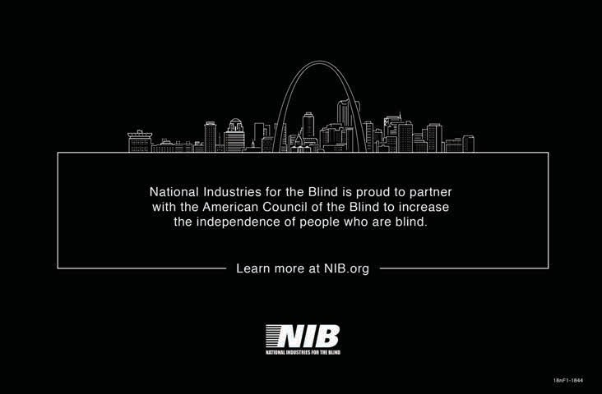

The American Council of the Blind sincerely thanks
for supporting the

2018 Conference and Convention as a
2018 Walk Sponsor of the
All Aboard 10 Dillon Express

The highest quality, lowest priced, true production Braille embosser available

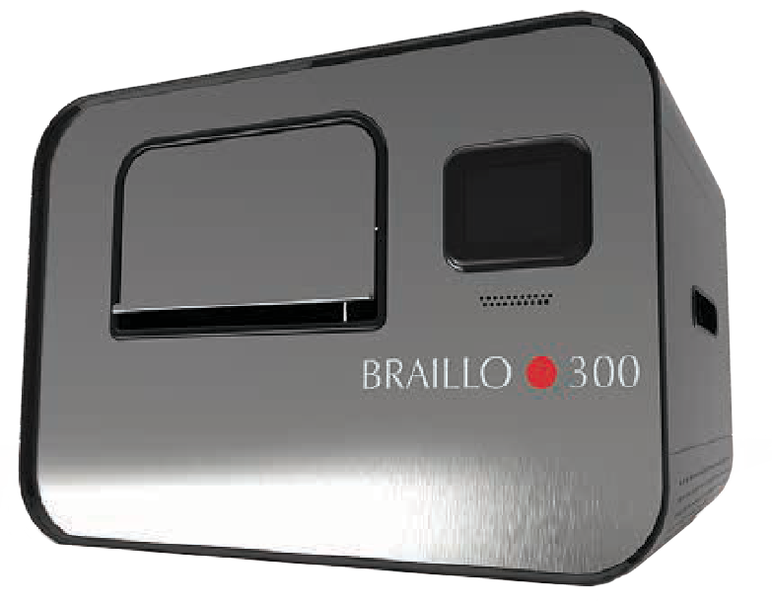
BRAILLO 300 S2
The Braillo 300 S2 Braille embosser is a reliable and dependable embosser for light to heavy Braille production.
Embossing at 300 CPS (900 pages per hour) using continuous / tractor / fanfold Braille paper, it offers exceptional dot quality and consistency. Its combination of speed, durability, reliability and qui- etness are the reasons why it is used across the world by most of the largest Braille production facilities.

Feature Highlights:

Braille publishers count on running their machines 24/7, at high speeds while continuously producing high quality Braille documents. High quality throughput means profit. Only Braillo true production Braille embossers can per-
form at this level. Trust your business to the industry leader with 30 years dedicated to engineering the best production Braille embossers. Trust your business with Braillo.

- The only manufacturer of true production Braille printers
- Built specifically for all-day, heavy duty Braille embossing
- Perfect Braille alignment – every time
- Industry leading 3 year comprehensive warranty
- The most trusted Braille translator, Duxbury, included free
- Superior Braille quality and reliability
- Lowest priced true production Braille printer available
- Easy to setup and easy to service
- The most trusted Braille translator, Duxbury, included free
- 300 characters per second (900 pages per hour)
www.BRAILLO.com

AMERICAN THERMOFORM

1758 Brackett Street La Verne, CA 91750 Tel: (800) 331-3676
Tel: (909) 593-6711
Email: sales@americanthermoform Web: www.americanthermoform.com

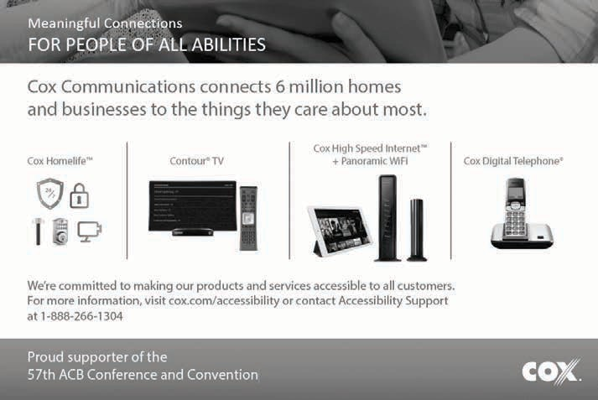

IOB- We are Excellence!

Industries of the Blind provides opportunities for employment and personal development for people who are blind or visually impaired to achieve greater independence.
We invite you to become part of our growing and diverse workforce. You will receive competitive wages and benefits, opportunities for professional development, tuition reimbursement, 401 K, and relocation assistance.

Apply today online at www.industiesoftheblind.com or call 336 274 1591.

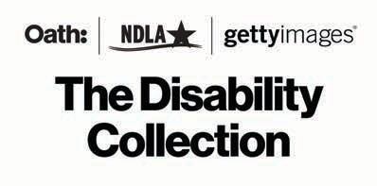

People with disabilities make up about 20% of the population, but are featured in
less than 2% of the images we see in the media.

Let’s change that.

Join us at DisabilityCollection.com

SKYDIVE SOLO WHILE TOTALLY BLIND?
Yes, John Fleming did, over 1200 times. John’s daring story is being told in a forthcoming documentary. A dedicated member of ACB and president of Visually Impaired Veterans of America, John was an equally passionate thrill- seeker and advocate for rights of people who are blind.

Now, we need your help to finish this documentary.
Here’s how you can get involved today:
  - Become a sponsor. Email: producers@blindjohnmovie.com or call (503)522-3272 to learn about the many sponsorship benefits.
  - Like us on Facebook@blindjohnmovie.
  - Donate at acb.org. Choose Honorary Donation, be sure to specify “John Fleming movie” and include your contact information. We’ll be in touch about your donation “producer perks.”
  - Invite us to speak to your organization to share John’s inspiring story and show movie clips.

The American Council of Blind Lions

ACBL is a proud Topaz sponsor assisting outstanding scholarship winners to attend the ACB National Convention.

ACBL gives Lions across America a chance to share ideas and experiences, and encourages others in ACB to become Lions and participate in service projects in their local communities.

Want to know more? Join our conference calls the first Thursday of each month at 9:00 PM Eastern; dial 712-432-3900 and
enter code 796096#.
RSVA®

Randolph-Sheppard Vendors of America promotes the
expansion of Randolph-Sheppard opportunities and the welfare of blind vendors nationwide who are engaged in the operation
of vending machine facilities, cafeterias, military dining contracts, snack bars, and other retail businesses. RSVA is proud to sponsor the scholarship dinner
and luncheon for outstanding blind students.

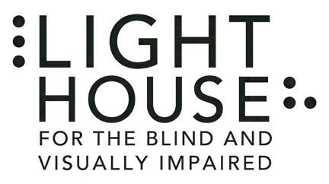
LightHouse for the Blind in San Francisco is a leading blindness organization and

a proud sponsor of the ACB Conference.
We offer unique tactile maps, immersive blindness skills training, a camp for the blind in Napa, the annual $25,000 Holman Prize and more.

lighthouse-sf.org
Alphapointe is one of the country’s largest employers of people who are
blind and a national leader in low vision and blind rehabilitation services.
Our mission it to empower people with vision loss to achieve their goals and aspirations. We are always creating new career employment opportunities and we serve thousands of people of all ages each year who strive for greater independence.
Learn more at www.alphapointe.org Contact us for employment opportunities or your training needs at (866) 240-
1352 or info@alphapointe.org.

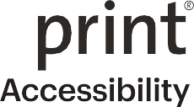
Sprint Vision: Putting the power of independence in your hand
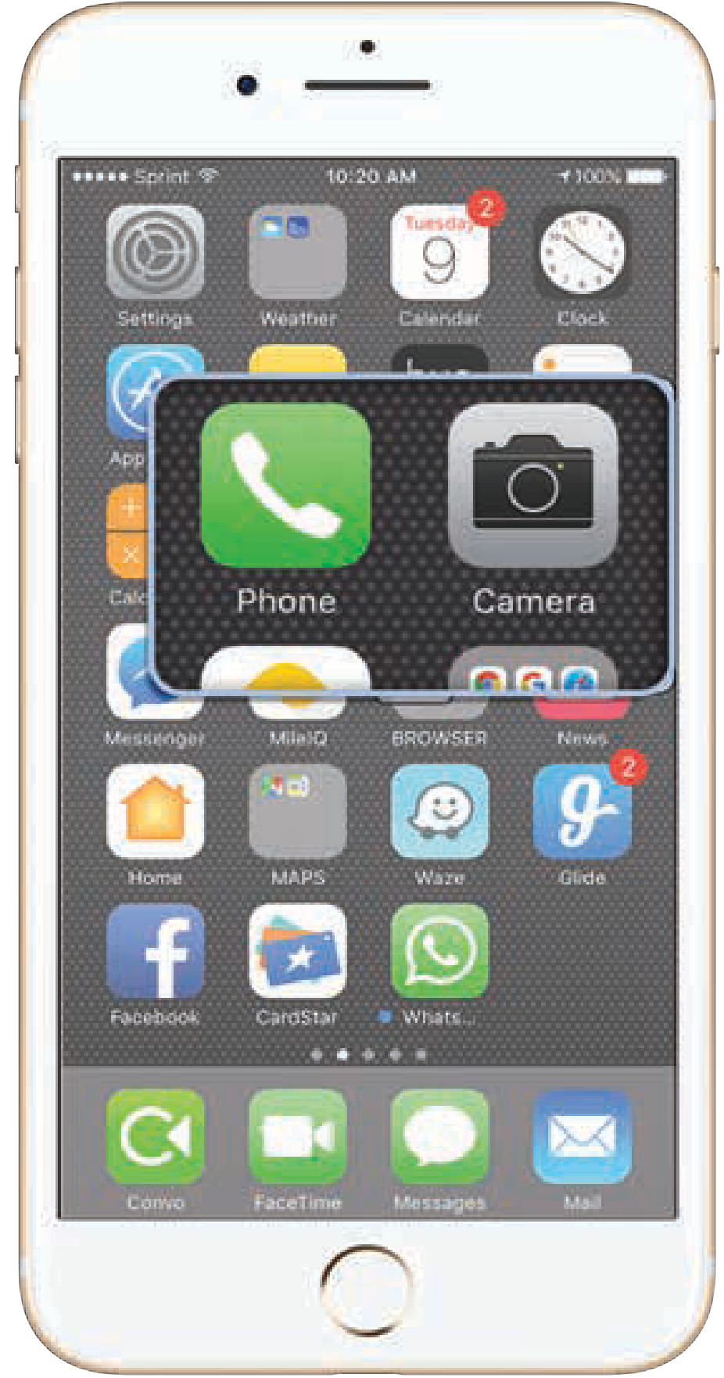
Delivers user-friendly accessible devices, offers affordable plans with extraordinary customer service.
l Promotional service plans
l Free directory assistance
l Free KNFB
Reader Enterprise*
l Accessible website: sprint.com/vision
l Sprint Accessibility Care:
- 855-885-7568
- accessibility@sprint.com
* App with new line activation or eligible upgrade.
Offers and coverage not available everywhere or for all phones/networks. Restrictions apply. See www.sprint.com/vision for details.
© 2018 Sprint. All rights reserved.

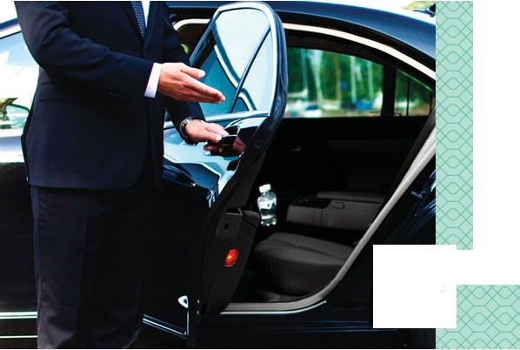
UBER

Uber is proud to once again partner with the American Council of the Blind
Uber is working with ACB to improve Uber's accessibility for everyone

Learn more about our accessibility efforts at accessibility. uber.com

NM to Uber?use the promo codeHITTHEROAO toget $15offyoor firstride.

